**R&D RECOMMENDATION REPORT 2017**

**FOR THE NEXT GENERATION OF GAS TURBINES**

Table of contents

Introduction 3

Market conditions & political boundaries 4

Operational flexibility 6

Efficiency, (considering the entire load range) 8

Fuel flexibility 9

Emissions 11

Carbon mitigation 12

Advanced cycles 13

Materials 15

Reliability, availability and maintenance 18

Condition monitoring & lifing 19

Sensors and instrumentation 21

Micro-gas turbines 23

Proposed type of projects 26

# Introduction

I

n 2013 the General Assembly assigned to ETN’s Project Board the task to produce a Research & Development (R&D) Recommendation Report. The purpose of this report is to summarise recommendations for R&D topics based on interpretations of the user community’s needs and requirements as well as energy policy targets. The report is intended to be a living document revised on a biennial basis. The report lists topics in technical areas relevant to gas turbine systems being used in the two business segments ETN members are active in namely “oil & gas” and “power generation”. The topics suggested should trigger respective actions within the ETN community in various forms: R&D pro- jects, feasibility studies, best practice guidelines, development of standards and technical briefing papers.

The ETN Project Board provides a consultative forum and independent support to new initiatives or issues that are brought to its attention. Providing a sounding Board for these ideas and initiatives that have originated from the entire body of ETN members, the Project Board advises on how to maximise the potential of new initiatives and provides recommendations for future action, as appropriate.

The Project Board, nominated by the ETN Board in 2016, consists of the following members who have all contributed to the various parts of this second edition of the recommendation report:

**Project Board**



* **Peter Jansohn** (chair)

Paul Scherrer Institute (PSI) Switzerland

*Technical areas*:

Fuel flexibility, emissions

###### Peter Breuhaus

International Research Institute Stavanger (IRIS)

Norway

*Technical areas*:

Condition monitoring, advanced cycles



* **Dominique Orhon**

Total France

*Technical areas*: Turbomachinery, oil and gas operations



* **John Oakey** Cranfield University UK

*Technical areas*:

Materials, CO2 mitigation/CCS



* **Nicola Rossi**

Enel Italy

*Technical areas*:

Power plant efficiency and flexibility



###### Abdulnaser Sayma

City, University of London UK

*Technical areas*:

Operational flexibility, efficiency



* **Mark George**

Cullum Detuners Limited UK

*Technical areas*:

Turbomachinery, noise control, filtration, emissions reduction

# Market conditions & political boundaries

nergy systems are undergoing major changes in many countries across the world. Decentralized energy generation, intelligent power grids, unconventional sources and of course, renewable energy sources (RES) are at the top of the energy agenda.

E

Despite the renewable boom, it is foreseen by the International Energy Agency (IEA) that conventional gas-fired power generation will still be needed to provide a reliable and cost effective, dispatchable power source to respond to peaks in demand and when intermittent renewable sources are not available for many decades to come.

This chapter outlines topics which have a strong influence on gas turbine technology development, gas turbine sales and gas turbine deployment and use.

## Economic environment for oil & gas business

Following four years of stability, oil prices fell abruptly in the second half of 2014. In June 2014, the price of Brent crude was around $115 per barrel and as of January 2015, it had fallen by more than half, down to $49 a barrel. The low oil and gas price, the shale gas boom (USA), the rise in oil and gas supply, the diversification of the energy mix and the decline in consumption have now changed the global energy landscape worldwide. The unfavourable conditions of the European gas turbine market and a potentially prolonged period of low oil and gas prices create immense pressure on production cost. Most likely this will have significant implications on the gas turbine industry, hence cost reduction measures are of paramount importance.

## Climate change

The Paris Agreement reached at the United Nations Framework Convention on Climate Change (UNFCCC) COP21 conference in December 2015 is expected to give new strength to policies on climate change and the low-carbon energy transition. However, according to the International Energy Agency (IEA) projections for Organisation for Economic Cooperation and Development (OECD) economies, the average CO2 intensity of electricity needs to fall from 411 grams per kilowatt hour (g/kWh) in 2015 to 15 g/kWh by 2050 to achieve the goal of limiting the global increase in temperatures to 2°C. While many studies conclude that this is both technically and economically feasible, reaching this goal calls for new power market designs.

The roles of Carbon Capture and Storage (CCS) and low CO2 emission technologies need to be considered in order to achieve CO2 mitigation goals. However, for the moment, there is no market pull for the reduction of CO2 emissions in Europe as the EU Emission Trading System (ETS) does not yet incentivise the investments needed in the sector.

EU countries have also agreed on a new 2030 Framework for climate and energy, including EU-wide targets and policy objectives for the period between 2020 and 2030.

 At least 40% emissions reduction from 1990 levels by 2030;

 At least 27% energy efficiency increase by 2030;

 At least 27% renewable energy share by 2030;

 15% increased energy interconnections between member states by 2030.

These targets aim to help the EU achieve a more competitive, secure and sustainable energy system and to meet its long-term 2050 greenhouse gas (GHG) reductions target (long-term goal of reducing GHG emissions by 80-95% when compared to 1990 levels).

## Operating conditions of gas turbine based power plants

Gas turbines are a viable and secure option both economically and environmentally for power and heat generation. In future energy scenarios renewable energy resources (wind, solar) will play a much more significant role than in the past. As these resources do exhibit a weather dependent fluctuating non-controllable energy source (for electricity production), it is indispensable to have additionally controllable electricity production technologies available which can compensate the variable electricity production from wind & solar, in order to keep the electricity network stable i.e. to maintain the balance between production and consumption of electricity. Even with large electric storage systems hopefully becoming available in the future as well, flexible controllable electric power generation technologies, like gas turbine power plants, will be still required to provide sufficient generation capacity necessary to maintain grid stability and security of supply for electricity.

## Integration of Renewable Energy Sources (RES)

The increasing share of intermittent Renewable Energy Sources (RES) is changing the pattern of energy generation. In the short term, GTs and Micro Gas Turbines (MGT) can help the integration of RES into the energy system by absorbing the fluctuations of the RES in the grid as well as by using low or CO2 neutral fuels like natural gas, biogas, industry waste gas or landfill gas. In the long term, hybrid GT and MGT applications that can assure high utilisation of RES and ensure security of energy supply due to the fuel flexibility if needed. This will provide significant contributions to a decarbonisation of the energy system and to the full deployment of RES in the grid.

Rapid improvements in low-carbon, demand-response and storage technologies can lead to a smarter, more efficient and more secure system, but achieving their full potential requires new approaches to policy and regulation. “Power-to-gas“ technology could also provide significant amounts of hydro- gen (H2) and/or synthetic natural gas (SNG) making it necessary to adapt gas turbines for the future use.

## Decentralised electricity production

We are currently moving from a highly-centralized to a more decentralized energy system relying on more distributed generation, energy storage and a more active involvement of consumers through demand response. If regulatory regimes, market design and system operation end up lagging behind technology deployment, the result may undermine electricity security and, ultimately, the low-carbon transition itself.

*© Clean Coalition*

In this context, small scale power plants and MGT with micro-CHP can play a substantial role in supporting renewables and meeting the challenges of the modern electricity grid. MGT technology is able to support renewables at the system level in Europe and can realise multiple benefits as a form of demand response. They can operate as a stand-alone unit in off-grid operations or grouped in farm arrangement generating higher output and providing electrical power support to a local microgrid. They offer flexibility in operations, fuels and connection methods, modularity, stable and reliable operations and lower emissions than alternative generation systems.

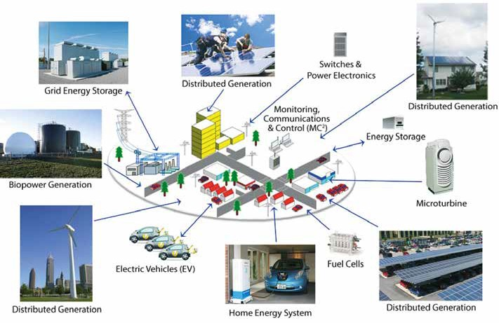Figure 1: Decentralised generation

# Operational flexibility

T

he two main contributors to the increasing share of renewables in the power generation mix are solar and wind. Since both of them are non-dispatchable technologies, back-up solutions are needed in order to assure grid stability. Though large scale energy storage is expected to be used for this scope in the medium to long term, at the present time technologically and commercially viable large-scale energy storage technologies are not available, with pumped storage only possible in site-specific locations. In this scenario, conventional power plants will cover the backup needs for the next decades. Due to the significant time required to modulate, start up and shut down nuclear and coal power plants, they will continue to be mainly suitable for providing base load electrical demand. Although coal is also used to provide back-up, this has been mainly driven by short-term cost of coal in relation to gas. As a consequence, open cycle gas turbine or combined cycle power plants are considered to be the most suitable technologies to provide the major part of flexible back-up to the intermittent renewables in the foreseeable future. To enable this to be commercially viable and reduce emissions, such plants should have higher operational flexibility than the current state-of-the-art. Increased operational flexibility is also prompted by the shift of combined cycle plants’ operation mode from providing base load to load following due to changing gas prices, changing market conditions and market deregulation. Current designs of combined cycle plants were typically not optimised for the required shift from base load to intermediate or cycling requirements.

##### To enable plants to support flexible operation, they need to be designed for:

 Frequent start-up and shutdown

 Fast load changes and load ramps capability, while keeping GT combustion stability and maintaining emissions within the permitted levels.

 High start-up reliability

 Long components life under the above mentioned operating modes

 Suitable frequency control and ancillary services

Historically, the drivers were addressed in the context of risks of fluctuating fuel and electricity prices among other factors related to business opportunities. Hence there have been some related research and development. Thus any research activity requires an extensive review of this fast changing subject to identify areas of future R&D.

##### The following areas have been identified as active R&D topics:

 Minimum environmental load: this is the minimum load at which the gas turbine is able to operate while meeting the environmental limits, in particular NOx and CO emissions, taking into account that these limits will certainly become more stringent in the coming years. This opens the need for further research into combustion technology.

 Efficiency at part load and minimum load conditions: combined cycles are operated at low load for an increasing number of hours. Although for new plants the efficiency penalty for operation at medium load has been reduced, future plants should be designed to further reduce the efficiency penalty at part-load and minimum-load conditions.

 High cycling capability: recently built combined cycle plants are generally characterised by fast start-up (15-30 minutes hot start-up, 60 minutes warm start-up) and shut down, fast load change and load ramps (35-50 MW/minute max), moderate start-up emissions, high start-up reliability. R&D is required on further reduction in start-up times and increasing load ramp rates while ensuring minimum impact on the lifetime of critical components.

 Operational flexibility at low operating costs: this means high part-load efficiency and short start-up time. This also requires addressing R&D to the entire plant including the bottoming cycle.

 Energy storage solutions: integration of energy storage solutions in thermal power plants is a field which needs to be further explored, in order to increase ramp capabilities and allow operation at nominal maximum and minimum load though maintaining the possibility to provide ancillary services.

 Renewable energy storage through hydrogen: a different path requiring further R&D is related to utilising excess energy from renewable sources or from conventional power plants during off-demand (e.g. night) hours for hydrogen production. There is a significant drive to use the gas grid to accommodate a higher hydrogen content which helps to maximise renewable energy storage. It is thus imperative to conduct research and development to increase the tolerable level of hydrogen in natural gas to be fired in existing gas turbines or new designs (see “Fuel Flexibility” chapter).

 Reliability under fast cycling: to prevent increased outages due to fast cycling, the following topics need to be addressed:

* Key equipment design, materials and corrosion aspects
* Component replacement, maintenance and operating costs
* Strategies for optimising cyclic operation
* Effect on thermal barrier coating
* Effect on Creep-fatigue of turbine blades, cracking and degradation of combustor

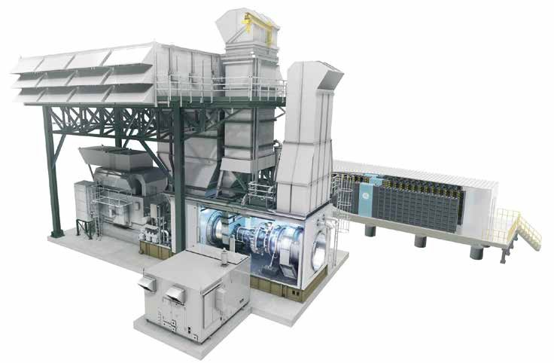 CCS for flexible operations: incorporation of CCS leads to restrictions on operational flexibility due to constraints in the part- load operation of the CO2 capture and compression train, which is typically limited to 70% turndown. The impact is increasing the hot start-up to 1-2 hours and cold start-up to 3-4 hours. Strategies should be developed to reduce the impact of CCS on operational flexibility.

 Computational tools: there is a strong need for the development of high fidelity computational tools to model the power plant allowing for virtual simulations leading to lower cost system optimisation and development.

 Technologies for improved control: an area of increasing interest for R&D is the use of more instrumentation and new sensor technologies to monitor and improve the control of operation of the power plants. This is combined with developments in the processing and visualisation of the large data sets resulting from the arrays of sensors, a field of research known as ‘big data’ (see “Sensors and Instrumentation” chapter).

Figure 2: LM6000 gas turbine integrated with 10MW batteries

*© General Electric*

# Efficiency, (considering the entire load range)

nergy efficiency is very important from the supply side as well as the demand side. The IEA estimates that of all efforts required to deliver a 50% reduction in global CO2 emissions by 2050, 7% will need to come from power generation efficiency. Current European gas turbine based plants operate at an average efficiency of 52%, while best available technology operates at above 60% efficiency. General measures to improve turbine efficiency are increasing Turbine Inlet Temperature (TIT) and compressor pressure ratio in parallel with cooling air reduction, more advanced aerodynamic concepts to improve component efficiencies in addition to cycle innovations. The above measures imply the need for development of new materials for improved component life at high part-load efficiency.

E

One of the implications of future flexible operation in power generation is the requirement for high part-load efficiency. Conventional power plants designed for base load have high design point efficiency, while part-load efficiency is comparatively low. Flexibly operating power plants should be developed to have higher average efficiency over the operating cycle, with higher part-load efficiency possibly being achieved at the expense of some reduction in design point efficiency as shown in Figure 3 (unless some innovative concepts become commercially viable).

To enable efficiency improvements to meet the required targets, research and development is needed in the following areas:

 Advancements in design both for the primary and secondary flow paths. This requires adjusted axial and radial load distributions, new aerodynamic blade shape technologies, improved sealing and active tip gap control. It may also be possible to introduce end wall profiling or features that can disrupt secondary and leakage flows to improve efficiency particularly at part load.

 Reduction in cooling air requirements through advanced cooling system concepts as well as adjustable cooling air mass flow. This requires advancement in both modelling and testing methodologies.

 Design optimisation to achieve high efficiency over a wide range of operating conditions. This requires advancement in modelling and design tools to reduce the lead time for new designs. Ultimately, it may also be possible to achieve higher design point and off-design efficiencies through more variable pitch blading and using further improvements in aerodynamic and mechanical designs.

 Improvements in material technology and thermal barrier coatings to withstand the higher turbine thermal loads resulting from elevated turbine inlet temperatures. This requires the development of tools to quantify material life under real operating conditions and improved material testing techniques.

 Optimisation of system efficiency should consider the combination of the gas turbine and the bottoming cycle at the same time, and thus R&D should take into account the performance of the Heat Recovery Steam Generator (HRSG) and the steam turbine.

 New combustor technologies to enable low emissions and stable operation at part-load. This requires improvements in both modelling and experimental technologies in the field of combustion and issues of flame instability/lean blow-out and pressure pulsations.

**Ultimate Technology**

**Desired**

**Technology**

**Current**

**Technology**

Efficiency

Load

Figure 3: Efficiency versus load

# Fuel flexibility

T

he need for gas turbines to be operated safely, with high efficiency and low emissions, using a variety of gaseous & liquid fuels still remains to be an important issue for current and future gas turbine models.

Besides a wide variety of natural gas qualities, including gas compositions with high content (> 1%vol.) of higher hydrocarbons (so-called C2+, like ethane C2H6, propane (C3H8) and butane (C4H10)) or with high content (> 10%vol.) of inert species (N2, CO2), which cover a wide range of Wobbe Index values (35 - 55 MJ/Nm3), additional fuel gas mixtures (syngas - CO/H2, hydrogen - H2) and diluents (CO2, H2O) come into the scene as new gas turbine based processes and new fuel resources (biogas, shale gas, LNG) are being proposed for power generation and industrial applications. Additionally, liquid fuels remain to be of interest for mobile applications (aero engines, marine engines), oil & gas industries, island/off-grid operation and as back-up fuels. Meanwhile, their spectrum is increased by biomass derived liquid products (FAME, DME, pyrolysis oil, etc.).

The issue of wide fuel spectrum capability of gas turbines is strongly coupled with operational flexibility topics such asNatural gas/syngas mixtures

Biomass derived syngas (CO/H2 mixtures from biomass/ wood gasification) is considered CO2-neutral and thus has to play a role in future power generation scenarios. Co-firing of such syngas in large gas fired combined cycle plants offers high electricity conversion efficiency. With co-firing shares of up to 20% (by energy), the combustion performance is being influenced. Issues to be addressed are safe combustion performance (flame stability, flashback, combustor cooling, thermoacoustics), emission behaviour (NOx, CO) and material degradation due to fuel contaminants (particulates, corrosive species like sulphur, chlorine, sodium).

## H2-rich fuel gases (e.g. syngas)

High hydrogen concentration (> 50%vol.) in fuel gas mixtures requires significant changes to the fuel-air mixing/burner/combustor design of gas turbine combustion systems. Beyond the findings of the EU funded project “H2-IGCC” it is still important to find solutions and demonstrate the applicability (at full scale/full pressure) of potential low emission, reliable (safe ignition, stable flames) combustion technologies. Issues to be addressed are safe combustion performance (flame stability, flashback, combustor cooling, thermoacoustics) and NOx

flame stability and emissions, and can be exacerbated if fuel switch-over procedures are to be considered.

Typically achieving ultra-high efficiency requires very narrow fuel specifications, whereas with widely variable fuels, one needs to accept somewhat lower performance and possibly a redesign of key components in order to arrive at a fuel-flexible gas turbine set-up.

Specific issues, which need to be addressed in this respect, are:

## Natural gas/H2 mixtures

With large capacities of wind & solar PV installed, storage of intermittently produced surplus electricity has become an important challenge. Storage via H2 production from water electrolysis is one option being considered. As storage of pure H2 in large quantities is difficult and expensive, its injection into the natural gas grid is considered to be an attractive option. This would require consumers connected to the grid (like gas turbine power plants) to cope with a variable H2 content in natural gas (may be up to 20%vol.). Issues to be addressed are safe combustion performance (flame stability, flashback, combustor cooling, thermoacoustics) and NOx emission behaviour.

x

emission behaviour for process conditions relevant to gas turbines integrated with pre-combustion carbon capture schemes and/or solid fuel gasification (coal, biomass, process residues).

## LNG/LPG

LNG (liquefied natural gas) and LPG (liquefied petroleum gas) have very peculiar composition when they are re-gasified and used as fuel gases for gas turbine operation. LNG consists of (mainly) CH4 and thus reduces any impacts due to inert species (N2, CO2), but the low levels of higher hydrocarbons (e.g. C2H6/ C2H4) can cause operability issues due to the reduced reactivity of the fuel. LPG consists of propane (C3H8) and butane (C4H10) in various ratios and exhibits strongly different physical and chemical properties (i.e. combustion characteristics). Flame stability, flame speed and ignition delay times can be sufficiently different, such that a re-design of key combustor components could be required. Re-gasified LPG may be an attractive alternative to liquid fuels in locations where a natural gas supply is not available.

## Shale gas

Shale gas (so called unconventional natural gas) can show an even wider variation in composition than (conventional) natural gas qualities and expands the range towards even lower Wobbe Index values (below 35 MJ/Nm3) due to higher content of inert species (N2, CO2) which can also vary temporarily depending on the exploration conditions.

## Biomass (derived) liquid fuels

Liquid products generated from syngas of biomass gasification systems (FAME, DME) or directly formed in pyrolysis processes of various types of biomass (i.e. pyrolysis oils of different origin) pose a significant challenge to the operation of gas turbine systems. Not only physical properties (viscosity, lubricity) bear certain difficulties, but also chemical properties (S/N/Cl content; acidity/corrosivity; combustion chemistry/ flame speed) vary significantly and are not yet fully characterized (operational limits such as lean blow out and flashback; NOx/CO/SOx emissions).

*© AirProducts*

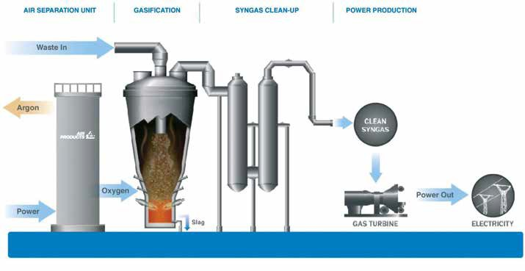Figure 4: Tees Valley Renewable Energy Facility

# Emissions

T

he NOx emission level of gas turbine engines has continuously been reduced over the last few decades. Even though 25ppm NOx (corr. to 15%vol. O2) is still accepted as industry standard (for gaseous fuel firing), more and more projects adopt 15ppm NOx as a emission target, and even single digit ppm NOx levels are being asked for in certain regions. For liquid fuel operation, 42ppm NOx has long been accepted as the emission limit, but recently a new version of the Industrial Emission Directive (IED) of the EU has been drafted which calls for 25ppm NOx also for liquid fuels. Legislation for CO emissions has been less stringent (usually less than 100ppm CO is acceptable), but in some cases CO emission limits (at base load) have been put as low as those for NOx (e.g. 25ppm). Subsequent to the publication of the IED, the Best Available Techniques Reference document (BREF) has set an expectation for further reduction in NOx levels for both existing and new plant.

Individual issues which should be addressed in the near future are:

## Emission limits at part load

As gas turbines are much more often required to run at (low) part load and to cover a lot of cycling duties, including starts and stops, emission limits at part load are being given much more attention and emphasis. Maintaining low emission val- ues (e.g. 25ppm) for NOx (as well as for CO) down to very low part load and during transient load operation has become an important selling argument for gas turbine products. Issues to be addressed are safe combustion performance (flame stability, thermoacoustics) in combination with maintained low emission (NOx, CO) characteristics over a wide load range (from below 50% up to 100% load).

## Liquid fuels (emission of NOx, CO and particulates)

Extremely low NOx emission limits (less than 25ppm) for liquid fuel operation of gas turbines pose a significant technical challenge if they should be achieved by combustion measures alone (no additional flue gas treatment via selective catalytic reduction (SCR)). Issues to be addressed are liquid fuel atomization/evaporation and pre-mixing fuel with air for homogeneous combustion in the gas phase as a prerequisite for low NOx formation. Combustion performance (flame stability) should not be compromised, either with or without addition of water/steam, and a combined minimum of emission species (NOx, CO, particulates) has to be targeted. As particulate emissions are typically very low, the challenge of measuring such low levels in a reliable way is not yet fully resolved.

## Exhaust gas recirculation

Exhaust gas recirculation (EGR) applied to gas turbine engines can be a viable method to address a couple of issues: EGR can help to mitigate NOx emission (via moderation of peak flame temperatures and a reduced oxygen level) or keep NOx emission low even for increased turbine inlet temperatures (TIT). Additionally post combustion CO2 capture systems can be operated more effectively (lower specific energy consumption per ton of CO2 removed) due to an increased concentration of CO2 in the gas turbine exhaust. Critical is- sues with high EGR rates are combustion performance (flame stability) and potentially high CO emission.

## Dilute combustion / wet combustion / flameless combustion

As alternatives to conventional lean premix combustion for which heat release is localized in a distinct flame front, other combustion technologies which target spatially distributed heat release offer potential advantages such as low NOx emission even if the premixing quality is imperfect. Volumetric heat release also provides more favourable conditions to avoid thermoacoustic feedback loops which can cause catastrophic pressure fluctuations. Possible means for achieving distributed heat release are strong dilution with steam (so-called wet combustion; e.g. related to Cheng cycle combustion conditions) or strong internal recirculation of exhaust gas leading to so-called flameless combustion conditions. Issues such as reduced burnout/increased CO emission and low load operating conditions need to be carefully addressed and managed.

## H2-rich fuel gases / NG-H2 mixtures

Combustion of fuel gas mixtures containing high hydrogen concentrations (> 50%vol.) tend to show higher NOx emissions and require significant changes to the design of fuel-air mixing/burner/combustor systems in order to avoid this. If dilution with steam or nitrogen (N2) is not an option, issues regarding safe combustion performance (flame stability, flashback, combustor cooling, thermoacoustics) need to be addressed while trying to keep NOx emission low.

As H2 will likely become available more abundantly (via water hydrolysis driven by surplus electricity from RES) and be injected for energy storage reasons in larger amounts (> 2%vol.) into the natural gas grid, unambiguous data is required for such fuel mixtures (up to 20%vol. of H2 in natural gas) concerning combustion properties and emission characteristics in order to define methods and designs which can mitigate the associated risks.

# Carbon mitigation

hile there is significant momentum behind the continued use of gas turbines for power generation using gaseous or liquid fuels, such as natural gas, shale gas or renewable biofuels, there is a continuing threat from policy and regulatory actions being taken to reduce CO2 emissions. This underpins the strategic importance for the gas turbine industry to maintain their commitment to continuing R&D into the development of low carbon options and cost-effective CCS for both new designs and for retrofit to existing units.

W

Reducing CO2 emissions from gas turbines can be achieved through the improvement in efficiency, the use of flow carbon fuels or by the integration of CO2 capture technologies. The first of these options is addressed in another part of this document, while the second shares close linkage to the challenges from fuel flexibility. The application of CO2 capture approaches may be post-combustion, with the capture unit located on the gas turbine exhaust; pre-combustion, where the carbon is largely removed early on in the process leaving a hydrogen-rich fuel gas; or by using oxy-combustion where the CO2 is more readily separated from the steam in the exhaust gas stream. The following priorities reflect those not covered elsewhere.

## Integration of post-combustion CO2 capture technologies with gas turbines

The decarbonisation of gas turbine power generation, whether for existing natural gas-fired units or for new build schemes will have significant impacts on operating costs and levels of dispatchable power, due to the energy penalties arising when CO2 capture is included. Selecting the most suitable capture technologies and optimising their integration (while maintaining plant flexibility) provide significant challenges. Among others, the following options are worthy of further research:

 Integration of ‘conventional’ post-combustion amine scrubbing, or competing liquid based technologies, to minimise costs and energy penalties, and to optimise operational flexibility.

 Investigation of alternative post-combustion capture tech- nologies, such as Ca-looping cycles or solid sorbents us- ing pressure or temperature swing concepts, which allow for improved heat integration, and hence lower operating costs. Also, the investigation of other post- combustion capture options, e.g. CO2 separation membranes.

 Studies of the impact of exhaust gas recycling, including enhanced recycle options (e.g. using CO2 separation membranes), to enhance exhaust gas CO2 levels and so reduce the size and costs of the capture plant. This approach will lead to significant changes to combustion and hot gas path environments, and may also impact on operability, materials and component lives.

**Operation with hydrogen, biomass-derived and other low carbon gases**

Such gases are often less clean than their fossil-derived counterparts and so can lead to combustion and hot gas path challenges. This links with research aimed at improved fuel flexibility and the use of H2 used either in direct firing, or in dilution of natural gas distribution networks, such as reformed natural gas, H2–rich syngas from gasification processes with pre-combustion capture, or from H2 generated by electrolysis (from unused renewable electricity) or from biomass-derived sources.

**Advanced, high-efficiency cycles using oxy-fired gas turbines**

A range of advanced, high-efficiency cycles are under development to provide higher efficiency alternatives with inherent CO2 separation to the application of post-combustion capture options. These use oxy-combustion to provide a low N2 exhaust gas from which it is easier to separate the CO2. In these cycles, the separated CO2 is compressed for transport and storage, and some of either the CO2 or the condensed steam may be recycled to the combustor to moderate combustion. Such cycles operate at very high pressures, up to 300bar, and present significant operational and component manufacturing challenges. Examples are supercritical CO2 power cycles (e.g. the NetPower cycle), where the exhaust gas CO2 is recycled, or the Clean Energy Systems cycle (which comprises natural gas/O2 combustion) where steam is used to moderate the combustion conditions.

While offering significant potential for the generation of low cost, low carbon electricity, these cycles require major developments in combustion, hot gas path environments (due to the impact of high steam/CO2 levels), materials, turbomachinery requirements, control strategies, etc., as these are very different to conventional systems and present many challenges and uncertainties which may limit the potential performance of the cycles and significantly hinder their development. Research into the impacts of these altered operating environments would help the identification of those cycles with most potential, and so provide a possible pathway for future turbine development.

# Advanced cycles

hanging boundary conditions in energy politics result in the need for new concepts and “advanced” cycles. Innovative cycles using a gas turbine as the main component seem to be one of the possible options to provide the needed back-up and balancing power. In focus are new plants as well as upgrading and conversion of existing plants with a long remaining lifetime. In this context methods and tools that provide the user with “reliable simulation results” for evaluation of various alternatives (both technically and economically) will become valuable in the near future. Additionally, it is necessary to evaluate activities in an interdisciplinary manner, for example, alterations to blading and flow paths will have an impact on the combustion process and materials.

C

In this context the required research activities can be divided into two main categories:

###### Development of the necessary tools for evaluation and design of advanced and new cycles

**1**

###### The evaluation of innovative, advanced cycle concepts

**2**

## Development of necessary technologies

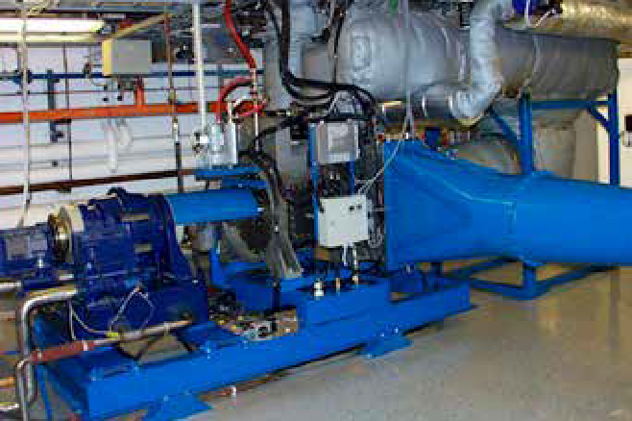Advanced cycles, both new and / or retrofitted might require interconnection to other systems, components or processes such as for example high temperature fuel cells or solar air heaters. Most GTs currently on the market are not designed for this type of process integration. Integration also often requires to a change in mass flow rates of compressor or turbine as well as changing composition of the working fluid.

Figure 5: Humid air turbine

*© Lund Univeristy*

Examples of significantly changed mass flow ratio of compressor and turbine are humid air turbines (Figure 5), the Topspool concept or biogas fired engines. R&D activities should therefore target developing concepts for easy to integrate and flexible gas turbines, most likely for industrial size units.

Currently simulation tools are more or less specialized for certain applications, such as power cycles, using detailed and well validated models or chemical plants and processes having a variety of fluid properties and chemical reactions embedded but often missing detailed models for turbo-machinery components. In many cases, advanced cycles have fluid compositions as well as pressures and temperatures which might exceed the “current” range of gas turbines. Moreover the processes are closely integrated with various volumes and characteristics of their components. For the evaluation and design of new concepts, it is necessary to have efficient, robust and reliable tool sets for analysis.

R&D activities might target to close the gaps of:

 A tool or system of tools that allow the analysis of advanced integrated cycles without the need to manually iterate be- tween power plant simulation and process modelling tools. This will avoid errors and should also result in a faster analysis and evaluation process.

 Tools well-suited for transient analysis of the process, as gas turbines are increasingly used to balance energy demand and the growing share of fluctuating renewables in the grid. Furthermore is it necessary to combine components of very different response characteristics in energy systems. Higher complexity and higher flexibility needs during start-ups and transients support this requirement.

 Tools for life cycle analysis in terms of costs as well as in terms of the environmental impact (CO2 and other emissions and impacts accumulated over the entire lifetime) as a base for standard evaluation of concepts.

## Advanced cycle concept evaluation

The Evaluation and R&D activities related to advanced cycles are usually closely connected to specifically chosen type of cycle and thus can’t be used to generate new ideas for general R&D activities and possible projects. The need to carry out evaluations in an interdisciplinary fashion was already mentioned above.

c/ac Inverter

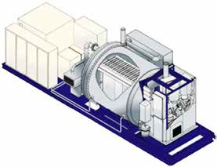

UPS

Fuel Supply System

Gas Turbine

Electrical Cabinets

SOFC Generator

Possible advanced cycles might be:

Wet cycles: processes with extraordinary high water content in the work fluid. Water might be either added before the combustor (e.g. humid air turbine or TopCycle (Figure 3), in the combustor itself (e.g. Cheng Cycle) or after it (e.g. for power augmentation). There are some general aspects to these cycles which might be topics of R&D activities.

*© Siemens*

1

Figure 7: Schematic of a Solid Oxide Fuel Cell/Gas Turbine hybrid system



Exhaust Gas

Condensor

Combustor

Steam

Injection

TopSpool

**G**

**G**

Base GT

Heat Load (80 C)

Figure 6: Top Cycle

*© Vattenfall*

Aspects besides those mentioned under 1. could be:

 The combustion process and design conditions very close to stoichiometric in the combustor, and the operation and stability under changing operational conditions.

 The challenges when connecting the GT to larger volumes such as humidification towers and the resulting change in transient behaviour as well as during start-up and shut down need to be addressed in close connection to the development of basic technologies as mentioned above.

 Topics such as changes in the condenser design, mismatch of mass flow in turbine and compressor were also already mentioned. In addition there is a need for the development of a humid air condenser and the extraction of the condensed water to be highlighted. It might be also necessary to consider additional or adjusted water treatment and its integration into the process.

Using Exhaust Gas Recirculation (EGR) as a method and tool for enhanced CO2 capture and sequestration by increasing the content of CO2 in the exhaust gas of the GT is also a cycle under evaluation. EGR is already used by Mitsubishi Heavy Industries for NOx control in J-series

2

GTs with a Turbine Inlet Temperature (TIT) of 1700°C. This technology is thus close to commercial use.

The use of other working fluids than air, such as supercritical CO2, is an issue which requires additional R&D efforts. In this context topics of interest might be:

3

 External combustion, allowing the use of various fuels and at the same time reducing the overall process complexity by avoiding extra efforts and components for fuel preparation/ treatment.

 High efficiency, high temperature heat exchangers with optimized heat transfer and, depending on the fluids used, possibility for easy cleaning to reduce the effect of degradation.

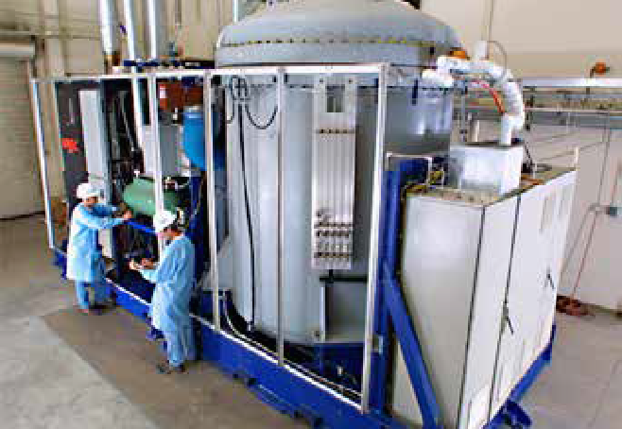Hybrid cycles, combining different electricity production technologies (e.g. fuel-cell/gas turbine hybrids (Figures 7 & 8)) or renewable based power generation with fossil fuelled generation should also be developed better. The combination of solar heat input to a natural gas fired GT is a particular technology which shows great promise.

4

Figure 8 - Picture of a Solid Oxide Fuel Cell/Gas Turbine hybrid system

*© Siemens*

# Materials

he materials and coatings used for the hot gas path components in gas turbines, and their behaviour in service, place limitations on turbine performance and reliability, and represent significant elements in the capital and operating costs of the system.

T

In recent years, changing operational requirements, such as the use of alternative fuels and plant cycling, and factors affecting components lives and costs, have focused attention on specific materials issues. These include:

 The need for improved alloys and coatings (bond-coats, corrosion resistant coatings, TBCs, etc.) for increased efficiency and/or reliability, including ceramics and ceramic matrix composites for uncooled parts, e.g. in micro gas turbines;

 Hot corrosion of blades and vanes arising from the use of H2S-containing gas in offshore operations or biofuels in distributed power applications;

 The use of advanced and additive manufacturing methods for non-structural parts and component repair;

 Component materials inspection, condition assessment (linking to Condition Monitoring and Sensors and Instrumentation sections) and characterization of service-aged materials for life prediction modelling and residual life assessment;

 Condition assessment and durability of TBC coatings;

 The impact of flexible operation and plant cycling on component lifetimes, monitoring requirements and repair costs;

 Reduced usage of strategic and environmentally-damaging elements (re. compliance with EU REACH legislation);

 ‘Fit for purpose’ materials selection (i.e. cost effective materials selection to match the design and operating requirements, and no more).

While increased efficiency with low emissions have long been priority drivers for gas turbine OEMs, end-user focus for current markets has broadened to embrace reliability, operating costs and the ability to handle cheap fuels. In these circumstances, the challenge for the materials used has become more important and more diverse, as indicated above. Operators are now demanding higher reliability of components combined with the capability to maximize service lives, while minimizing the risk of unforeseen failures and extending maintenance intervals.

## Improved alloys, coatings and ceramics

The design of components for use in the hot gas paths of mod- ern gas turbines of all sizes and for all applications, involves:

 the production of complex-shaped parts to meet performance needs;

 systems of compatible materials which can be manufactured to produce the required shapes, with the required mechanical and chemical properties;

 the need to allow for inspection and repair.

As a result, understanding the behaviour of these materials systems, comprising base alloys, bond-coats/corrosion resistant coatings and TBCs during component manufacture and during service is now of fundamental importance if required performance levels and manageable operating costs are to be maintained.

It is also necessary to develop knowledge of the materials suitable for advanced cycles, such as closed bottoming cycles using supercritical CO2 or those using semi-closed oxy-firing where the turbine working fluid will be a mixture of CO2 and steam. Changes in design of the required turbomachinery combined with the changed operating environments will mean that translating existing materials knowledge will require qualification.

The application of monolithic ceramics and ceramic matrix composites is also an important development area, in particular for micro gas turbines where uncooled parts are required. Improved understanding of their failure mechanisms and in-service behaviour are required to ensure reliable operation.

## Hot corrosion behaviour

Hot corrosion is a major cause of damage, and service failures, which is seen in many operational environments when aggressive fuel contaminants (e.g. alkali metals, sulphurous species, etc.) and poor air quality (e.g. containing alkali metal chlorides) fail to be satisfactorily reduced or eliminated through filtration or other means and reach the turbine’s hot gas path. The resulting formation of deposits and gaseous operating environments lead to very aggressive forms of ‘hot’ corrosion which can rapidly lead to failures. The successful elimination of such damage mechanisms must be tack- led through a combination of approaches to ensure that the aggressive combinations of contaminants do not reach the

gas path with the use of materials and coatings with maximum resistance to this form of attack. The multiple factors involved in hot corrosion mechanisms mean that no single approach can be wholly successful on its own.

## The application of advanced and additive manufacturing

Advanced and additive manufacturing techniques are being explored by OEMs, third party suppliers and operators for the manufacture of new parts to reduce costs or provide new materials compositions/ structures which cannot be achieved through conventional ‘subtractive’ methods. These methods can also be used as a repair option. However, these new or repaired parts, when used, must not compromise the mechanical performance, environmental resistance or the life of plant components.

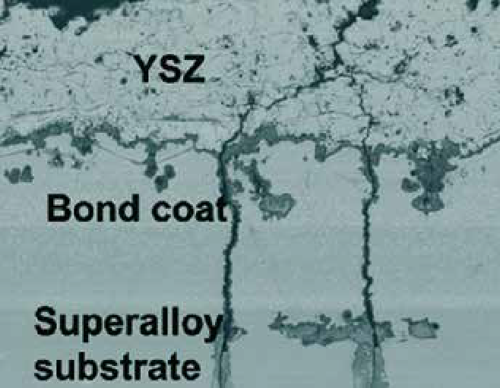Additive manufacturing (AM) processes allow production of components with geometries which are impossible to produce using conventional manufacturing through a layer-by-layer material addition process. This process opens up new design opportunities which could have significant advantages where intricate geometries may be beneficial, such as fuel injectors for gas turbine engines, heat exchangers, gas turbine blades or other aggressive environment applications found in energy technologies. In addition, when components have to be repaired, damaged regions of a component can be removed and replaced via an AM process. For the end user of the component which has been manufactured or repaired in this way, it is important that the materials behave in a predictable manner which is equivalent to those produced in a more conventional way.

*© Sohn, UTSR Project SR118*

## Inspection and characterisation of ex-service parts for component life extension

There is an ongoing challenge to develop understanding of how on-line or off-line component monitoring or inspection techniques can be used to determine the condition of the materials used in the components, and hence inform an assessment of the component’s condition with respect to it continuing in service. Stretching routine maintenance intervals to reduce operating costs has been a continuing aim, although the growing use of gas turbines for flexible generation or with low quality fuels have required more regular inspections to help avoid problems. Relating ex-service component micro- structures to monitoring/inspection data, and its application in predicting the remnant life of the component remains an important area of research.

## Condition assessment and durability of TBCs

TBC systems are based on yttria-stabilised zirconia or other formulations. Flexible plant operation to meet cyclic demands leads to additional thermal cycles which impacts directly on the risk of spallation of TBCs. Premature spalling of TBCs reduces component lives and increases costs through in- creased need for blade refurbishment. Improved on-line and off-line monitoring and inspection techniques are required to ensure costs are managed to avoid unforeseen failures and excessive maintenance/refurbishment costs.

Figure 9: Scanning electron micrograph of cross-section of coated blade material expose in a combusted syngas environment showing deposit penetration

Figure 10: Image of Siemens V64.3 gas turbine blade being used for coating demonstration trials in the EC FP7 H2-IGCC Project

## Impact of flexible operation

The increased cycling of gas turbines in power generation applications has led to increasing incidences of unforeseen failures through fatigue and related mechanisms, as well as the premature spallation of protective coating systems. The current practice of applying the highest temperature performing base alloys with protective coatings may not provide an optimum approach where plants are designed for flexibility, rather than efficiency and low-NOx performance. Research into the costs of different approaches across the full materials life cycle may lead to alternative strategies which have potential to reduce operating costs.

## Reduced usage of strategic and environmentally-damaging elements

European legislation requiring the registration, evaluation and authorisation of specific chemicals that can be considered injurious to health (REACH) came into force in 2007. This has implications in many aspects of gas turbine component manufacture and use, as both chromium (hexavalent chrome) and nickel (notably fine nickel oxide particles) are on this list of SVHC (substances of very high concern) – those that are considered carcinogenic or offer risks to health – along with some 26 other base materials or alloying additions found in our structural materials and coating systems. Many alloys and coatings in common gas turbine use will need to be registered and the implications for component manufacture, performance and repair need to be considered. For example, corrosion by-products that give rise to chromium-6 release is an area of concern.

# Reliability, availability and maintenance

eliability, Availability and Maintenance (RAM) is one of the – if not the – most important issue for the economic viability of gas turbine products in the market. High reliability, availability and maintainability of any gas turbine installation are paramount to achieve a profitable economy for the operator and low prices for the market. Keeping RAM values high is of utmost interest to the user communities and a very important topic not only during the introduction of new technologies, but for the entire lifetime of gas turbine systems. RAM issues have very often a strong link with other technical areas such as condition monitoring, sensors and instrumentation, and materials, and have to be seen in conjunction with the introduction of any new feature in a gas turbine product.

R

To improve the reliability, availability and maintainability of a gas turbine the following technologies and developments should be considered:

## Reliability

 Tools (sensors and/or data evaluation procedures) for early warning of incipient failures (to detect deviation from expected operational conditions before damage is done or to prevent severe subsequent damage);

 Detailed characterization of operating conditions e.g. improved monitoring of intake filter performance especially in wet and salty harsh environment, improved control systems to avoid deterioration and / or damage of GTs components.

 More robust instrumentation (longer service life, reduced requirements for redundancy);

 Instrumentation for severe environments (like in the hot gas path);

 Condition monitoring such as online monitoring of lubrication oil condition.

## Availability

 Increase time between overhaul (TBO)

 Improved performance of air intake filters (longer service time between maintenance);

 Improved capability of engine and its associated systems to sustain gas and liquid fuels with high sulphur content;

 Efficient water wash methods (for compressors), with less frequent intervals, on-line capability and applicability to a wide range of operating conditions;

 Slippery coating on compressor airfoils in order to reduce fouling and the need for operational interruptions (shut- down for a compressor wash);

 Monitoring and prediction of degradation processes to better plan for required shut-downs;

 On-line borescope inspection tools for hot section components.

## Maintenance

 Improved tools for Condition Monitoring, also through the integration of different tools available, enabling the adoption of Condition Based Maintenance;

 Risk-Based maintenance approach, taking into account for the probability and the economic consequences of the potential failure modes;

 Algorithms for predictive analysis (thermal engine performances, sub-system performances, etc.);

 Engine sub-system life extension depending on operating conditions;

 Optimization of spare part management;

 Online transfer of data from remote locations and communication with centralized experts;

 Smarter contract models - risk and reward sharing with maintenance service suppliers;

 Technology and methodology transfer from other industries considered to be best in class (nuclear, aviation, etc.).

# Condition monitoring & lifing

s the share of renewable energy sources in electrical power generation increases, there is a need for more flexibly operating plants to maintain grid stability as well as meeting peaks in demand and providing dispatchable power.

A

This plant cycling together with quick start-ups and rapid load changes, results in less predictable effects of aging and degradation than in continuous operating conditions. Significantly changed operational profiles affect also reliability, availability and maintenance of plants. At the same time service and maintenance costs are a main focus area for many operators. Condition monitoring is a central tool and base to estimate operating hours to next service, remaining lifetime as well as required service activities and spare parts. It contributes to avoiding unexpected outages and reducing outage durations by allowing in advance detailed resource planning and identification of required spare parts. For the use of advanced alloys and coatings, for GTs and HRSGs, condition monitoring supports the early detection of TBC spalling/blade hot-spots and the need for repair/refurbishment. Condition monitoring is therefore a necessary tool to ensure and support increased reliability, availability and maintenance planning of GT plants.

###### The following list of proposed research and development activities represents a collection of ideas which might result in further / future projects.

## Processing of measured signals from sensors and data storage

Signals from sensors, which are the base for condition monitoring activities (combined with routine process operating data), need to be processed and often stored before any further activity. This time consuming process is usually done by the operator and often based on manual interactions. An R&D activity could therefore target to automate the process, for example removal of bad data while, at the same time, avoiding loss of information. Additionally, the storage of important data and information is a critical topic; it is important not to lose information, which could be relevant for later usage in the frame of long term monitoring, and diagnostics often requiring multiple years of data. A project could therefore focus on identifying the needs of long term condition monitoring and develop the necessary methodologies for data storage and handling (e.g. event driven data collection, data compression and averaging etc.).

## Sensor validation

Another interesting R&D topic to focus on is sensor validation, including differentiating between a failed sensor and a real event. This has the potential to avoid spurious gas turbine trips. Models can be developed and then tested in a first stage with physical net- works which simulate operating and fault conditions, and so can help understand sensor responses. Micro gas turbines could also be used as test beds, with sensor fault applied manually. This approach enables partial validation of approaches before testing on commercially operational plants, limiting the risk and allowing evaluation of different scenarios, e.g. the need for redundant sensors to back up a failed one.

## Monitoring systems where there is limited data available

These systems are used to evaluate the condition of components and plants for which not all characteristics are available to the required detail, thus data driven models are used such as artificial neural networks. The data needed for generating such a model are the results of real measurements on the individual plant and need to cover a relatively long period of operation to achieve a sufficient level of accuracy. This disadvantage could possibly be overcome by the development of so called “grey box” models, based on general available characteristics which are derived from physical laws and further improved by combining these characteristics with a data driven/black box model. The application of the resulting model should result in a significantly shorter period for data collection while still achieving a high level of accuracy for the specific plant/component of interest. A possible R&D activity could target building and implementing such a method for a gas turbine or e.g. a small scale CHP as a base for further development steps.

## The inclusion of non-sensor based information

The inclusion of non-sensor based information (e.g. from inspections etc.) and off-line monitoring (may be sensors or other measurement devices, e.g. to measure material condition) might significantly improve the interpretation of data from condition monitoring systems. However this information is usually not systematically implemented. A project might target development of routines and tools to close this gap to sharpen the picture resulting from condition monitoring systems and result in the improvement of the connection to asset management.

## Condition monitoring for transient operation

Condition monitoring during transient operation of the plant/ component is another area, which requires further R&D activities. It is also closely connected to advanced data analysis tools due to large amounts of data (high sampling rate) and required fast processing of them. Currently many maintenance systems rely on data from steady state operation as a base for analysis. Given the growing share of renewable energy sources, requiring balancing by conventional power generation technologies, the transient operation of

GTs will increase. An R&D project may focus on developing improved condition monitoring tools for transient operating conditions. This should also include defining required sampling rates of measured data to achieve accurate and reliable results. Results of such a project could also be used to refine the de- termination of consumed & remaining lifetime of the plant and / or components. A target would be, for example, to replace standard penalties for a start up or shut down with algorithms using measured values. Transients of load change during operation might be also covered based on the magnitude of the change as well as of the gradient of the change.

Input Layer

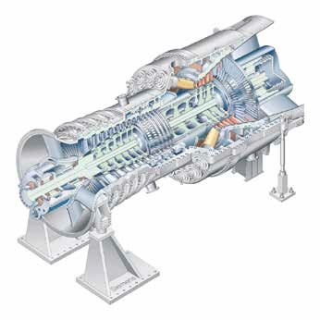

Mapping Layer

Bottleneck Layer

Demapping Layer

Output Layer

Rp

Rm Rm

H G

14

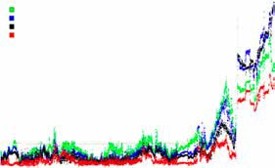

|  |  |
| --- | --- |
| 2 bottleneck neurons Clearindication of change in operation 3 bottleneck neurons   1. bottleneck neurons 2. bottleneck neurons   First indication of change in operation  Approximate residual level in the training data set |  |
| 56 hours |
|  |

12

10

8

6

4

2

0

*© Siemens*

0 500 1000 1500 2000 2500

3000 3500 4000 4500 5000

Data observations

Figure 11: Collecting data and generating an artificial network for monitoring and early detection of upcoming faults

# Sensors and instrumentation

ith the increasing share of non-predictable energy sources in the grid, gas turbines are required to operate in a very flexible mode. In order to maintain safe and reliable operation, a large number of machine parameters have to be continuously monitored.

W

Furthermore, the availability of a larger number of measures will enhance the benefits achievable with the adoption of data analytics techniques (“Big Data”), which will include the development of more accurate failure prediction models as well as the optimization of the operation either for a generating unit or for a whole fleet.

Better sensing techniques could facilitate large fuel savings, with consequent CO2 emissions reduction and economic benefits.

Sensors and instrumentation for the following purposes should be further developed:

## Instrumentation for operation optimisation

The main control parameter of gas turbine operation, turbine inlet temperature (TIT), is currently indirectly evaluated from exhaust gas temperature measurement and other parameters. Direct TIT measurement would allow for a better control of the machine; enabling operation closer to its design values with benefits on efficiency. Measurement of the uniformity of turbine inlet conditions could also prompt combustion system design improvements, with consequent reduction of NOx and CO emissions and increased hot gas path components life, enabling longer maintenance intervals.

## Instrumentation for maintenance optimisation and failure prediction models

Power plants cycling results in additional accumulation of fatigue and creep damage in thick components, such as GT and steam turbine (ST) rotor and HRSG headers. The ability to accurately measure component strain with semiconductor strain gauges enables the online monitoring of high temperature component integrity, including welds. On-line monitoring of elastoplastic strains and dynamic rotor dissymmetry of GT and ST rotors during operation would provide information for the implementation of failure prediction models and would give the possibility to plan corrective actions and reduce the cost and time for repairs.

Real time monitoring of rotating component temperature with infrared systems and telemetry would also provide information for the implementation of failure prediction models, enabling the adoption of a condition based maintenance approach, as described in “Reliability, Availability and Maintenance” chapter.

## Instrumentation for flexible operation (fast ramps/high gradients)

Gas turbines are required to rapidly change their operating conditions in order to maintain grid stability, especially when non-dispatchable plants cover a large proportion of the total generation.

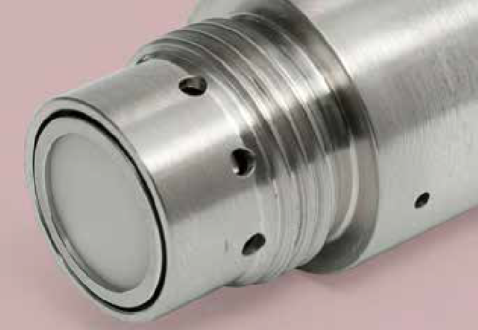Turbine blade tip clearance has a relevant impact on efficiency. With the fast load changes differential thermal expansion of rotor and casing could be a limiting factor for maintaining low clearance values. A reliable measurement of tip clearance with micro-wave, optical fibre or capacitance sensors is crucial for keeping high efficiencies while preventing rubs between gas turbine blades and engine casings and avoiding the risk of failures.

Figure 12: Microwave blade tip sensor

*© Meggitt*

## Instrumentation for machine protection

With the continuous reduction of NOx emissions, combustion stability remains a critical issue for GTs. Ultra high temperature dynamic pressure sensors, based on piezoelectric or optical probes, allow for a more precise measurement, and potential control of pressure fluctuations inside the combustion chamber.

Optical sensors for early detection of heat release fluctuations related to combustion instabilities would also enable protection of the machine against the damages caused by very high intensity instabilities. Real time monitoring of dynamic response of

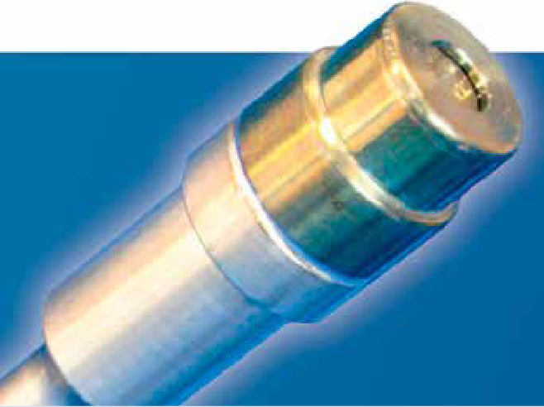both compressor and turbine blades during GT operation with blade tip vibration monitoring systems could prevent blade cyclic damage due to flutter or blade stalling.

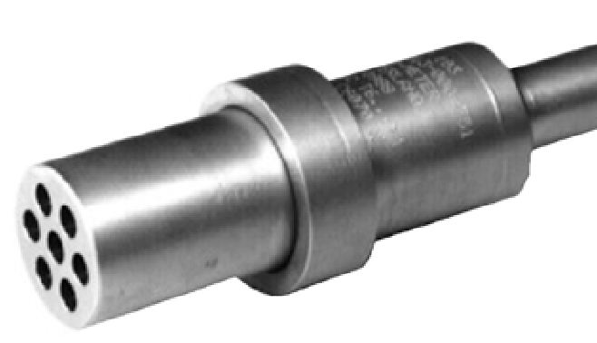

Figure 13: Piezoelectric Pressure Transducer

*© Oxsensis*

Figure 14: Optical Dynamic Pressure Transducer

## Instrumentation to prevent shutdown or to reduce inspection time

Borescope inspections are frequently used to assess the status of the machine when a risk appears on a gas turbine. A borescope inspection demands a prolonged stop with an unavailability penalty. An automated borescope inspection, using robotised technologies and a high temperature borescope would enable inspection during short stops.

## Instrumentation for GT development

High temperature thin film strain gauges could be used for the study of crack development and propagation, residual stress, stress and strain distribution, thermal expansion coefficient of materials at very high temperatures as well as for blade vibration measurements. These sensors would be extremely

useful in the design and development of advanced gas tur- bine engines.

Video cameras for real time flame visualisation in various wave- length intervals would allow monitoring of the dynamic behaviour of the flame, supporting the development of stable combustors, with higher fuel flexibility and larger operability ranges.

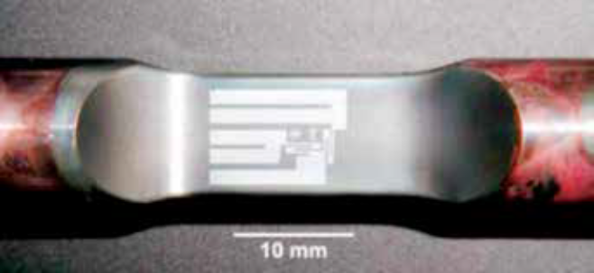Entropy probes can be used to measure the time-dependent relative entropy field, which is related to the aerothermal losses. Entropy can be inferred from pressure and temperature measurements. The development of small-dimension fast-response entropy probes will help the design of turbomachinery with higher efficiencies and wider operating ranges.

*© Meggitt*

*© Nasa*

Figure 15: PdCr thin-film strain gauge on a turbine engine alloy test specimen

## Wireless sensor networks

The advent of low-power processors, intelligent wireless net- works, and low-power sensors coupled with “Big Data” analytics has led to what has become a booming interest in the Industrial Internet of Things (IIoT). In this context, the application of Wireless Sensor Network (WSN) technology in process monitoring and control of gas turbines has demonstrated great potential.

WSNs bring several advantages over traditional wired industrial monitoring and control systems:

 eliminates wiring and conduit, reducing installation cost;

 requires low maintenance efforts (only the battery change is necessary after years of operation);

 gives high flexibility to relocate devices or to deploy additional ones.

The installation of wireless sensors on critical equipment which is not convenient to monitor with traditional sensors will favour the adoption of predictive maintenance, thereby helping to avoid unplanned downtime and critical, unexpected fault events.

# Micro-gas turbines

he development of Micro Gas Turbines (MGT) started in the late 1980s, mainly driven by the automotive industry for mechanical drive as an alternative to reciprocating diesel and gasoline engines (internal combustion engines – ICE) mainly driven by the advantages of the MGT regarding low emissions, fuel flexibility and a potential to compete on cost with ICE due to less maintenance requirements. With the use of a high-speed generator instead of mechanical drive the technology became suitable for use in hybrid vehicles in the 1990s. How- ever, at that time the hybrid electrical drive train was not a sufficiently mature technology and did not raise further interest. Instead other non-automotive companies picked up the technology and introduced it on the decentralised power generation market where its long life and low maintenance cost could compensate for the higher initial cost. Recent years witness a drive for effective distributed power generation systems with fuel flexibility, particularly utilising various types of biofuel stock and coupling to concentrated solar power. This, in addition to recent developments in automotive hybrid electrical drive train and requirements for range extenders, led to renewed interest in re-considering MGT technology. MGTs are generally developed and produced in Europe by SMEs with limited research and development resources to move the technology to the same level as larger gas turbines (Market leader is Capstone, USA). Designs

T

from the system configuration for given component characteristic which affect both design point and off design performance in addition to fuel flexibility. The second is related to system components performance which also affects cycle efficiency and fuel-flexibility, but also system operation, cost, reliability, operability and life.

Consequently following are the recommended areas for re- search and innovations in this field.

## Cycle innovations

**Fuel**

**Combustor**

**Compressor**

**Expander**

**Air**

**Exhaust**

**gas**

#### Simple cycle

**Air**

**Fuel**

**Heat Exchanger**

**Compressor**

**Expander**

typically rely on off-the shelf components such as those designed for automotive turbochargers, which are relatively cheap but are not optimised for MGT operation due to the different trade-off between high design point efficiency and system size and cost. Thus their performance characteristics are limited to what is achievable to balance research and development and production costs. With the growing demand for more efficient and cost effective energy systems to meet emission reduction targets, it is timely that research and development is conducted to take MGTs to a level that realises their theoretical potential in terms of performance and reliability.

### Exhaust

### gas

### Combustor

There is sufficient evidence that MGTs have the potential to become a fast growing industry in multiple applications with significant contributions to the energy efficient low carbon economy if a concerted research and development effort is accelerated to overcome the technological challenges that still hinder their progress.

## Challenges

The research challenges are related to two categories. The first is mainly related to the general cycle efficiency resulting

### (b) Recuperated cycle

Figure 16: Conventional MGT cycle

The simple gas turbine cycle typically used in industrial and aero-engine gas turbines shown in Figure (a) relies on high pressure ratio and turbine inlet temperatures (TIT) to achieve the high cycle efficiency. This is facilitated by the ability to have multistage axial compressors and turbines in addition to turbine cooling technology. These are not feasible in the small scale and thus MGTs are typically constructed from single stage compression and expansion with limited pressure ratio and scope for turbine cooling. They rely on the recuperated cycle configuration to achieve higher efficiency than the simple cycle configuration (Figure (b)). Almost all commercial MGTs use this cycle, which in practice cannot achieve more than

about 30% efficiency. To be competitive on efficiency with similar power output ICE’s, new cycle configurations are required that are practical and commercially viable. Some of the research areas may include increasing the pressure ratio via multi-stage compression while increasing the TIT through the use of ceramic components or innovative turbine cooling technologies that may be facilitated by the advancements in additive manufacturing technology.

New cycle configurations may also arise from the nature of the application. For example, the MGT may be used for combined heat and power with the primary operational cost factor being the provision of heat and power over an operating period, for example a year of operation. In order to adapt to seasonal changes in heat demand, it may be possible to utilize part of the heat output for generating steam which can be injected into the turbine to augment electric power output when the demand for heat is low. Other options which have been considered in the past, but still require significant R&D are MGTs coupled to fuel cells.

## Component performance

 **Combustion:** Areas of improved combustion technology aim either to improve combustion efficiency and stability while reducing NOx emissions or develop effective combustion technologies for alternative fuel, in particular biofuels of variable composition and quality in terms of calorific value and impurities. Lean premixed combustion and flameless combustion are emerging as important development areas for MGTs.

 **Turbomachinery:** The efficiency of small-scale compressors has been limited by the lack of detailed fundamental research into aerodynamics in comparison with their large counterparts that benefited largely from huge investments from the aviation applications. The effects of secondary and leakage flows, shock boundary layer interactions, surface finish, and relatively large geometric tolerances on aerodynamic performance require further research to determine when the payback from improved efficiency can counter the additional cost of design and manufacturing improvements. Newly emerging research into surface features that can provide passive control of secondary and leakage flows seem to be worth considering.

 **Heat Exchangers:** Used as recuperators or as the main heating unit in externally fired MGTs, heat exchangers are in principle a well-established technology with a large number of design options. However, the main challenges are to achieve the

high effectiveness and low pressure losses required to maintain high cycle efficiency while keeping the weight and cost down. The main barrier to reducing the capital costs of MGTs is the difficulty in reducing the cost of manufacture of recuperators even when mass production is possible. Thus technological advances are required in materials and manufacturing processes to improve performance and increase reliability while reducing production costs. Additive manufacturing has recently been used to produce compact heat exchangers, but typically at the expense of low effectiveness and high pressure losses. Thus further research and development is still required in this area. Another area of research and development is in the use of metallic foam materials for producing compact heat exchangers.

 **Rotordynamics and bearings:** Most of the current micro gas turbine designs rely on centrifugal compressor and radial turbine designs. An alternative approach is to use two-stage compressors and two-stage turbines in order to reduce the rotational speed and improve the dynamic behaviour. There are four options for MGT bearings: rolling angular contact ball bearings, oil film bearings, floating ring bearings, magnetic bearings and air/foil bearings. The first is the most common type particularly in smaller MGTs. The technology is well known, however, it requires an oil system. The second type is most common in automotive turbochargers. It is robust, but has high friction losses making it unattractive for MGT applications. Much work in larger engines was done on magnetic bearings; however, their development and implementation cost for MGTs prevented them from being used despite their advantages of oil free operation and the inherent ability to control vibrations. Foil air bearings have made significant progress during the last 25 years in many applications due to their reliability and oil free operation. However, despite their potentially superior performance, they are still not used in MGTs due to the high development costs and thus more research and development are required to capitalise on their advantages.

## Integrated power electronic and control system

A key enabling technology for MGTs is the integrated high-speed electrical machines typically installed on the same shaft as the compressor and turbine eliminating the need for mechanical gear-boxes that can be problematic, if even possible at the high rotational speeds. The result is a very com- pact high efficiency system. High-speed permanent magnet

(PM) machines are typically used due to their high power density and high efficiency characteristics. These machines operate as a motor during start up and switch to generation via power electronics. Although power electronics and control technology are well-developed fields, the challenge is to provide a robust and cost effective design for the application at hand. An additional area of research is in MGTs driven by concentrated solar power, where the fuel supply cannot be used as a control parameter as in the case of combustion powered MGTs; the challenge is to produce a grid tie inverter with the synchronous motor drive capability incorporated to provide a suitable optimal control for the system to optimise the overall performance over a wide range of solar input radiation. Such challenges are still un-resolved.

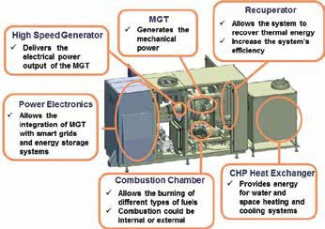Figure 18: AE-T100

*© AnsaldoEnergia*

# Proposed type of projects

## Collaboration schemes

Various types of collaboration schemes are envisioned for the topics identified for cooperative work between ETN partners, subject to the topic/issue to be covered (level of knowledge, maturity level, TRL level):

 the partners (potentially) involved (academia/industry, competences/skills),

 the goals to be achieved (increased knowledge level, general dissemination of information, development of tools, demonstration/proof of concept) and

 the funding arrangement (in-kind, industry funding, national funding, EU funding).

In this respect the Project Board will give a recommendation on which type of project deems most appropriate and will offer to provide support during the start-up phase of the collaboration.

###### Thermal Barrier Coatings

This project focuses on performing an in-depth literature survey into thermal barrier coatings and provides, based upon operator’s feedback, an overview of TBC related topics of interest to them. Further details may be found on the ETN website.

###### Micro Gas Turbines

The objective of the MGT project is to pave the way for future cooperation among stakeholders in research and developments. Further details may be found on the ETN website.

## R&D Projects

This kind of collaboration will likely be the most common type of project and can span a wide range in terms of number of partners involved, budget volume and source of funding. This type of cooperation would be best suited for system and pro- cess development, the design of hardware components and the (experimental) testing of new technologies, as well as for the development of (software, modeling) tools & procedures. Funding schemes and number of participating members can cover the full range from small group (2-3 parties)/internally funded (in-kind work, direct industry funding) arrangements up to large size (10 and more partners)/EU funded consortia.



###### H2-IGCC

Co-funded project under the EU’s 7th Framework Programme, the objective was to provide and demonstrate technical solutions which will allow the use of state-of-the-art highly efficient, reliable gas turbines (GTs) in the next generation of Integrated Gasification Combined Cycle (IGCC) plants. [www.h2-igcc.eu](http://www.h2-igcc.eu/)

###### OMSoP



Co-funded by the EU’s 7th Framework Programme for Research and Development aims to provide and demonstrate technical solutions for the use of state-of-the-art concentrated solar power systems (CSP) coupled to micro turbines to produce electricity.

[www.omsop.eu](http://www.omsop.eu/)

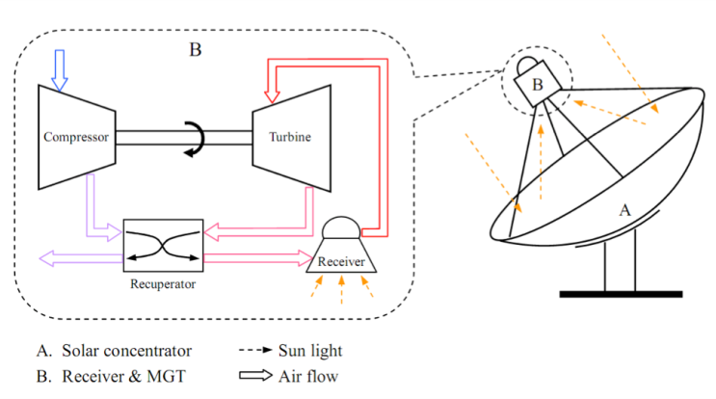

## Pre-study / Feasibility Study

If a certain topic bears high risk and/or knowledge is very limited, it might be warranted to deal with it at first in a well- defined, short duration (max. 12 months) type of work. Usually such studies will be performed by only a few partners (1-3), while parties interested in a follow-up project (in case of a promising outcome of the study work), would provide funding and serve as review body. Depending on the complexity of work required such studies might be linked with student thesis.

**Shale Gas Study**

## Best Practice Guidelines

Open issues about tasks which are performed repetitively and by a large number of parties for different business segments and applications, may warrant the documentation of best practice guidelines. These guidelines would help the knowl- edge transfer across different businesses and speed up the learning curve for new entrants into existing markets or for established companies venturing into new business models. This domain of cooperative work is best covered by suppliers and service providers which aim to broaden their customer basis and are willing to promote their business by showcasing their accumulated experience.

## Development of Standards

For quality assurance, certain business segments might want to define binding rules for how to perform certain tasks, for how to design certain components or for how to execute certain services. Definition of such standards goes beyond the documentation of best practices and must adhere to a formalised approach which requires the cooperation with a standardisation institution. This usually long-term, meticulous process is most likely initiated by customers (users of a certain service or a certain component of a plant), but suppliers will benefit from the well-defined procedures as guarantee issues and liability questions will reduce.

###### Air Filtration

The objective of this project is to allow the GT users to have a single point of reference for state-of-the-art filtration technology and to address air filtration issues through projects of common interest. Further details may be found on the ETN website.

###### Exhaust Systems

The aim of this project is to create an ISO standard on exhaust system designs for gas turbines. Further details may be found on the ETN website.

## Position papers

Topics which are being discussed more widely in the public and/or in political institutions and for which their future perception will have a major influence on the business model of ETN members, the formulation of position papers is advised. Such documents are suited to describe the status/ state-of-art, to express the opinion of a group of parties, and to recommend future actions. Position papers must be balanced, but still address issues to the point. In order to be used for lobbying purposes, position papers should express the standpoint of a majority of parties whose business is directly affected by the public perception of the subject matter covered by the document.

**Gas Turbine Fuel Flexibility for Zero Emission Power Plants**

**The Impact of Natural Gas Quality on Gas Turbine**

**Performance**

**Enabling the Increasing Share of Renewable Energy in the Grid**

**The Importance of Flexible and Efficient Power Generation in Horizon 2020**

## Technical Committees

The Technical Committees cover the most crucial areas of future gas turbine technology development. They serve as forums where the ETN members meet to share experiences and discuss ideas and initiatives, which can later be developed into individual projects.

###### TC1: Low Carbon Gas Turbine Operations

###### Chair: Mohsen Assadi, University of Stavanger, Norway

###### TC2: Operational and Fuel Flexibility

Chair: Jean-Louis Vignolo, GE Power, France

Co-Chair: Yannis Hardalupas, Imperial College London, United Kingdom

###### TC3: Material Degradation, Repair Technologies and Manufacturing

Chair: Ron van Gestel, Chromalloy, The Netherlands

Co-Chair: Daniel Mack, Forschungszentrum Jülich, Germany

Co-Chair: Nigel Simms, Cranfield University, United Kingdom

###### TC4: Condition Monitoring and Instrumentation

Chair: Chris Dagnall, DNV GL Energy, United Kingdom

Co-Chair: Herwart Hönen, RWTH Aachen University of Technology, Germany

###### TC5: Asset Management

Chair: Pascal Decoussemaeker, GE Power, Switzerland

Co-Chair: Giuseppina Di Lorenzo, Cranfield University, United Kingdom

**The European Turbine Network is a membership association bringing together the entire value chain of the gasturbine technology community in Europe and beyond. Through cooperative efforts and by initiating projects, ETN optimises gas turbine research and technology development and promotes environmentally friendly gas turbine technology with reliable and low cost operation.**

###### ETN a.i.s.b.l.

Chaussée de Charleroi 146-148/20

1060 Brussels

Belgium Tel: +32 (0)2 646 15 77

[info@etn-gasturbine.eu](mailto:info@etn-gasturbine.eu) [www.etn-gasturbine.eu](http://www.etn-gasturbine.eu/)