**Sensors & instrumentation**

**S. Sigali**

Comments from the PB meeting

M. Ruggiero:

• Add optic fiber, and embedded sensors

With the increasing share of non-predictable energy sources in the grid, gas turbines are required to operate in a very flexible mode. In order to maintain safe and reliable operation, a large number of machine parameters have to be continuously monitored.

Furthermore, the availability of a larger number of measures will enhance the benefits achievable with the adoption of data analytics techniques (“Big Data”), which will include the development of more accurate failure prediction models as well as the optimization of the operation either for a generating unit or for a whole fleet.

Better sensing techniques could facilitate large fuel savings, with consequent CO2 emissions reduction and economic benefits.

Sensors and instrumentation for the following purposes should be further developed:

**Instrumentation for operation optimisation**

The main control parameter of gas turbine operation, turbine inlet temperature (TIT), is currently indirectly evaluated from exhaust gas temperature measurement and other parameters. Direct TIT measurement would allow for a better control of the machine; enabling operation closer to its design values with benefits on efficiency. Measurement of the uniformity of turbine inlet conditions could also prompt combustion system design improvements, with consequent reduction of NOx and CO emissions and increased hot gas path components life, enabling longer maintenance intervals.

**Instrumentation for maintenance optimisation and failure prediction models**

Power plants cycling results in additional accumulation of fatigue and creep damage in thick components, such as GT and steam turbine (ST) rotor and HRSG headers. The ability to accurately measure component strain with semiconductor strain gauges enables the online monitoring of high temperature component integrity, including welds. On-line monitoring of elastoplastic strains and dynamic rotor dissymmetry of GT and ST rotors during operation would provide information for the implementation of failure prediction models and would give the possibility to plan corrective actions and reduce the cost and time for repairs. Real time monitoring of rotating component temperature with infrared systems and telemetry would also provide information for the implementation of failure prediction models, enabling the adoption of a condition based maintenance approach, as described in “Reliability, Availability and Maintenance” chapter.

**Instrumentation for flexible operation (fast ramps/high gradients)**

Gas turbines are required to rapidly change their operating conditions in order to maintain grid stability, especially when non-dispatchable plants cover a large proportion of the total generation.

Turbine blade tip clearance has a relevant impact on efficiency. With the fast load changes differential thermal expansion of rotor and casing could be a limiting factor for maintaining low clearance values. A reliable measurement of tip clearance with micro-wave, optical fibre or capacitance sensors is crucial for keeping high efficiencies while preventing rubs between gas turbine blades and engine casings and avoiding the risk of failures.

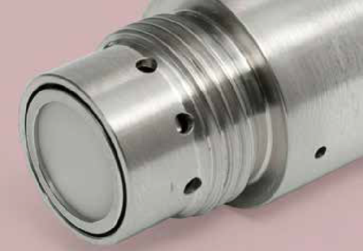

**Instrumentation for machine protection**

With the continuous reduction of NOx emissions, combustion stability remains a critical issue for GTs. Ultra high temperature dynamic pressure sensors, based on piezoelectric or optical probes, allow for a more precise measurement, and potential control of pressure fluctuations inside the combustion chamber.

Optical sensors for early detection of heat release fluctuations related to combustion instabilities would also enable protection of the machine against the damages caused by very high intensity instabilities. Real time monitoring of dynamic response of both compressor and turbine blades during GT operation with blade tip vibration monitoring systems could prevent blade cyclic damage due to flutter or blade stalling.

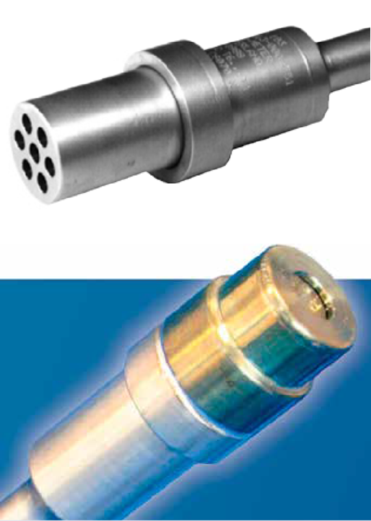

**Instrumentation to prevent shutdown or to reduce inspection time**

Borescope inspections are frequently used to assess the status of the machine when a risk appears on a gas turbine. A borescope inspection demands a prolonged stop with an unavailability penalty. An automated borescope inspection, using robotised technologies and a high temperature borescope would enable inspection during short stops.

**Instrumentation for GT development**

High temperature thin film strain gauges could be used for the study of crack development and propagation, residual stress, stress and strain distribution, thermal expansion coefficient of materials at very high temperatures as well as for blade vibration measurements. These sensors would be extremely useful in the design and development of advanced gas tur- bine engines.

Video cameras for real time flame visualisation in various wave- length intervals would allow monitoring of the dynamic behaviour of the flame, supporting the development of stable combustors, with higher fuel flexibility and larger operability ranges.

Entropy probes can be used to measure the time-dependent relative entropy field, which is related to the aerothermal losses. Entropy can be inferred from pressure and temperature measurements. The development of small-dimension fast-response entropy probes will help the design of turbomachinery with higher efficiencies and wider operating ranges.

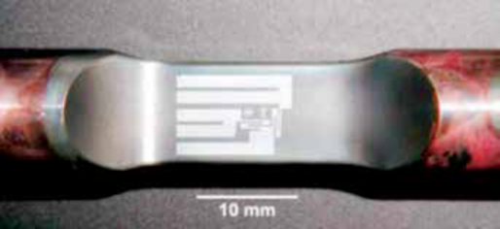

**Wireless sensor networks**

The advent of low-power processors, intelligent wireless net- works, and low-power sensors coupled with “Big Data” analytics has led to what has become a booming interest in the Industrial Internet of Things (IIoT). In this context, the application of Wireless Sensor Network (WSN) technology in process monitoring and control of gas turbines has demonstrated great potential.

WSNs bring several advantages over traditional wired industrial monitoring and control systems:

* eliminates wiring and conduit, reducing installation cost;
* requires low maintenance efforts (only the battery change is necessary after years of operation);
* gives high flexibility to relocate devices or to deploy additional ones.

The installation of wireless sensors on critical equipment which is not convenient to monitor with traditional sensors will favour the adoption of predictive maintenance, thereby helping to avoid unplanned downtime and critical, unexpected fault events.