**Advanced cycles**

**M. Ruggiero, P. Kutne**

Comments from the PB meeting

*General note*: It was suggested to use subtitles instead of numbers for consistency with the other chapters

M. Ruggiero:

* Update sCO2, hybridization

A. Sayma:

* Add Organic Rankine Cycles

Changing boundary conditions in energy politics result in the need for new concepts and “advanced” cycles. Innovative cycles using a gas turbine as the main component seem to be one of the possible options to provide the needed back-up and balancing power. In focus are new plants as well as upgrading and conversion of existing plants with a long remaining lifetime. In this context methods and tools that provide the user with “reliable simulation results” for evaluation of various alternatives (both technically and economically) will become valuable in the near future. Additionally, it is necessary to evaluate activities in an interdisciplinary manner, for example, alterations to blading and flow paths will have an impact on the combustion process and materials.

In this context the required research activities can be divided into two main categories:

###### Development of the necessary tools for evaluation and design of advanced and new cycles

###### The evaluation of innovative, advanced cycle concepts

**Development of necessary technologies**

Advanced cycles, both new and / or retrofitted might require interconnection to other systems, components or processes such as for example high temperature fuel cells or solar air heaters. Most GTs currently on the market are not designed for this type of process integration. Integration also often requires to a change in mass flow rates of compressor or turbine as well as changing composition of the working fluid.

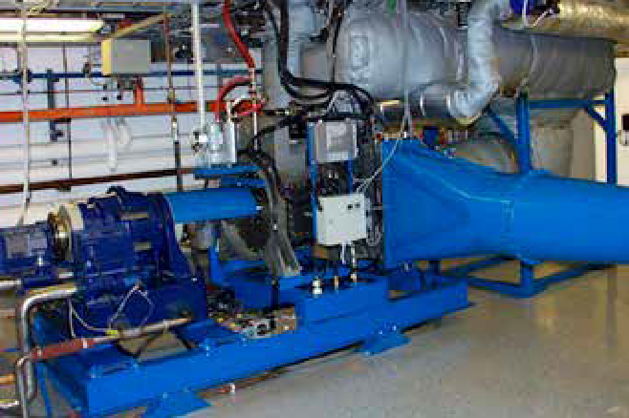

Examples of significantly changed mass flow ratio of compressor and turbine are humid air turbines (Figure 5), the Topspool concept or biogas fired engines. R&D activities should therefore target developing concepts for easy to integrate and flexible gas turbines, most likely for industrial size units.

Currently simulation tools are more or less specialized for certain applications, such as power cycles, using detailed and well validated models or chemical plants and processes having a variety of fluid properties and chemical reactions embedded but often missing detailed models for turbo-machinery components. In many cases, advanced cycles have fluid compositions as well as pressures and temperatures which might exceed the “current” range of gas turbines. Moreover the processes are closely integrated with various volumes and characteristics of their components. For the evaluation and design of new concepts, it is necessary to have efficient, robust and reliable tool sets for analysis.

R&D activities might target to close the gaps of:

* A tool or system of tools that allow the analysis of advanced integrated cycles without the need to manually iterate be- tween power plant simulation and process modelling tools. This will avoid errors and should also result in a faster analysis and evaluation process.
* Tools well-suited for transient analysis of the process, as gas turbines are increasingly used to balance energy demand and the growing share of fluctuating renewables in the grid. Furthermore is it necessary to combine components of very different response characteristics in energy systems. Higher complexity and higher flexibility needs during start-ups and transients support this requirement.
* Tools for life cycle analysis in terms of costs as well as in terms of the environmental impact (CO2 and other emissions and impacts accumulated over the entire lifetime) as a base for standard evaluation of concepts.

## Advanced cycle concept evaluation

The Evaluation and R&D activities related to advanced cycles are usually closely connected to specifically chosen type of cycle and thus can’t be used to generate new ideas for general R&D activities and possible projects. The need to carry out evaluations in an interdisciplinary fashion was already mentioned above.

Possible advanced cycles might be:

1. 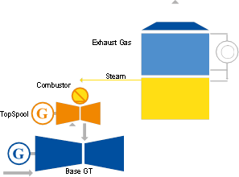Wet cycles: processes with extraordinary high water content in the work fluid. Water might be either added before the combustor (e.g. humid air turbine or TopCycle (Figure 3), in the combustor itself (e.g. Cheng Cycle) or after it (e.g. for power augmentation). There are some general aspects to these cycles which might be topics of R&D activities.

Aspects besides those mentioned under 1. could be:

* The combustion process and design conditions very close to stoichiometric in the combustor, and the operation and stability under changing operational conditions.
* The challenges when connecting the GT to larger volumes such as humidification towers and the resulting change in transient behaviour as well as during start-up and shut down need to be addressed in close connection to the development of basic technologies as mentioned above.
* Topics such as changes in the condenser design, mismatch of mass flow in turbine and compressor were also already mentioned. In addition there is a need for the development of a humid air condenser and the extraction of the condensed water to be highlighted. It might be also necessary to consider additional or adjusted water treatment and its integration into the process.

1. Using Exhaust Gas Recirculation (EGR) as a method and tool for enhanced CO2 capture and sequestration by increasing the content of CO2 in the exhaust gas of the GT is also a cycle under evaluation. EGR is already used by Mitsubishi Heavy Industries for NOx control in J-series GTs with a Turbine Inlet Temperature (TIT) of 1700°C. This technology is thus close to commercial use.

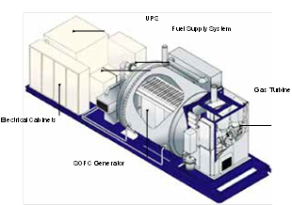

1. The use of other working fluids than air, such as supercritical CO2, is an issue which requires additional R&D efforts. In this context topics of interest might be:

* External combustion, allowing the use of various fuels and at the same time reducing the overall process complexity by avoiding extra efforts and components for fuel preparation/ treatment.
* High efficiency, high temperature heat exchangers with optimized heat transfer and, depending on the fluids used, possibility for easy cleaning to reduce the effect of degradation.

1. Hybrid cycles, combining different electricity production technologies (e.g. fuel-cell/gas turbine hybrids (Figures 7 & 8)) or renewable based power generation with fossil fuelled generation should also be developed better. The combination of solar heat input to a natural gas fired GT is a particular technology which shows great promise.

