**Extended Fuel Spectrum**

The need for gas turbines to be operated safely, with high efficiency and low emissions (longterm zero CO2 emissions), using a variety of gaseous & liquid fuels still remains to be an important issue for current and future gas turbine models.

Besides a wide variety of natural gas qualities, including gas compositions with higher content (> 1%vol.) of higher hydrocarbons (so-called C2+, like ethane C2H6, propane (C3H8) and butane (C4H10)) or with higher content (> 10%vol.) of inert species (N2, CO2), which cover a wide range of Wobbe Index values (35 - 55 MJ/Nm3), additional fuel gas mixtures (syngas - CO/H2, hydrogen - H2) and diluents (CO2, H2O) come into the scene as new gas turbine based processes and new fuel resources (biofuel, shale gas, LNG) are being proposed for power generation and industrial applications. Additionally, liquid fuels remain to be of interest for mobile applications (aero engines, marine engines), oil & gas industries, island/off-grid operation and as back-up fuels. Meanwhile, their spectrum is increased by biomass and power derived liquid products (FAME, DME, Fischer-Tropsch products, pyrolysis oil, etc.).

The issue of wide fuel spectrum capability of gas turbines is strongly coupled with operational flexibility topics such as flame stability and emissions, and can be exacerbated if fuel switch-over procedures are to be considered.

Typically achieving ultra-high efficiency requires very narrow fuel specifications, whereas with widely variable fuels, one needs to accept somewhat lower performance and possibly a redesign of key components in order to arrive at a fuel-flexible gas turbine set-up.

Specific issues, which need to be addressed in this respect, are:

**Natural gas/H2 mixtures (up to 100% hydrogen)**With large capacities of wind & solar PV installed, storage of intermittently produced surplus electricity has become an important challenge. Storage via H2 production from water electrolysis and later re-electrification is one option being considered. This would require consumers to cope with an increasing H2 content in natural gas (e.g. up to 20% vol. till 2022 up to 100% vol. till 2030), especially in decentralized small gas grids or hydrogen grids. This requires increasing hydrogen combustion capabilities of modern gas turbines (pure, premix or diffusion combustion with inertia dilution). Issues to be addressed are safe combustion performance and control (flame stability, flashback, combustor cooling, thermo-acoustics) and NOx emission behaviour.

**Natural gas/biomass derived syngas mixtures**Biomass derived syngas (CO/H2 mixtures from biomass/ wood gasification) is considered CO2-neutral and thus has to play a role in future power generation scenarios. Co-firing of such syngas in large gas fired combined cycle plants offers high electricity conversion efficiency. With co-firing shares of up to 20% (by energy), the combustion performance is being influenced. Issues to be addressed are safe combustion performance (flame stability, flashback, combustor cooling, thermo-acoustics), emission behaviour (NOx, CO) and material degradation due to fuel contaminants (particulates, corrosive species like sulphur, chlorine, sodium).

**H2-rich fuel gases (e.g. syngas or coke oven gas)**High hydrogen concentration (> 50%vol.) in fuel gas mixtures requires significant changes to the fuel-air mixing/burner/combustor design of gas turbine combustion systems. Beyond the findings of the EU funded project “H2-IGCC” it is still important to find solutions and demonstrate the applicability (at full scale/full pressure) of potential low emission, reliable (safe ignition, stable flames) combustion technologies. Issues to be addressed are safe combustion performance (flame stability, flashback, combustor cooling, thermos-acoustics) and NOx emission behaviour for process conditions relevant to gas turbines integrated with pre-combustion carbon capture schemes and/or solid fuel gasification (coal, biomass, process residues).

**LNG/LPG**LNG (liquefied natural gas, LNG boil-off gas) and LPG (liquefied petroleum gas) have very peculiar composition when they are re-gasified and used as fuel gases for gas turbine operation. LNG consists of (mainly) CH4 and thus reduces any impacts due to inert species (N2, CO2), but the low levels of higher hydrocarbons (e.g. C2H6/ C2H4) can cause operability issues due to the reduced reactivity of the fuel. LPG consists of propane (C3H8) and butane (C4H10) in various ratios and exhibits strongly different physical and chemical properties (i.e. combustion characteristics). Flame stability, flame speed and ignition delay times can be sufficiently different, such that a re-design of key combustor components could be required. Re-gasified LPG may be an attractive alternative to liquid fuels in locations where a natural gas supply is not available.

**Unconventional natural gas**Unconventional natural gas (e.g. shale gas, coalbed methane) can show an even wider variation in composition than (conventional) natural gas qualities and expands the range towards even lower Wobbe Index values (below 35 MJ/Nm3) due to higher content of inert species (N2, CO2) which can also vary temporarily depending on the exploration conditions.

**(Biomass / Power) Liquid fuels**Liquid products generated from syngas (of biomass gasification systems or power to gas processes), e.g. fatty acid methy**l** esters (FAME), alcohols, dimethyl ether (DME), Fischer-Tropsch products, …) or directly formed in pyrolysis processes of various types of biomass (i.e. pyrolysis oils of different origin) pose a significant challenge to the operation of gas turbine systems. Not only physical properties (viscosity, lubricity) bear certain difficulties, but also chemical properties (S/N/Cl content; acidity/corrosivity; combustion chemistry/ flame speed) vary significantly and are not yet fully characterized (operational limits such as lean blow out and flashback; NOx/CO/SOx emissions).

**Non-carbon fuel (e.g. Ammonia)**Ammonia has different combustion characteristics compared with conventional hydrocarbon and hydrogen fuels. Ammonia is attractive for energy storage because it is carbon free and can be liquefied and stored at moderate temperatures and pressures. To convert the ammonia back into electrical power gas turbines can be used. There are basically two ways to use ammonia as gas turbine fuel: direct usage as fuel or to preprocess ammonia by reconverting it to nitrogen/ hydrogen mixtures e.g. via thermal cracking. The main drawbacks of using ammonia for combustion is the production of NOx due to the ‘fuel-bound’ nitrogen contained within NH3: this issue is very severe if pure ammonia is burnt but is still present for the NH3 crack gases because of the residual ammonia left over from the crack process. Special low NOx combustion processes needs to be explored to minimize fuel bound nitrogen conversion. For direct usage as fuel, ammonia has demonstrated to have a very slow reaction hence flame speeds, thus one option is to dope the fuel with a more reactive molecule such as hydrogen, which conveniently can be obtained from cracking ammonia or with natural gas. Also ammonia or ammonia crack gases can be mixed with natural gas which reduces the NOx formation.

**Special fuels incl. fuel pretreatment**There are economic reasons to use also “poor quality” fuels for power generation. Despite the fact that fuel pretreatment is necessary to avoid problems in gas turbines, they are sufficient and cheap to provide.

**W**ith regard to natural gas, about 40% of the worldwide remaining reserves contain so called “sour gas” components like H2S and CO2 at a concentration, that these gas qualities cannot be utilized without further purification for turbine applications. This is also the case for associated gas which is by-product of oil production. Currently sour associated gas is often flared, what will be not legal in the future.

If sour gas should be utilized in gas turbines, focus has to be laid on the treatment of toxic and/or corrosive elements, e.g. Sulphur. In addition to the aggressive properties of Sulphur, burning of H2S can produce SOx emissions at unacceptable levels.

It is desirable to have smaller, local and decentral pretreatment processes to remove H2S from the natural gas, so it can be used for the local energy demand. Such a pretreatment process have to be much less complicated compared to the typical large scale gas processing, since it is usually not necessary to achieve the strict pipeline grade in order to utilize a raw gas in a gas turbine.

With regard to liquid fuels e.g. crude oils are used in gas turbines as a cheap and reliable available fuel. Due to the content of alkali/heavy metal salts and sulphur the use of e.g. crude oils in gas turbine is also difficult. These components cause severe hot path corrosion and remarkable maintenance costs and/or efficiency losses.

The emission of these components and their combustion products harms the environment.

A fuel pretreatment that removes these undesired components would cause a significant reduction of the maintenance costs and would also improve the power plant efficiency and thus the harmful emissions (and thereby the CO2 footprint).

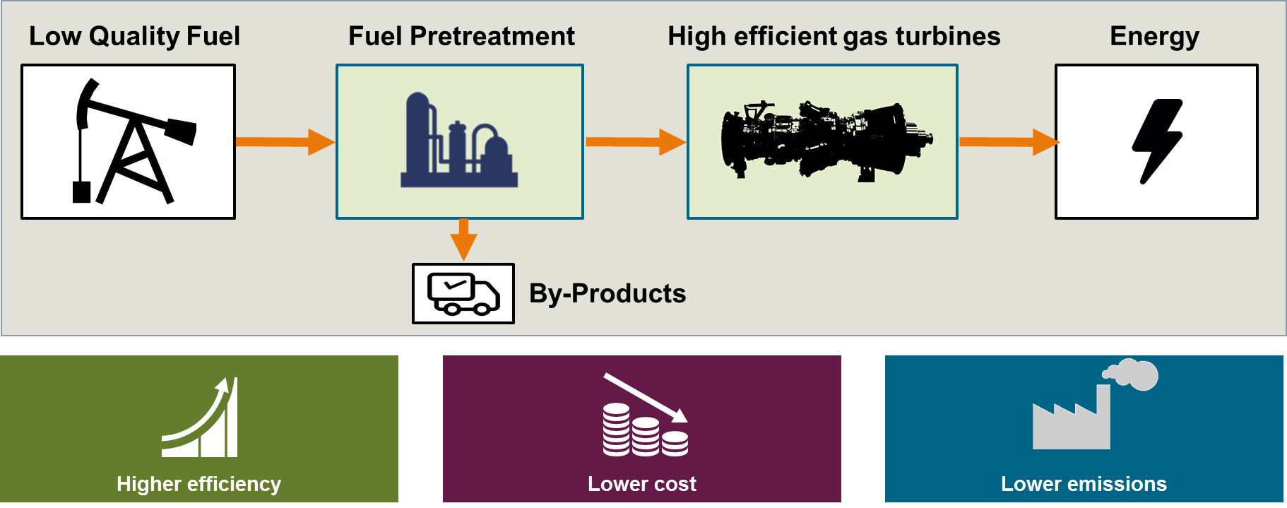

Figure X: Fuel pre-treatment for economic and environmental friendly energy production