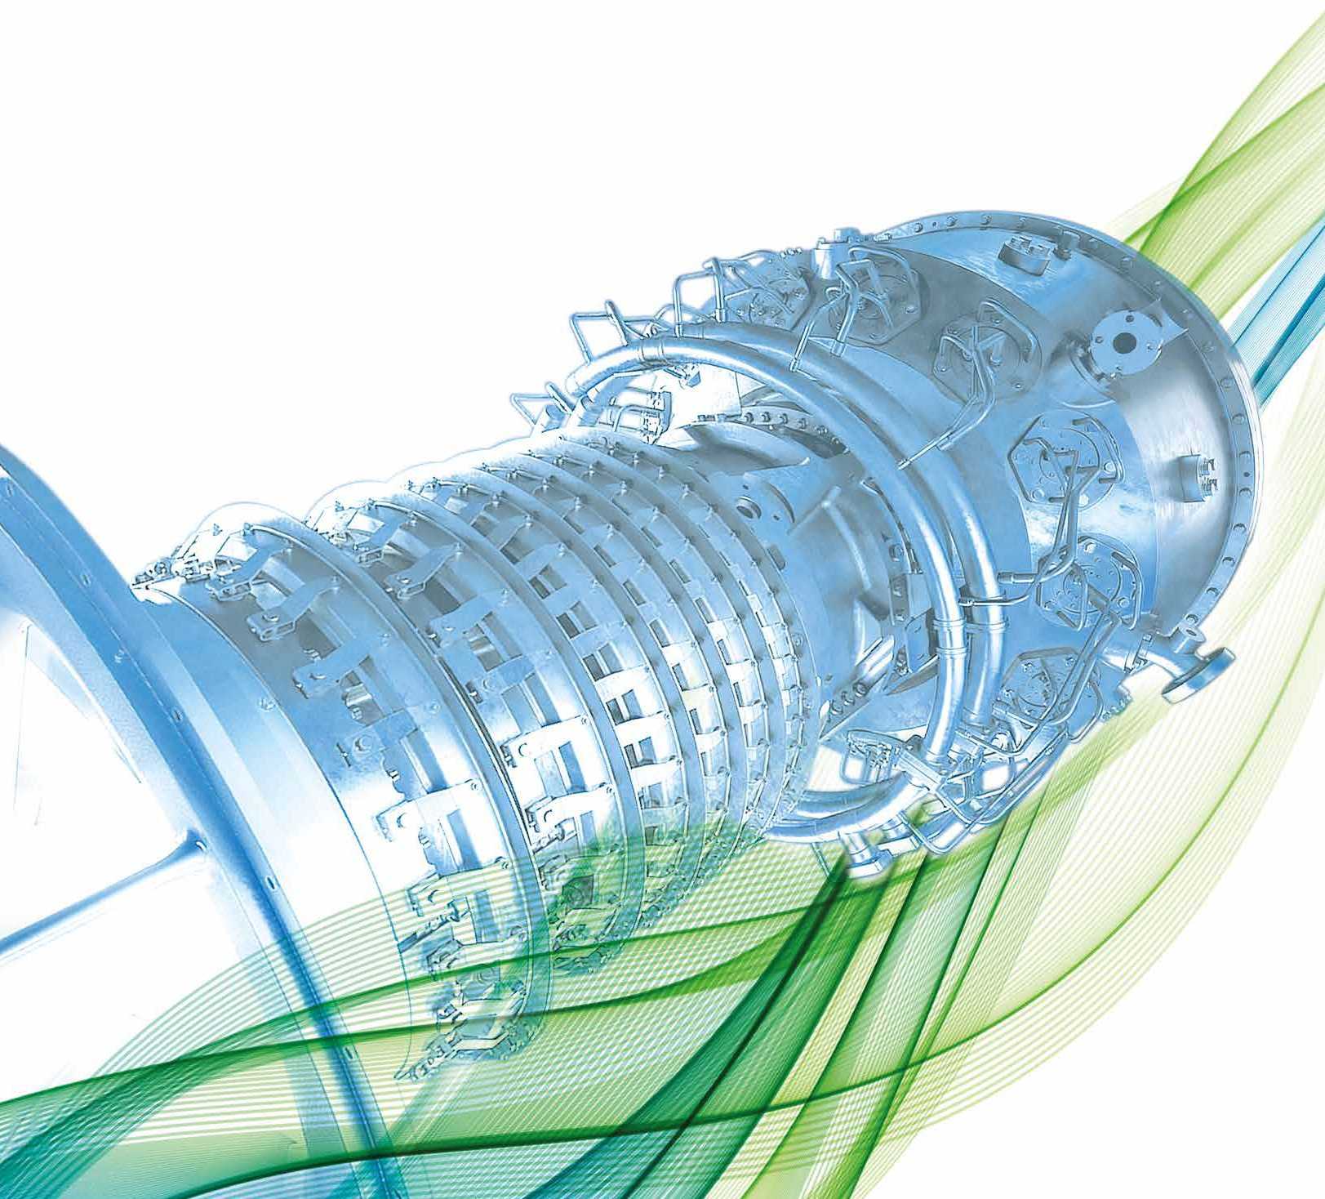

**Sponsorship & exhibition package**

[**www.etn.global/events/igtc-25/**](http://www.etn.global/events/igtc-25/)

12th IGTC “Advancing turbomachinery innovations and strategies

for net-zero pathways”

14-15 October 2025, Brussels, Belgium

# IGTC 2025 Sponsorship & Exhibition Package

## About the event

The International Gas Turbine Conference (IGTC) is ETN Global’s flagship biennial event, bringing together the turbomachinery and energy community.

## The objective

IGTC offers a powerful platform to position your company at the forefront of the energy transition. It brings together global energy stakeholders to showcase the latest innovations, highlight user priorities, explore global market opportunities and build new partnerships.

The conference also provides a forum to engage with policymakers on the frameworks and conditions needed to enable the required investments. From net-zero strategies to cutting-edge R&D, IGTC highlights suitable applications and global opportunities for carbon-neutral fuels, CCUS, hybrid systems, and sustainable heat solutions.

For manufacturers, suppliers and service providers it is an unmatched opportunity to connect with the global user community and policymakers, gain visibility and demonstrate leadership in delivering tomorrow’s energy solutions.

## **Parallel technical sessions**

Designed around the needs of the gas turbine user community, these sessions address key R&D priorities essential for advancing turbomachinery. Showcasing the latest technology developments and innovations, they offer a balanced view of operational, environmental, and cost-related challenges.

## **Keynote and panel sessions**

Focused on net-zero strategies and technical pathways, these high-level discussions will address capacity gaps, flexibility needs, low-carbon solutions, energy efficiency opportunities, and product sustainability. Distinguished experts and high-level policymakers will explore how energy policy frameworks can better align with market needs.

## Attendees

The turbomachinery and energy community: utilities, industrial operators, energy companies (including oil & gas, pipeline operators and LNG companies), gas turbine manufacturers, suppliers and service providers, consultancies, research centres, universities, international analysis & forecasting organisations and policymakers.

## Why sponsor?

* Connect with global gas turbine users and decision makers
* Gain high visibility before, during and after the event
* Engage exclusively with industry leaders and policymakers
* Position your brand as a leader in the energy transition

12th IGTC “Advancing turbomachinery innovations and strategies

for net-zero pathways”

14-15 October 2025, Brussels, Belgium

2023 IGTC in numbers

|  |
| --- |
| **165 participants** |
|  |
| 18 Keynote speakers & 20 Technical paper presentations |
|  |
| 9 sponsors & 6 media partners |
|  |

12th IGTC “Advancing turbomachinery innovations and strategies

for net-zero pathways”

14-15 October 2025, Brussels, Belgium

Our offer

This conference provides a unique opportunity to showcase your company’s commitment and contribution to a secure and timely development of a carbon-neutral society.

As a sponsor you will benefit from:

* High visibility before, during and after the event through ETN Global communication channels
* Direct access to high-level decision makers, user communities, OEMs, technical suppliers, and turbomachinery experts from around the world
* Extensive networking opportunities and the chance to explore future partnerships & collaborations

Conference venue

Tangla Hotel provides exclusive access to sponsors, with the entire event area dedicated solely to attendees of ETN Global’s 12th IGTC.

* **Royal Rooms II-III** and the **Imperial Ballroom** will host keynote panels and technical presentations.
* **A floor plan of a hotel

  AI-generated content may be incorrect.The Foyer** is reserved for sponsors’ booths, offering prime visibility and direct engagement opportunities.

Review the available opportunities on the following page and secure your space by completing the sponsorship form.

# Sponsorship and exhibition opportunities

|  |  |  |  |  |  |
| --- | --- | --- | --- | --- | --- |
| **BENEFITS** | **Gold** | **Silver** | **Bronze** | **Exhibitor** | **Supporter** (coffee break) |
| Logo on event programme and conference webpage | YES | YES | YES | YES | YES |
| Logo on conference welcome slide (also projected during conference breaks) | YES | YES | YES | YES | YES |
| Sponsors name included in digital communication – Monthly News Summary & Quarterly Newsletter (reaching 2000 contacts) | YES | YES | YES | YES | YES |
| Acknowledgement on social media posts | YES | YES | YES | NO | NO |
| Opportunity to include a ½ A4 page announcement in the digital and printed conference package 1 | YES | YES | NO | NO | NO |
| Lunch sponsor with short welcome speech (max 2-3 mins) | NO | YES | NO | NO | NO |
| Choice of:   * Gala dinner sponsor (14 Oct) - Branding visibility, VIP seating and spoken recognition during dinner * Networking reception sponsor: Branding visibility, a brief welcome message (1 min) and an opportunity to introduce your team | YES | NO | NO | NO | NO |
| Exclusive invitation to the High-Level User Meeting dinner on 13 Oct -a unique opportunity to engage directly with senior users and decision makers. | YES  2 passes | YES  1 pass | NO | NO | NO |
| Verbal acknowledgment as coffee break sponsor before one networking break | NO | NO | NO | NO | YES |
| Complimentary delegate pass | YES  3 passes | YES  2 passes | YES  1 pass | YES  1 pass | YES  1 pass |
| Ability to display poster/banner 2 | YES, at dinner or reception. Your logo will also be displayed in the main room 4 | YES  Max 2 pieces (~2x1m),  or 1 piece (~2x2m) **3** | YES  Max 2 pieces (~2x1m),  or 1 piece (~2x2m)**3** | YES  Max 2 pieces (~2x1m),  or 1 piece (~2x2m)**3** | NO |

2 The location of the banners will be decided by the ETN Global office based on the number of pieces/types of sponsorship

3 Display area with table (~2x0.8m) for brochures and space behind a table (~2x2m) for banners in the exhibition area

1 GOLD & SILVER sponsors will have the opportunity to include an ½ A4 page announcement in the digital and printed conference package, as shown in the example from IGTC 2023:

4 GOLD sponsors will have their logos displayed on the LED screen in the main conference room – the Imperial Room – throughout the two-day event, during presentations, providing with premium visibility throughout the two-day event, as shown in the example below:

Sponsorship form

|  |  |  |  |  |
| --- | --- | --- | --- | --- |
| **Types of Sponsorship** | **Sponsorship amount** | **Available** | **Space taken by** | **Tick a box** |
| **Gold** | € 8,000 | 4 |  |  |
| **Silver** | € 6,000 | 1 |  |  |
| **Bronze** | € 4,800 | 2 |  |  |
| **Exhibitor** | € 3,800 | 5 |  |  |
| **Supporter - coffee break sponsor** | € 2,000 | 2 |  |  |

|  |  |
| --- | --- |
| **Name:** | **Position:** |
| **Organisation:** | **Address:** |
| **Postcode:** | **City:** |
| **Country:** | **Tel:** |
| **Email:** | **VAT number:** |
| **PO number (please provide, if required):** | |
| **Please issue an invoice to the above address.**  **Signature: Date:** | |

**Please return this form by email to the ETN Global office:** [**vc@etn.global**](mailto:vc@etn.global)

**Sponsors confirmed before 15 July will receive additional online visibility through pre-event promotion.**

**SPONSORSHIP TERMS AND CONDITIONS:** The sponsorship fees are due 3 weeks after signing this agreement. ETN Global shall not in any circumstances be liable for any loss damage or injury which may occur to you or a third party, or for any damage of your property. If the event is cancelled or delayed through no fault of the venues managers including but not limited to fire, flood, labour disputes, natural disasters, global health emergencies, civil disorders, riots, insurrections, work stoppages, slowdowns or disputes, or other similar events, you will not be entitled to any refund or to claim for any loss or damage.