5th European Micro Gas Turbine Energy Forum
15-16 October 2025, Brussels, Belgium

EMGTF 2025 Sponsorship & Exhibition Package

About the event
The European Micro Gas Turbine Forum (EMGTF) is a leading biennial event that unites experts from the turbomachinery and energy sectors specialising in micro-gas turbines.

The objective
The EMGTF is an initiative established to accelerate the commercial deployment of micro gas turbines by providing a dedicated platform where key stakeholders can come together to share knowledge, exchange experiences, and define a clear roadmap for advancing the technology. The objective of the forum is to bring the main actors in the micro-gas turbine value chain—industry leaders, researchers, policymakers, and end-users—around the same table to foster meaningful collaboration and develop solutions to the pressing challenges affecting the sector. Through open dialogue and joint action, EMGTF aims to create momentum for innovation, market growth, and long-term sustainability in the micro-gas turbine business.

Programme Overview
The European Micro Gas Turbine Forum will kick off in the afternoon with two parallel sessions. One will be a closed, invitation-only roundtable gathering selected stakeholders for in-depth discussions on strategic topics. The second session will welcome all other attendees, officially opening the Forum and setting the stage with a series of talks and interactive discussions that delve into the current state of the micro-gas turbine sector.
The second day will build upon the insights gathered during the opening sessions, featuring a dynamic programme of technical presentations, expert panels, and facilitated discussions. The focus will shift toward evaluating the status of the technology and market, identifying key challenges and opportunities, and shaping a shared vision for the future. The aim is to align on actionable pathways that will drive innovation, foster market growth, and position micro-gas turbines as a viable solution for a decarbonized energy system.

Why sponsor?
For manufacturers, suppliers and service providers, and media partners, the EMGTF presents a valuable opportunity to:
- Showcase expertise and innovation to a highly targeted audience of industry stakeholders, end-users, and decision-makers.
- Strengthen partnerships by engaging directly with potential clients, collaborators, and technology developers across the micro-gas turbine value chain.
- Gain early insights into market needs, policy directions, and emerging research, helping to align product development and services with real-world demand.
- Position your company as a key player in shaping the future of micro-gas turbine technology and contribute to a collaborative roadmap for commercial deployment.
- Generate leads and visibility within a growing community dedicated to overcoming barriers and unlocking the full potential of micro-gas turbines.
By participating in EMGTF, manufacturers, suppliers and service providers, and R&I projects, not only support the advancement of the technology but also secure a strategic role in its evolving ecosystem.

5th European Micro Gas Turbine Energy Forum
15-16 October 2025, Brussels, Belgium
Our offer
This conference provides a unique opportunity to showcase your organisation’s commitment and contribution to a secure and timely development of a carbon-neutral society.
As a sponsor you will benefit from:
- High visibility before, during and after the event through ETN Global communication channels
- Extensive networking opportunities and the chance to explore future partnerships & collaborations
- Opportunity to participate as a speaker during the 1.5-day programme, subject to alignment with the final agenda.
Conference venue
Tangla Hotel provides exclusive access to sponsors, with the entire event area dedicated solely to attendees of ETN Global’s 5th EMGTF during 16 October.
- Royal Rooms I-II-II will host keynote panels and technical presentations.
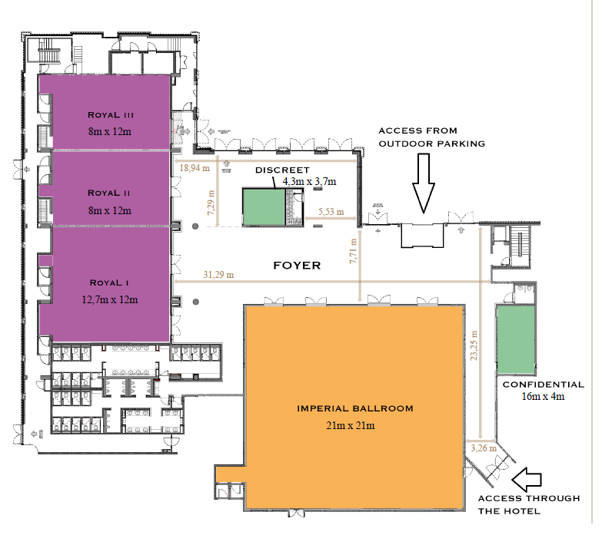
- The Foyer is reserved for sponsors’ booths, offering prime visibility and direct engagement opportunities.
Review the available opportunities on the following page and secure your space by completing the sponsorship form.

Sponsorship and exhibition opportunities
BENEFITS | Exhibitor | Project Outreach
Logo on event programme and conference webpage | YES | YES
Logo on conference welcome slide (also projected during conference breaks) | YES | YES
Sponsors name included in digital communication – Monthly News Summary & Quarterly Newsletter (reaching 2000 contacts) | YES | YES
Acknowledgement on social media posts | YES | YES
Sponsor with short welcome speech (max 2-3 mins) | YES | NO
Complimentary delegate pass | YES  2 passes | YES  1 pass
Ability to display poster/banner (16 October) ² | YES  Max 2 pieces (~2x1m),  or 1 piece (~2x2m)³ | YES  Max 1 piece(~2x1m) ⁴

² The location of the banners will be decided by the ETN Global office based on the number of pieces/types of sponsorship
³ Display area with table (~2x0.8m) for brochures and space behind a table (~2x2m) for banners in the exhibition area
⁴ Display area with a shared table and space behind for all projects in the exhibition area.

Types of Sponsorship | Sponsorship amount | Tick a box
Exhibitor | €1,400 with early bird discount (available until 31 July), €1,700 thereafter. | ☐
Project Outreach ⁵ | € 750 | ☐
⁵ A tailored sponsorship package designed to support the visibility, communication, and stakeholder engagement of EU-funded
and collaborative R&I projects.

Name: | Position:
Organisation: | Address:
Postcode: | City:
Country: | Tel:
Email: | VAT number:
PO number (please provide, if required):
Please issue an invoice to the above address.
Signature: Date:

Please return this form by email to the ETN Global office: aep@etn.global

Sponsors confirmed before 15 July will receive additional online visibility through pre-event promotion.

SPONSORSHIP TERMS AND CONDITIONS: The sponsorship fees are due 3 weeks after signing this agreement. ETN Global shall not in any circumstances be liable for any loss damage or injury which may occur to you or a third party, or for any damage of your property. If the event is cancelled or delayed through no fault of the venues managers including but not limited to fire, flood, labour disputes, natural disasters, global health emergencies, civil disorders, riots, insurrections, work stoppages, slowdowns or disputes, or other similar events, you will not be entitled to any refund or to claim for any loss or damage.

