The event
Join us at ETN Global’s (Energy & Turbomachinery Network) (biannual October Workshop titled “Driving sustainable pathways forward”. This prestigious 2,5-day event brings together the turbomachinery user community, industry leaders, policy makers and technical experts to discuss and shape the future of clean, secure, and affordable power generation.

Our event provides a great opportunity for all our members to meet in person, to discuss and assess the current market situation, the users’ needs, technology developments and listen to local policy developments, and explore future cooperation and partnerships. At ETN Global we want to ensure that our activities are addressing the most relevant topics for our community while progressing towards the net-zero goals.
Why sponsor
- Exceptional networking opportunities: with expected participation from 150+ ETN Global members from the whole value chain including high-level users (ETN’s High Level User Meeting take place the day before the workshop), OEMs, suppliers and R&D community.
- International visibility: your company will get exclusive opportunity to receive high visibility during the conference as well as through publicity before and after the event in ETN Global communications.
- Position your company in line with market trends: the event will provide you with the opportunity to verify and align your internal strategy based on the latest updates on markets and, research & development needs.
- Promote your company as a leader in the sustainable energy transition: Highlight how your company can contribute with expertise and solutions in line with your customer’s needs.

About us
ETN Global is a non-profit association that brings together the entire value chain of the gas turbine technology. Through common activities, and projects, we encourage and facilitate information exchange and collaboration to accelerate research, development, demonstration, and deployment of safe, secure, and affordable carbon-neutral energy solutions.

With 145 members from 22 countries across the globe we represent the interest of utilities, energy companies, industrial users, GT original equipment manufacturers (OEMs), suppliers & service providers, consultancies, research institutes and universities. You can find a full list of our members at the following link.

Venue map
Le Méridien Stuttgart hotel
Willy-Brandt-Straße 30
70173 Stuttgart, Germany

October Workshop in numbers
150+ participants
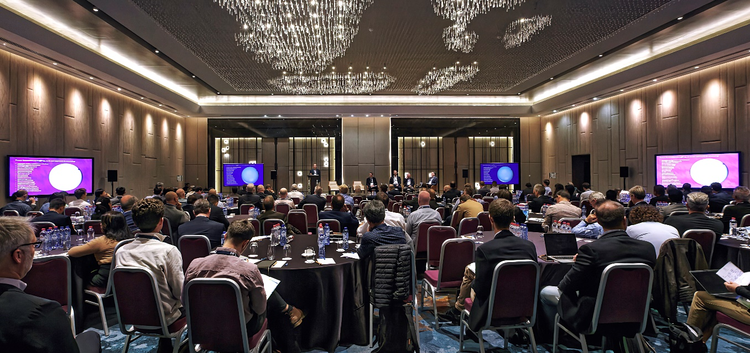
15+ Speakers
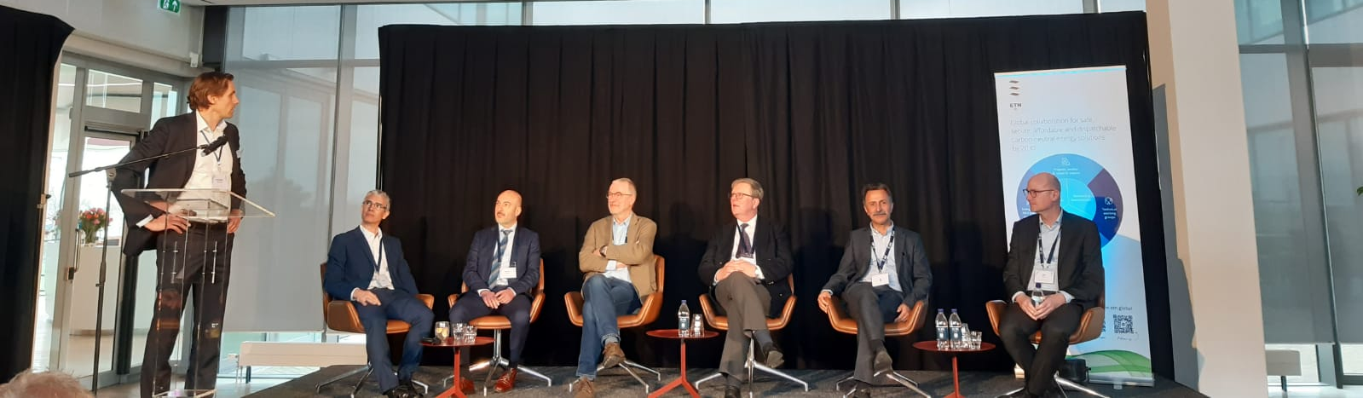
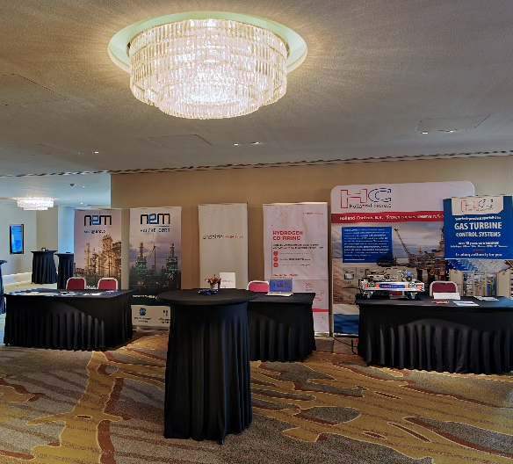
10+ exhibitors
2 days of conference
6 breaks for networking opportunities
1 gala dinner

Sponsorship & exhibition packages
Gala dinner: € 9000
Gold: € 5400
Silver: € 4200
Bronze: € 3200
Evening reception: € 3000

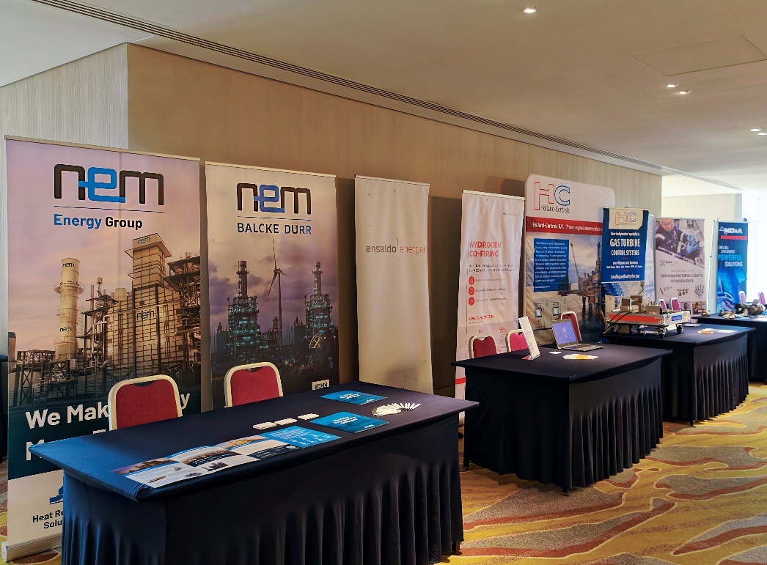
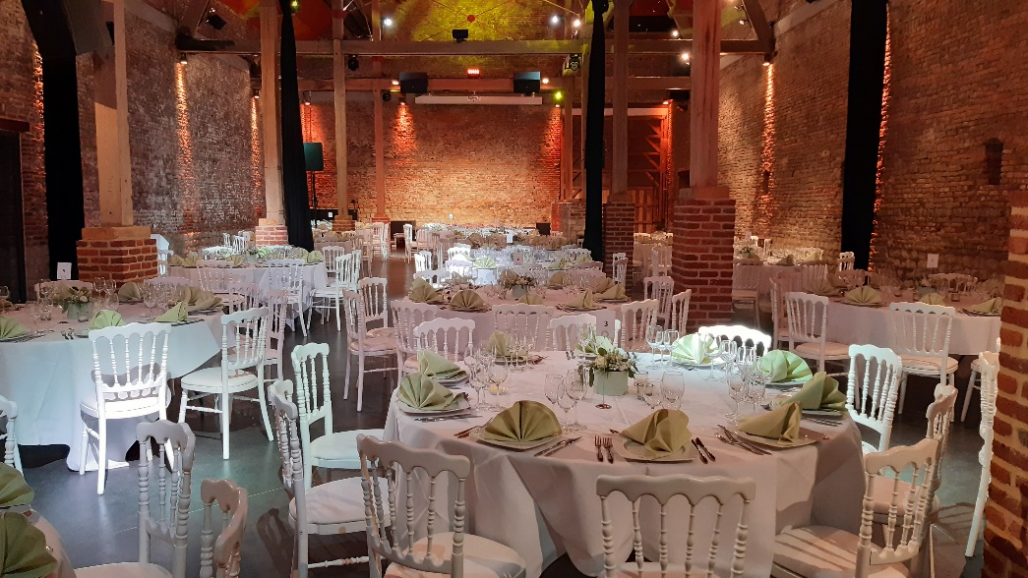

Sponsorship & exhibition packages
BENEFITS | Gala dinner | Gold | Silver | Bronze | Evening reception
On-site benefits
Short speaking slot | YES  (At the Dinner event  Max 5 min) | YES  (During lunch either day 1 or day 2:  max 2-3 min) | - | - | YES  (At canape hour  Max 5 min)
VIP seating | YES  (during dinner) | - | - | - | -
Complimentary delegate pass | 3 | 2 | 2 | 1 | 1
Ability to display poster/banner¹ | Max 3 pieces (~2x1m),  or 1 piece (~2x4m)  (At the Dinner ONLY) | Max 2 pieces (~2x1m),  or 1 piece (~2x2m) | Max 2 pieces (~2x1m),  or 1 piece (~2x2m) | Max 2 pieces (~2x1m),  or 1 piece (~2x2m)² | -
Exclusive invitation to High-Level User Meeting dinner (08 October 2024) | 3 | 2 | - | - | -
Logo on event programme | YES | YES | YES | YES | YES
Logo on the conference welcome slide (projection during the conference breaks) | YES | YES | YES | YES | -
Online benefits
Logo on conference webpage | YES | YES | YES | YES | YES
Logo in mailings | All | All | 3 mailings | 2 mailings | 1 mailing
Social media shout-out | 3 | 2 | 2 | 2 | 1

¹ The location of the banners will be decided by the ETN office based on the number of pieces/type of sponsorship
² Display area with table (~2x0.8m) for brochures and space behind a table (~2x2m) for banners in the exhibition area

Sponsorship form
Type of Sponsorship | Sponsorship amount | Available | Space taken by | Tick a box
Gala dinner: | € 9000 | 1 |  | ☐
Gold: | € 5400 | 1 |  | ☐
Silver: | € 4200 | 1 |  | ☐
Bronze: | € 3200 | 7 | 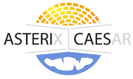  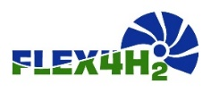 | ☐
Evening reception: | € 3000 | 1 |  | ☐

Name: | Position:
Organisation: | Address:
Postcode: | City:
Country: | Tel:
Email: | VAT number:
PO number (please provide, if required):
Please issue an invoice to the above address.
Signature: Date:

Please return this form by email to the ETN Global office: vc@etn.global

SPONSORSHIP TERMS AND CONDITIONS: The sponsorship fees are due 3 weeks after signing this agreement. ETN Global shall not in any circumstances be liable for any loss damage or injury which may occur to you or a third party, or for any damage of your property. If the event is cancelled or delayed through no fault of the venues managers including but not limited to fire, flood, labour disputes, natural disasters, global health emergencies, civil disorders, riots, insurrections, work stoppages, slowdowns or disputes, or other similar events, you will not be entitled to any refund or to claim for any loss or damage.

