Exhibition package

The event
Energy & Turbomachinery Network’s (ETN) Annual General Meeting (AGM) and Workshop is a 2,5-day event, that brings together representants from the whole gas turbine (GT) community.

This year we are thrilled to be celebrating our 20-year anniversary since the first AGM, which took place in 2005. We are being generously hosted by our member NEM Energy at their bright and modern facilities in the city of Leiden, in the Netherlands.

Our event does not only provide an opportunity to receive the annual activities’ update and planned activities for 2024, but also creates a perfect setting to hear about the latest gas turbine technology developments and trends; to find out the needs and requirements from users’ perspective; and to explore, discuss and exchange ideas with GT experts.
Our offer to exhibitors:
- Networking opportunities: with expected participation from 150+ ETN members from the whole value chain, including users (utilities, oil & gas companies, pipeline firms, and industrial users), OEMs, suppliers, and the R&D community, the event gives you a great chance to engage with high-level decision makers. Our thoughtfully designed agenda features extended coffee and lunch breaks, offering you ample time for informal discussions, relationship-building, and exploring potential partnerships and collaborations. Maximize your exposure and make lasting connections at every break, ensuring your brand stands out in the crowd.
- International visibility: your company will get exclusive opportunity to receive high visibility during the event, as well as publicity before and after the AGM & Workshop through various ETN communication channels (Monthly and Quarterly Newsletters, Emails and LinkedIn).
- Position your company in line with market trends: the event will provide you with the opportunity to verify and align your internal strategy based on the latest updates on policies, research & development needs.
- Promoting your company: the event will provide you with the opportunity to contribute with expertise and solutions in line with your customer’s needs.

About us
ETN Global is a non-profit association that brings together the entire value chain of the gas turbine technology. Through common activities, and projects, ETN encourages and facilitates information exchange and collaboration to accelerate research, development, demonstration, and deployment of safe, secure, and affordable carbon-neutral energy solutions by 2030, implemented globally by 2050.

With 135 members from 22 countries across the globe ETN represent the interest of utilities, gas companies, industrial users, GT original equipment manufacturers (OEMs), suppliers & service providers, consultancies, research institutes and universities. You can find a full list of our members at the following link.

Please review the available opportunity on the following page and secure your space by filling in the attached form.
Exhibition opportunity
Benefits | Exhibitors
Logo on the event programme | YES
Logo on the conference website with link to the company website | YES
Logo on the conference welcome slide | YES
Acknowledgement to sponsors on social media posts | YES
Complimentary delegate pass | YES (1 pass)
Ability to display poster/banner¹ | Max 2 pieces (~2x1m), or 1 piece (~2x2m)²
¹ The location of the banners will be decided by the ETN office based on the number of pieces/type of sponsorship
² Display area with table (~2x0.8m) for brochures and space behind a table (~2x2m) for banners in the exhibition area

Images from ETN’s 2023 International Gas Turbine Conference expo
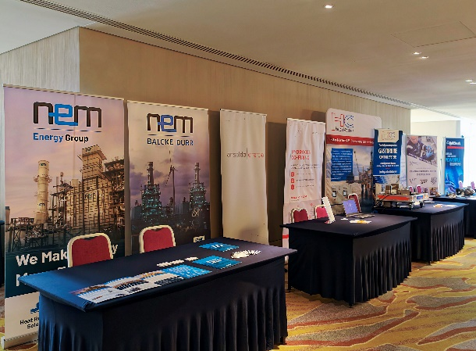 | 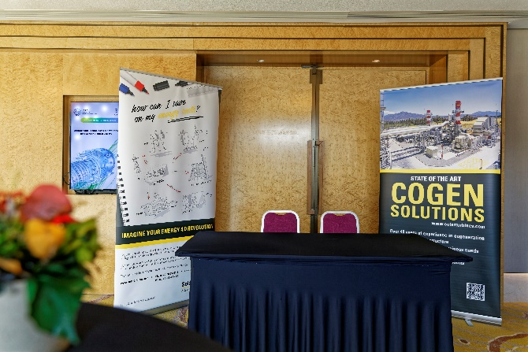
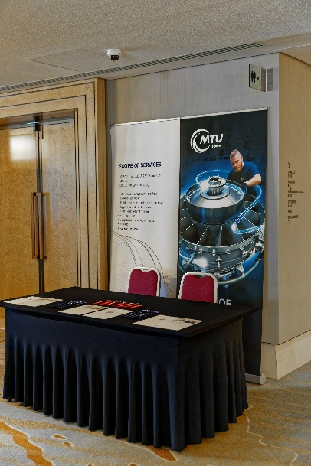 | 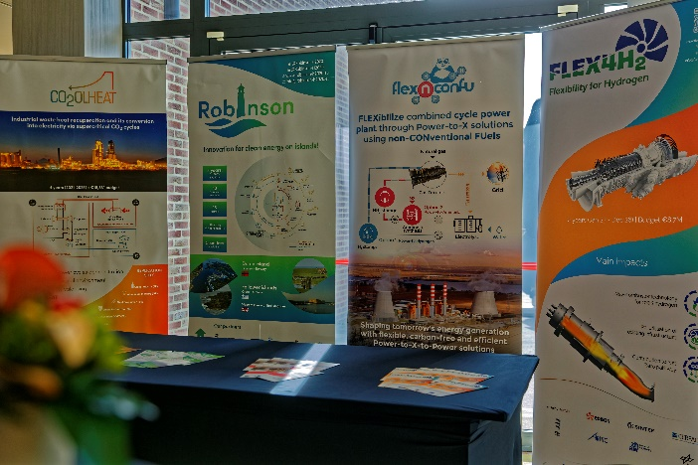

Sponsorship form
Type of Sponsorship | Sponsorship amount | Available | Space taken by | Tick a box
Expo | € 2,500 | 2 |     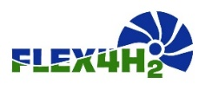  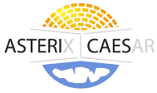  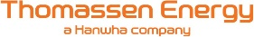         | ☐

Name: | Position:
Organisation: | Address:
Postcode: | City:
Country: | Tel:
Email: | VAT number:
PO number (please provide, if required):
Please issue an invoice to the above address.
Signature: Date:

Please return this form by email to the ETN office: vc@etn.global

SPONSORSHIP TERMS AND CONDITIONS: The sponsorship fees are due 2 weeks after signing this agreement. If the agreement is signed less than two weeks before the event payment is due immediately. In case of cancellation by sponsor or exhibiter, ETN will refund the following amounts: 100% up to 5 weeks before the event, 50% up to 3 weeks before the event. No refund will be made for cancellations 2 weeks or less before the event. In case of cancellation by the hotel due to government COVID regulation all sponsorship will be carried over to the revised event. However, if ETN decided to cancel the event all Sponsorship & Exhibition payments will be refunded. ETN shall not in any circumstances be liable for any loss damage or injury which may occur to you or a third party, or for any damage of your property. If the event is cancelled or delayed through no fault of the venues managers including but not limited to fire, flood, labour disputes, natural disasters, civil disorders, riots, insurrections, work stoppages, slowdowns or disputes, or other similar events, you will not be entitled to any refund or to claim for any loss or damage.

