**Sponsorship & exhibition package**

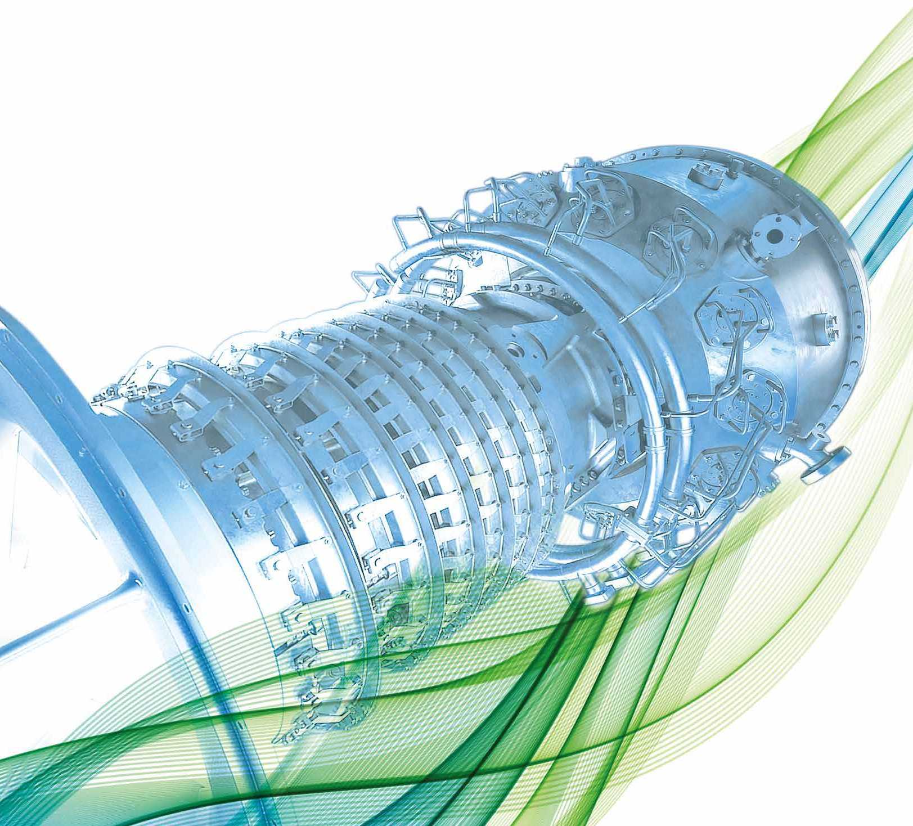

](http://www.etn.global/events/igtc-23/)

](http://www.etn.global/events/igtc-23/)



**[Sponsorship & exhibition package](http://www.etn.global/events/igtc-23/)**



**[www.etn.global/events/igtc-23/](http://www.etn.global/events/igtc-23/)**

**11th IGTC “Dispatchable technology & innovations**

**for a carbon-neutral society”**

10-11 October 2023, Brussels, Belgium

# The event

The International Gas Turbine Conference (IGTC) is a well-established and renowned biennial conference, organised by ETN, bringing together the gas turbine user community (utilities, industrial and oil & gas users), manufacturers and suppliers, the research community and policymakers.

Our objective is to raise the awareness of how gas turbine technology can contribute and enable the required energy transition, and to highlight from power generation, oil & gas and industrial operators’ perspectives, commitment and development needs to successfully do so. The conference also provides an opportunity to emphasise and discuss with policymakers the importance of a supportive regulatory framework that will incentivise the required investments.

The IGTC will highlight global opportunities for gas turbine technology in key markets, as well as present, publish and disseminate the latest R&D developments, and address achievements that will help to accelerate the transition to sustainable energy systems by adapting the gas turbine technology to carbon-neutral fuels, hybrid power systems and alternative heat sources.

For manufacturers, suppliers and service providers the conference provides an unprecedented opportunity to reach out to the global gas turbine user community and policy makers and to highlight your commitment to provide the required energy solutions and services.

Our offer  
This conference will provide an exclusive opportunity for your company to show your role in the energy transition as well as commitment and contributions to the development of a carbon-neutral society.

For our sponsors we offer:

* **High visibility** for your company before and during the conference, as well as after the event in ETN communications
* **Presence** of high-level decision makers, the user community, OEMs & technical suppliers, as well as GT experts from around the world
* **Extensive networking opportunities** and a chance to explore future partnerships & cooperation

Review the available opportunities on the following page and secure your space by filling out the attached form.

For the IGTC 2021 the following organisations were sponsors and partners:

|  |  |
| --- | --- |
|  |  |
|  | |

Sponsorship and exhibition opportunities

|  |  |  |  |  |
| --- | --- | --- | --- | --- |
| **BENEFITS** | **Carbon neutral technology sponsor** | **Net-zero gold sponsor** | **Net-zero silver sponsor** | **Exhibitors** |
| Visibility | Priority display | Secondary display | Tertiary display | Tertiary display |
| Logo on event programme and on conference webpage with link to company website | YES | YES | YES | YES |
| Logo on the conference welcome slide (projection during the conference breaks) | YES | YES | YES | YES |
| Sponsors name included in digital communication – Monthly News Summary & Quarterly Newsletter (reaching 2000 contacts) | YES | YES | YES | YES |
| Acknowledgement to sponsors on social media posts | YES | YES | YES | - |
| Opportunity to include a welcome announcement in the conference package | YES | YES | YES | - |
| Opportunity to make a short welcome speech | YES  (At the Dinner event  Max 5-10 min) | YES  (During lunch either day 1 or day 2: max 2-3 min) | - | - |
| VIP seating | YES  (during dinner) | YES  (during lunch) | - | - |
| Complimentary delegate pass | YES  3 passes | YES  2 passes | YES  1 pass | YES  1 pass |
| Ability to display poster/banner**1** | Max 3 pieces (~2x1m),  or 1 piece (~2x4m)  (At the Dinner ONLY) | Max 2 pieces (~2x1m),  or 1 piece (~2x2m) | Max 2 pieces (~2x1m),  or 1 piece (~2x2m)**2** | Max 2 pieces (~2x1m),  or 1 piece (~2x2m)**2** |

1 The location of the banners will be decided by the ETN office based on the number of pieces/type of sponsorship

2 Display area with table (~2x0.8m) for brochures and space behind a table (~2x2m) for banners in the exhibition area

Sponsorship form

|  |  |  |  |  |
| --- | --- | --- | --- | --- |
| **Types of Sponsorship** | **Sponsorship amount** | **Available** | **Space taken by** | **Tick a box** |
| **Carbon neutral technology sponsor** | € 7,500 | 1 |  |  |
| **Net-zero gold sponsor** | € 6,000 | 2 |  |  |
| **Net-zero silver sponsor** | € 4,800 | 3 |  |  |
| **Exhibitor** | € 3,800 | 2 | A logo with a cross and oval shape  Description automatically generated  A white text on a black background  Description automatically generated  A close up of a logo  Description automatically generated  A purple and black logo  Description automatically generated  A close-up of a logo  Description automatically generated |  |

|  |  |
| --- | --- |
| **Name:** | **Position:** |
| **Organisation:** | **Address:** |
| **Postcode:** | **City:** |
| **Country:** | **Tel:** |
| **Email:** | **VAT number:** |
| **PO number (please provide, if required):** | |
| **Please issue an invoice to the above address.**  **Signature: Date:** | |

**Please return this form by email to the ETN office:** [**vc@etn.global**](mailto:vc@etn.global)

**SPONSORSHIP TERMS AND CONDITIONS:** The sponsorship fees are due 3 weeks after signing this agreement. ETN shall not in any circumstances be liable for any loss damage or injury which may occur to you or a third party, or for any damage of your property. If the event is cancelled or delayed through no fault of the venues managers including but not limited to fire, flood, labour disputes, natural disasters, global health emergencies, civil disorders, riots, insurrections, work stoppages, slowdowns or disputes, or other similar events, you will not be entitled to any refund or to claim for any loss or damage.