ETN Hydrogen Summary

Content

Chapter 1 Advantages of hydrogen gas turbines 3

Chapter 2 Pre-conditions of a hydrogen power plant 7

2.a Hydrogen production 7

2.b Hydrogen storage and transport 10

2.c Stability of hydrogen supply 12

2.d Plant installation and commissioning, plant standards and norms 12

Chapter 3 Hydrogen combustion 14

3.a State-of-the-art 14

3.b Challenges and Research Needs in Hydrogen Combustion 16

Chapter 4 Retrofit of existing gas turbines 21

4.a Fuel Flexibility 22

4.b Impact on Plant Performance and Flexibility 23

4.c Impact on Hot Gas Path Parts Lifetime 23

4.d Requirements for Retrofit Packages 24

Chapter 5 Current capabilities of gas turbines burning hydrogen 25

5.a Ansaldo Energia 26

5.b Baker Hughes 28

5.c General Electric 30

5.d MAN Energy Solutions 31

5.e Mitsubishi Hitachi Power Systems 32

5.f Siemens 34

5.g Solar Turbines 35

**Acknowledgments**

The ETN Hydrogen Executive Summary has been issued by the European Turbine Network (ETN), as part of the activities of the ETN Hydrogen Working Group. The report was directed by Peter Kutne (Head of Department Gas Turbines, DLR) with the support of the ETN secretariat.

The knowledge and expertise of the ETN members who contributed to this report added significant value to the publication. We would like to thank especially the main contributors: Mirko Bothien (Head Combustor Technology, Ansaldo Energia), Peter Breuhaus (Senior Scientist, NORCE), Peter Griebel (Head of High-pressure Experiments Group, DLR), Burak Kaplan (Business Development Manager, MHPS), Geert Laagland (Vattenfall), Peter Stuttaford (CEO, Ansaldo Thomassen).

Contributions to this document were provided by the organisations listed below.

|  |
| --- |
| ETN Hydrogen WG members Logos |

# Advantages of hydrogen gas turbines

According to the International Energy Agency (IEA) projections of the 2 Degree Scenario[1], the global decarbonisation of the power generation sector can be achieved by increasing the share of Renewable Energy Sources (RES) such as wind and solar. However, these renewable sources provide a fluctuating electricity supply which needs to be balanced by other forms of reliable, affordable and sustainable power generation. In the “Future of Hydrogen”, the IEA describes the potential of hydrogen to make a significant contribution to clean energy transition, including in the power sector. The development of the hydrogen gas turbine can be the future carbon-neutral technology to support the society achieving the ambitious energy and climate targets. Indeed, the hydrogen gas turbines would enable deep emissions reduction for the long-term, while integrating more renewables.

In January 2019, the gas turbine industry strongly committed to develop gas turbines operating with 100% hydrogen till 2030, such fully supporting the transformation of the European gas grid into a renewable based energy system by overcoming technical challenges and ensuring that this transformation takes place swiftly.

Gas turbines already fulfil the crucial balancing role in the energy system. By extending the fuel capabilities of gas turbines to hydrogen, their role can become predominant in the energy transition period but also in long-term energy strategies:

* In combined cycle configuration (CCGT), gas turbines are already the cleanest form of thermal power generation. Indeed, for the same amount of electricity generated, gas turbines running on natural gas emit 50% less CO2 emissions than coal-fired power plants;
* Mixing renewable gas (e.g. green hydrogen, biogas, syngas) with natural gas enables further reduction in net CO2 emissions. This can be achieved by direct injection in gas grids or at plant level;
* Industry is committed to enable gas turbines to run entirely on renewable gas fuels by 2030 and therefore achieve capabilities for 100% carbon neutral gas-fired power generation. The ensuing objective being to implement power plants reaching 65%+ thermal efficiency in combined cycle configuration;
* Gas turbines are flexible, well-suited for frequent starts, and able to provide a fast response to grid demands, making them complementary to the variable RES.

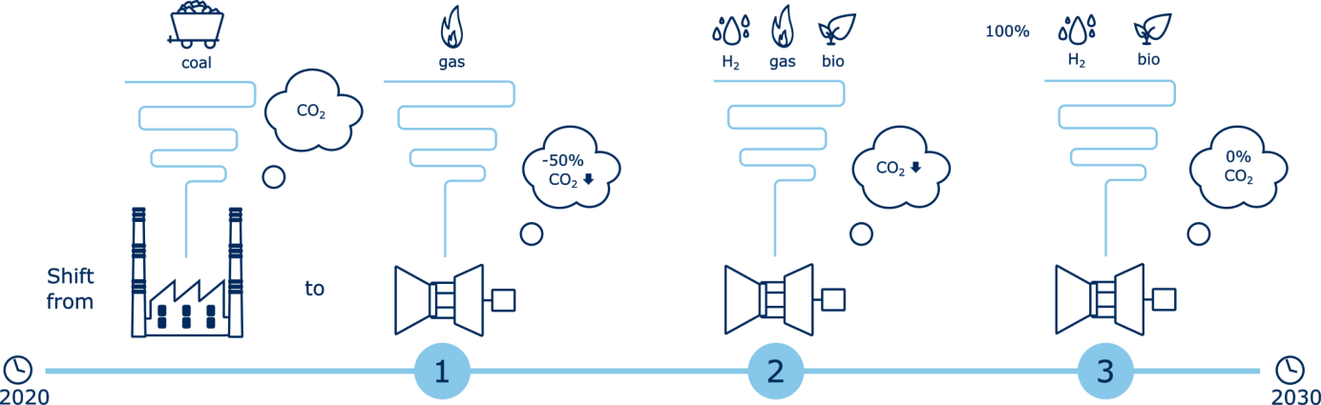

Figure 1 - The role of gas turbines in the global energy transition

In 2018 over a quarter of European electricity is produced by coal-fired power generation[2]. At the same time Europe has a large existing fleet of relatively new, highly efficient and very flexible gas turbines, both in open and combined cycle configuration, that operate at a limited percentage of their total capacity.

By accelerating a shift from coal-fired to gas-fired power generation, Europe can take a massive step forward in decarbonising the sector during the next ten years with relatively limited efforts and investments and with a future-proof technology.

Hydrogen gas turbines would, in essence, complement the intermittent nature of wind and solar power since they can be used as back-up power. Hydrogen can be produced via electrolysis, using excess renewable power during periods of abundant wind and daylight, or by natural gas reformation, which is also carbon neutral resource if carbon capture technology is utilised. In this context hydrogen reforming can be seen as the kick-starter to create sufficient hydrogen supply on short notice and enable the creation of a hydrogen infrastructure, including storages. The scalability of gas turbines from small decentralised to large centralised systems allows for adaptation to the production capability and local storage. All in all, hydrogen gas turbines can be an enabler for long term energy storage with power to gas technologies.

The development of retrofit solutions for existing gas turbines will be a key enabler for the implementation of the hydrogen gas turbine technology. The first steps can initially be achieved with relatively small modifications to existing combustors, allowing co-firing of hydrogen to significant fractions (>30 vol%, 11% of carbon reduction). Increased field experience will enable further developments, such as new types of combustors allowing up to 100% of hydrogen firing without the need for diluents for emission control. Due to the non-linear dependency of carbon content in the fuel versus the volumetric hydrogen content (shown in Figure 2), it is of importance to enable the use of higher hydrogen content as soon as possible to maximize the impact on CO2 emissions.

Figure 2 - Carbon content in the methane/hydrogen mixture

**Utilising the existing natural gas infrastructure**

Gas turbines use the robust and flexible natural gas infrastructure to source their fuel. With little to no modifications a blend of hydrogen with natural gas can be transported within this existing infrastructure, which makes the entire system reusable without major expenditure. For example the Netherlands has already injected up to 20% hydrogen into their natural gas grid in a pilot project on the Island of Ameland some years ago[3]. This concept can be replicated to other regions to start burning a blend of natural gas and hydrogen in gas turbines to reduce carbon emissions. However, new or retrofitted piping infrastructure would be necessary for 100% hydrogen transport, but combusting hydrogen at the point of production would be a solution to this problem during the initial phase.

**Retrofitting existing gas turbines**

The design of hydrogen gas turbines can rely to some extent on the existing gas turbine technology. There is no necessity to design and manufacture entirely new gas turbines for hydrogen combustion. Special attention is required on modifying the combustor and some auxiliary parts, but most of existing gas turbines can be retrofitted to either partially or fully burn hydrogen. This conversion would not only avoid large capital spending but also save time in switching large fleets of current gas turbines to hydrogen. An additional major benefit of developing and deploying the hydrogen gas turbine technology resides in the potential for new lifeline of existing equipment. Indeed, there are state-of-the-art gas turbines sitting idle or being underutilised in many European Countries. Keeping these power plants in activity would also make a significant contribution to society and industry, by maintaining their workforce which would otherwise either being laid off or shift to other sectors.

**100% emission compliance**

Current gas turbines can already burn pure hydrogen via diffusion combustion, thus generating still NOx emissions. For this reason research and development activities are nowadays focused on dry low NOx technology, which has to potentially to substantially reduce or eliminate NOx emissions. In terms of thermal efficiency and power output, differences between current gas turbines and hydrogen turbines, both with dry low NOx technology, would be marginal.

**Sector coupling for deeper decarbonisation**

The heating sector is one of the largest carbon emitters worldwide. In order to reduce the CO2 emissions, waste heat from hydrogen gas turbines in Combined Heat and Power (CHP) plants can be used. By coupling hydrogen gas turbines also with other industries (e.g. chemicals and refineries), further decarbonisation can be achieved.

**Wider hydrogen deployment**

Given its peculiarities, hydrogen gas turbines can stimulate commercial demand for large amount of low purity hydrogen, thus contributing to the reduction of hydrogen’s production costs and to its wider deployment in multiple sectors. Further costs reduction across the whole hydrogen value chain can be achieved through R&D. In this regard, governmental funding schemes for gas turbine R&D worldwide can be key contributor towards a hydrogen society. Collaboration between internal actors is needed to address to eliminate the barriers for the wider deployment of hydrogen-based solutions.

# Pre-conditions of a hydrogen power plant

This chapter assesses pre-conditions to the implementation of a hydrogen power plant, and covers critical points across the hydrogen value chain where further research and development efforts will be needed. Current technology pathways are described for hydrogen production, storage, and transport and the importance of stability of supply is highlighted as hydrogen availability on site is an essential pre-condition for its use as fuel in power generation. Eventually, these points converge to considerations for the installation and commissioning of a hydrogen power plant.

## Hydrogen production

Hydrogen production is the first fundamental pre-condition of a hydrogen power plant, and four decarbonised hydrogen production paths are identified here (see also Figure 3):

1. **Water electrolysis**, carried out with power produced with a high share of renewables in electricity generation ensuring the decarbonisation;
2. **Natural gas reforming** combined with Carbon Capture and Storage (CCS) or Carbon Capture and Usage (CCU) in order to ensure decarbonisation;
3. **Solid fuel gasification** (i.e. coal)and decarbonisation via also CCS or CCU;
4. **Biomass transformation** through digestion, gasification or reforming, followed by an upgrading process. It is carbon neutral or even negative when combined with CCS.

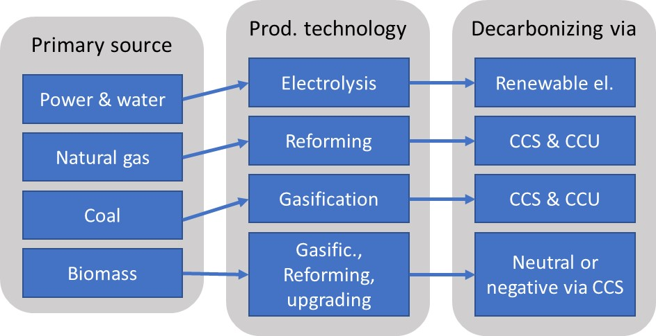

Figure 3 - Hydrogen production paths

An essential pre-condition for using hydrogen as fuel in power generation is based on its availability at site, considering transportation and storage solutions.

Water electrolysis and reforming of hydrocarbons are currently the main state-of-the-art technologies to produce hydrogen. Nowadays it is not economically and technically feasible to produce a large amount of hydrogen via electrolysis. Nonetheless, reforming of hydrocarbons could be used to start the implementation of a hydrogen based energy infrastructure.

According to the IEA[4], global hydrogen production is approximately 70 Mt annually, with 76% produced from reforming of natural gas at facilities across the world and the remainder produced from coal gasification almost exclusively in China. Current dispatch of electrolysis technologies accounts for only 2% of global hydrogen production, however, market penetration is expected to increase alongside increased renewable energy installation. Based on costs projections, fossil fuels are expected to continue dominating the European hydrogen production landscape in the near term up to 2030, as shown in Figure 4. The installation of CCU/CCS systems is also taken into consideration for carbon abatement.

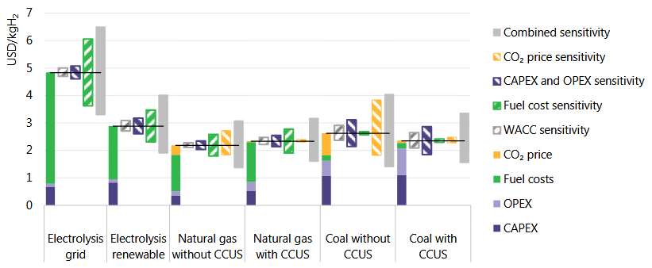

Figure 4 - Predicted hydrogen production costs for different technology options in 2030, WACC = weighted average cost of capital . Source: IEA (2019)

**Steam-Methane Reforming**

Steam methane reforming is the most common method for hydrogen production based on hydrocarbon fuels[5]. This is a well-established process in which steam at temperatures between 700°C and 1000°C is used to generate hydrogen from fuels with high methane content, under high pressure conditions of between 3÷25 bars. Fuels can either be natural gas or upgraded biogas, but also syngas, ethanol, propane or gasoline. A catalyst is necessary for this reaction, as well as heat to generate the high temperature steam.

An alternative process is partial oxidation, in which methane and other hydrocarbons in natural gas react with a limited amount of oxygen. With this reaction in substoichiometric condition, the products contain mainly hydrogen and carbon monoxide, with presence of nitrogen if the reaction is carried out with air rather than pure oxygen.

Partial oxidation is an exothermic process, thus releasing heat. The process dynamics are much faster than steam reforming and require less space due to smaller components. However, the produced amount of hydrogen per unit methane is lower than in a steam reforming process with the same type of fuel.

**Water electrolysis**

Hydrogen can be produced by electrolysis of water, i.e. using electricity to split water into hydrogen and oxygen. Currently there are three main different types of water electrolysers technologies on the market (or close to market introduction) for the production of hydrogen [[6], [7]]. They are defined by the electrolyte used: alkaline, proton exchange membrane, or solid oxide.

**Alkaline Electrolyser Cells (AEC)** is a well-established technology which corresponds to the most commercially available electrolysers at the moment. Current state-of-the-art plants operate at cell temperatures between 60oC and 90 oC with typical pressures within 10÷30 bar. Stack efficiencies based on the lower heating value vary between 63% and 71% while the efficiency of the system is more than 10% points lower (51% - 60%)[7]. Even though the cold start up time is between one and two hours, the AEC offers a flexible load (between 20% and 100%), and fast response time (seconds) when the operational temperature is reached.

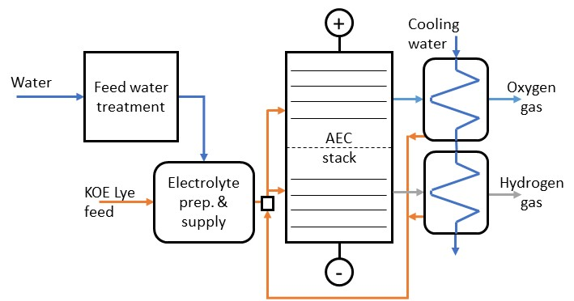

Figure 5: Layout of an alkaline electrolyser plant [6]

**Proton Exchange Membrane Electrolyser Cell (PEMEC)** operates between 50˚C and 80˚C (with the higher bound expected to increase to 90 °C in the future) and a pressure between 20 and 50 bar. The stack efficiency of products on the market varies between 60% and 68%, while efficiency of the complete systems is usually in the range of 46% - 60%, both based on the lower heating value [7]. The cold start up time of a PEMEC is with 5 to 10 minutes, with a flexible load that can vary between 0% and 100%. The main barrier to the commercialisation of this technology is its high stack cost [7].

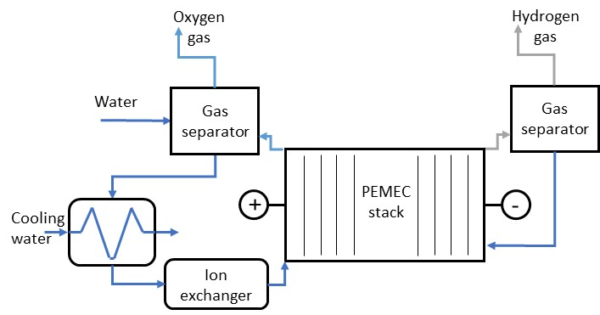

Figure 6: Plant layout scheme of a PEMEC [7]

**Solid Oxide Electrolyser Cell (SOEC)** is the newest and most efficient electrolyser cell with efficiency values reaching 100% for the stack, and 76% - 81% at the system level, based on lower heating value [7]. The technology operates with steam at higher temperatures (700oC to 900oC). SOECs are less flexible than the AEC and PEMEC, with a cold start up time in the range of several hours. State-of-the art SOECs suffer from significant degradation in both electrodes at high current densities (significantly above 1 A/cm2), but degradation mechanisms have been identified and improving the electrodes lifetime is currently under research.

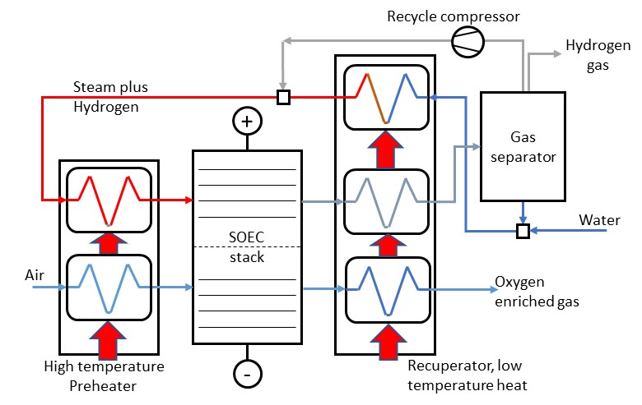

Figure 7: Plant layout scheme of a SOEC [7]

## Hydrogen storage and transport

Storage and transport will be crucial for the deployment of hydrogen in the future energy system. Technological solutions are closely connected to the physical state of the hydrogen and/or if it is in its pure form or bound to other molecules. These different states are described below:

* **Compressed hydrogen in gaseous state** transported via pipelines for a large-scale application is assumed to be the most efficient option[8]. However, producing and storing hydrogen on site could be an economically feasible alternative to use the otherwise curtailed renewable energy. Caverns or depleted oil/gas fields could also be used to store large quantities of gaseous hydrogen, depending on the topography of the site. High pressure storage seems to be the most feasible one as some energy could be recovered during expansion.
* **Liquified hydrogen**. Hydrogen turns into a liquid when it is cooled to a temperature below -252.87˚C at atmospheric pressure. In order to withstand such low temperatures and avoid heat transfer, transport and storage of liquid hydrogen requires the use of sophisticated insulated vessels, thus increasing the related costs. Current research mainly focuses on improving the energy efficiency of the liquefaction process as well as the insulation and cooling methods.
* **Ammonia**. Storage and transport of hydrogen in the form of ammonia is a technology receiving more and more attention. Research to reduce energy consumption of the process is ongoing[9].
* **Liquid organic hydrogen carriers (LOHC)**. The storage concept of hydrogen within LOHC is based on a two-step cycle: (1) loading of hydrogen (hydrogenation) into the LOHC molecule, and unloading of hydrogen (dehydrogenation) after transport and storage. They are still in the research phase, but might form an alternative technology in the future[10],[11]. Currently the technology has low efficiency and is bulky, and is therefore not suitable for gas turbine applications.

Figure 8 below visualises the options considered for storage and transport of hydrogen, depending on its state.

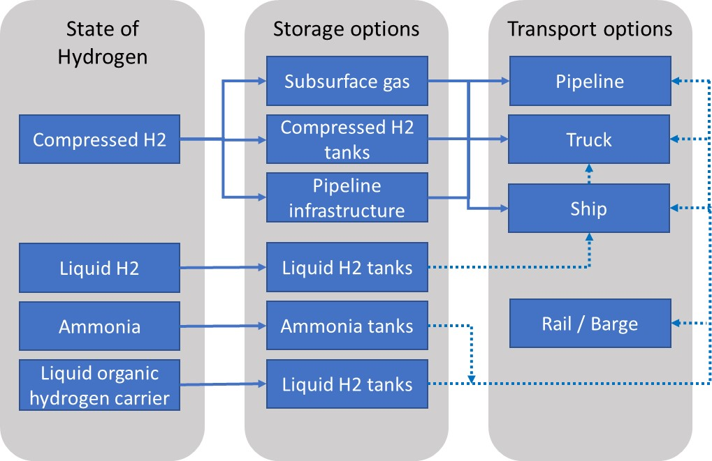

Figure 8: Options for Hydrogen transport and storage depending on the hydrogen status

Plants for hydrogen production, storage and transport are well established for most of the above-mentioned technologies. However, research needs to be done when considering the whole integrated system, taking into account system dynamics and the integration of fluctuating renewables.

## Stability of hydrogen supply

The increasing share of fluctuating renewable electricity and the mismatch of production and demand profiles require the energy to be stored in form of fuel. Hydrogen based power generation will then take over the role of dispatchable backup power for balancing demand and generation, as well as stabilising the grid. Storage and storage capacity are therefore essential elements of a stable fuel supply and thus a reliable and stable energy system. The high fuel flexibility of gas turbines would allow for using admixtures of hydrogen with different fuels depending on the availability.

## Plant installation and commissioning, plant standards and norms

Even though hydrogen technology is well known and established in the industry (e.g. chemical and oil industry), the operation of hydrogen power generation plants is restricted to test units. Therefore, no routines or standards exist for hydrogen plant installation and commissioning, which would include production, storage and power generation. One of the challenges is therefore to transfer and integrate the existing know-how of other industries to the power generation sector and, if necessary, adjust them to cover power plant specific conditions. Co-location of production of hydrogen and power plants might be beneficial as transporting hydrogen would be avoided, and therefore the associated costs and losses would be reduced. This would also reduce the overall geographical footprint and environmental impact as the technology would make use of already exiting electrical infrastructure and avoid the installation or modification of infrastructure for gas transport.

The integration of additional components for green-hydrogen production (i.e. electrolysers, storage and fuel mixing set-up), is very complex, and experience is limited. It is therefore anticipated that additional effort will be needed for the first prototype installations.

# Hydrogen combustion

In this chapter, the authors describe the current state of the art of pure hydrogen and natural gas/hydrogen blends combustion, covering diffusion flames with nitrogen or steam dilution, and lean premixed systems. In addition, previous international research effort on the topic is summarised, spanning technology readiness levels (TRL) from feasibility research to pilot projects.

The second part of the chapter focuses on practical considerations to take into account for combustion and controls systems. In particular, challenges associated to autoignition, flashback, thermosacoustics, and NOx emissions are addressed, and associated research needs to tackle them are described.

## State-of-the-art

* Diffusion flames with nitrogen or steam dilution.

Combustion systems with diffusion flames and nitrogen or steam dilution are state-of the art systems which can handle up to 100%vol. hydrogen. Nevertheless, these systems have several disadvantages, including efficiency penalty compared to systems without dilution, higher NOx level compared to lean-premixed technology, higher plant complexity and thereby higher capital and operational costs. In the case of large gas turbines running in a combined cycle or CHP configuration, steam dilution performs significantly better than nitrogen dilution with respect to emission reduction and plant efficiency.

Overall, premixing of the fuel with the diluent should be preferred, as it allows higher effectiveness in terms of emission reduction.

Although these systems can handle different fuels, in most cases a “safe” fuel (i.e. diesel or natural gas) needs to be used for start-up of the plant. Compared to gas turbines operated on natural gas or diesel, significant hardware modifications in the auxiliary system are needed to handle the increased fuel flow rate. Surge margin issue is handled by either compressor modifications or by reducing the inlet air mass flow.

* Lean premixed systems.

The lean-premixed combustor technology has much higher potential. However, this technology is less mature and not sufficiently developed yet with respect to operation on fuels with very high hydrogen contents or even pure hydrogen together with high fuel flexibility.

The maximum allowable hydrogen concentration in lean premixed combustors varies significantly across the gas turbine fleet of different original equipment manufacturers (OEMs), as different combustion technologies are employed. Fuels with significant hydrogen content are carefully evaluated by each OEM, and the applicability of lean premixed systems is assessed case by case considering the peculiarities of each specific project.

Typical values of hydrogen content currently tolerated by different gas turbine classes reach up to 30-50 vol.% for heavy duty engines, 50-70 vol.% for smaller engines (IGT), 20 vol.% for micro gas turbines. The reasons for these different upper H2 content limits are related to different firing temperatures and combustion technologies used in the different GT classes. Reference values for each gas turbine family of the different OEMs are given in Chapter 5 - *Current hydrogen capabilities of gas turbines*.

Several OEMs offer gas turbines which can handle H2 contents in the fuel up to 30 - 60 vol.%. However, no fuel flexible gas turbine that can handle pure hydrogen is nowadays commercially available, and additional R&D activities are needed to pave the way for such a technology. The development of combustion systems that can handle full range of 0-100% hydrogen contents blended with natural gas is even more challenging, but required for potential fluctuations in future hydrogen fuel supply.

* Previous research programs on H2 combustion

Previous EU-funded projects have focused on the potential to integrate hydrogen-rich syngas combustion turbines with pre-combustion carbon capture and storage systems. For example, extensive hydrogen combustion research was undertaken at DLR together with Siemens and Alstom as partners in the EU FP6 ENCAP project (EU Grant 502666)[12].

At higher technology readiness level (demonstration in the EU FP7 H2IGCC project, EU Grant 239349), blends of hydrogen and nitrogen were examined at Cardiff University (UK) up to 85% vol. H2 in 15% vol. N2 in a modified Ansaldo Energia (Italy) lean premixed burner up to 2 MW and 4 bar, particularly with respect to the influence on flashback, NOx emissions, and thermoacoustics[13]. Further to this testing, full engine scale combustion trials up to 83 %vol H2 in 17 %vol N2 were conducted at Sesta Lab (Italy) [1]. In the same H2IGCC project, developments in turbulent flame speed measurements for hydrogen-containing fuel blends (70-30% vol. H2-N2, 85-15% vol. H2-N2, and 100% H2) were made at PSI (Switzerland)[14].

Lower TRL-level research funded by the UK Engineering and Physical Sciences Research Council has focused on blending hydrogen into the natural gas grid (EPSRC Flex-E-Plant project, EP/K021095/1) up to 15 vol%. H2 in CH4 for pressurised burner testing[15] and up to 40 vol%. H2 in CH4 for atmospheric burner testing[16]. Additional projects have evaluated CO2 as a diluent for pure hydrogen combustion in SMR-CCS systems (EPSRC Advanced Gas Turbine project, EP/M015300/1), which showed the possibility of ultra-lean pure hydrogen combustion in fully-premixed operation and stable pressurised operation with CO2 dilution[17].

Industrial pilot projects in the EU considering either blending of natural gas with hydrogen or pure hydrogen gas turbines are also underway. One example is the Nuon/Vattenfall Magnum Carbon-Free Gas Power project, in the Groningen region, which is a partnership between Nuon/Vattenfall, Gasunie, Equinor, and Mitsubishi Hitachi Power Systems to convert one of Magnum’s three 440 MW CCGT to 100% hydrogen by 2023[18]. In another pilot project, Hotflex/ComSos (EU H2020 Grant 779481), a partnership between VERBUND, Graz University of Technology, and Sunfire in Mellach, Austria, aims to blend “green hydrogen” made from renewable energy into the 838 MW natural gas-fired CCGT power plant[19]. Further complementary EU research programs include the EU H2020 EnableH2 project which has a specific focus on the use of hydrogen as a fuel in the aviation sector (EU Grant 769241)[20].

Outside of the EU, hydrogen gas turbine research funding has been led by countries including the United States and Japan. From 2005-2015, approximately $15M - $30M annually was provided in research funding for the US DOE Office of Fossil Energy Hydrogen Turbine Program, including large grants to General Electric (Award NT42643) and Siemens (NT42644), among other industry and university partnerships[21]. Lower-TRL fundamental hydrogen combustion research is also currently being supported in the US, considering computational modelling of flashback (DOE Agreement FE0012053) and pilot-scale natural gas conversion to hydrogen for use in gas turbines (DOE Agreement FE0031615). In Japan, a “Basic Hydrogen Strategy” is currently being implemented by the New Energy and Industrial Technology Development Organization with funding levels of nearly 10 Billion JPY (~€80M) for hydrogen gas turbine development in 2018, hydrogen supply chain, and power to gas technology[22].

## Challenges and Research Needs in Hydrogen Combustion

In the transition to a hydrogen based energy system, fuel flexible gas turbines are needed to utilise blends of hydrogen and other gaseous fuels, such as natural gas. Combustors need to cope with a wide range of natural gas/H2-mixtures as well as with fast changes in the fuel composition. In the medium-term, fuel-flexible gas turbines capable of burning hydrogen/natural gas blends containing higher amounts of H2 than nowadays need to be developed (see H2 limits of today’s commercially available GTs given in Chapter 5). In the long-term, gas turbines offering the full fuel flexibility (any blend of hydrogen and natural gas as well as pure hydrogen) need to be developed, which requires intensive R&D activity in order to pave the way for such a technology.

The Dry Low Emission (DLE) technology has the potential to enable fuel flexible operation at 0-100% H2 with low emissions. However, further development effort is required to derive technical solutions with respect to the following challenges associated with high hydrogen contents in the fuel:

* Autoignition: Higher autoignition risk due to lower ignition delay time;
* Flashback: Higher flashback risk due to higher flame speed or lower ignition delay time;
* Modified thermo-acoustic amplitude level and frequencies;
* Increased NOx emissions;
* Other combustion related challenges;
  + Higher pressure drop due to lower Wobbe Index;
  + Reduced lifetime / need for more cooling of hot gas path components due to increased heat transfer;

Research at practically relevant conditions are needed (high pressure and air preheat, high combustor exit temperature, high flow rates and high Re-number). Academic studies at reduced pressure level and size can sufficiently capture conditions for micro gas turbine applications but clearly fall short for larger scale gas turbine combustion systems. Correlations and well defined validation cases are missing.

The presence of hydrogen strongly alters the combustion properties of “hydrogen blends” with respect to natural gas. Adding hydrogen to natural gas tends to increase its flame speed, to reduce its ignition delay time, and to enlarge its flammability limits[23]. These features affect positively the flame stabilisation in terms of flame anchoring and may also widen the emission compliant turn down ratio (part load performance). At the same time, increasing the presence of hydrogen will change the thermoacoustic behaviour of the combustion system and increase the local flame temperature which will potentially results in higher pollutant emissions (NOx) at the exit of the combustor if no additional measures are taken.

* **Autoignition**High reactivity of hydrogen inherently increases the auto-ignition risk in the premixing section which needs to be addressed in future combustor developments. This might be of a particular challenge in some systems with very high air inlet temperatures, e.g. in modern high-efficient gas turbines or micro gas turbines due to the recuperator.

To protect burners and fuel injectors from being overheated or damaged, burners typically are instrumented with thermocouples if more reactive fuels are used. In advanced, highly efficient gas turbines more and more complex burner design (e.g. multi-nozzle arrangements) are needed and therefore this method of protecting burners will become challenging and expensive. Other methods of detecting and preventing autoignition events leading to a flame stabilisation in undesired locations are needed especially when increasing the hydrogen fraction in the fuel blend.

* **Flashback**Burning hydrogen-rich fuels inherently increases flashback risks because of a higher flame speed or a shorter ignition delay time compared to natural gas. This may be a particular challenge in some systems with very high air inlet temperatures.

To protect burners and other components from being overheated or damaged because of a flashback initiated flame stabilisation in undesired locations (e.g. premixing section) methods of detecting and avoiding flashback have to be developed and applied in gas turbines.

* **Thermoacoustics**  
  Compared to natural gas flames, hydrogen flames exhibit significantly different thermoacoustic behaviour. This is due to higher flame speed, shorter ignition delay time and distinct flame stabilisation mechanisms resulting in different flame shapes, positions and different reactivity.

Therefore, the risk of combustion dynamics (self-sustained combustion oscillations at or near the acoustic frequency of the combustion chamber) in modern gas turbines operated on hydrogen-rich fuels is expected to increase compared to natural gas operation. This implies that undesired and dangerous phenomena, such as combustion instabilities, flashback and lean blow out, are likely to occur not only at steady conditions, but also more dangerously during transient operation, e.g. when rapid power changes are required and/or fuel composition changes (see Figure 9 below depicting an example of damage[24]).

In order to develop stable combustion systems for hydrogen-rich flames various measures are required to avoid high pressure pulsations. In addition, the turbulent flame speed of hydrogen is pressure dependent (unlike that of natural gas), which means that current low TRL testing strategies based on atmospheric rigs (e.g. the prediction of engine thermoacoustics via the measurement of flame transfer functions) is not possible and would have to be adapted.

Hence, besides a deeper understanding of the physical mechanisms contributing to combustion dynamics, real-time, reliable monitoring and control systems are required to make combustors more efficient and flexible, and guarantee gas turbine availability.

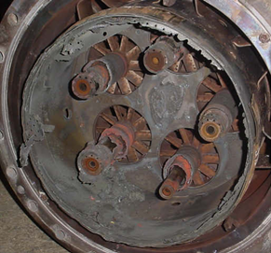

Figure 9 Damages due to high-frequency (2350 Hz) thermoacoustic instabilities due to inappropriate tuning of the machine [24].

* **Higher flame temperature, NOx emissions**

The higher adiabatic flame temperature of H2 will result in higher NOx emissions if no additional measures are undertaken. Some flexibility might be needed on NOx limits in future, in order to enable the decarbonisation. It will be particularly a challenge to achieve even stricter NOx-limits foreseen in the future.

Lowering the flame temperature by engine derating would result in efficiency and power decreases.

For retrofit projects applying post-combustion De-NOx technology (i.e. Selective Catalytic Reduction) is very difficult and costly. Therefore, reducing the combustor NOx emissions is the preferred path.

* **Other combustion related challenges**
  + **Wobbe Index change**

Compared to burning natural gas at the same thermal power, a larger volumetric fuel flow rate is needed when burning hydrogen due to its lower volumetric Lower Heating Value (LHV). In addition, hydrogen has a lower Wobbe Index (WI) which is the most commonly used parameter for specifying the acceptability of a gaseous fuel in a combustion system. The significance of the Wobbe Index is that for a given fuel supply and combustor conditions (temperature and pressure) and a given control valve positions two gases with different compositions, but the same Wobbe Index, will give the same energy input to the combustion system. Thus the greater the change in Wobbe Index, the greater the required flexibility of the combustion systems and associated control.

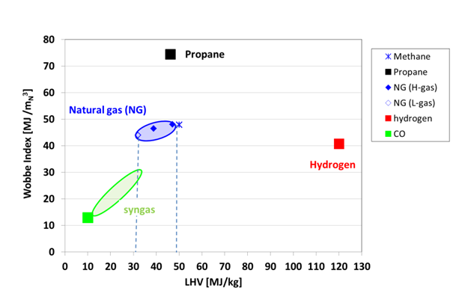

Figure 10 - Index as a function of the Lowest Heating Value for different fuels[25]

* + **Reduced lifetime /improved cooling of hot gas path components**

Burning hydrogen instead of natural gas will increase the moisture content in the exhaust gas causing higher heat transfer to the gas turbine hot gas path components. This will require an adaptation of the cooling in order to avoid overheating of components. In addition, due to the higher moisture content hot corrosion is more likely to occur. Therefore, measures need to be undertaken to avoid these effects.

# Retrofit of existing gas turbines

There is a requirement for research to address systems, materials, operations and control of gas turbines for their safe and economically effective transition to a hydrogen-containing fuel stream.

Every machine has to be evaluated on a case by case basis for hydrogen consumption, considering fuel skid, controls, and combustion system. As a general guideline, there are break points to consider, namely:

* Low levels of hydrogen mixed with natural gas, to a level that does not require any changes to materials, designs and control and protection. These levels may be considered to be in the range of [0-10% vol.], depending on system
* Medium levels of hydrogen mixed with natural gas, to a level that does not require significant changes to materials, designs, control and protection. These levels may be considered to be in the range of [10-30% vol.]
* Higher levels of hydrogen, which require a wider retrofit scope, and which probably then economically suggest that hydrogen fuel capability should be maximized given the assumption of fuel delivery, combustion module, control and protection retrofit [30-100% vol.]

In a perfect arrangement, from a fuel trading perspective, retrofitted gas turbines would be able to operate on a 0-100% hydrogen/natural gas mix. The nature of hydrogen processing, delivered from stochastic renewables generation, also implies the need for flexibility in fuel diet.

There is existing and ongoing research work which addresses some of the above – mostly on a gas turbine model-by-model basis. It is more advanced at the lower hydrogen combustion fuelling levels and significantly less advanced at high hydrogen firing levels. University research contributes to the fundamental understanding of the combustion processes.

**General fuel preparation considerations**

When using hydrogen as fuel, it is of utmost importance to take into consideration the delivery pressure and temperature in order to avoid embrittlement in the pipelines and other auxiliaries.

Existing piping and gas turbine valves shall be subject to retrofit when a gas turbine manifold running with natural gas is forecasted to run with H2. Changes may include new valves design with a different sealing arrangement, and potentially new piping material.

In oil & gas application, fuel gas pressure and temperature would normally be delivered respectively at a maximum of 50 barg and 100°C. At these values, the already existing equipment can operate with hydrogen without any issue.

However, for power generation applications in optimised CCGTs, the fuel may be pre-heated in order to improve the performance and reach temperatures as high as 320°C.

While hydrogen embrittlement does not occur in stainless steel equipment at 50barg and 100°C, increasing the temperature to around 200°C may cause H2 migration through the material. Indeed H2 embrittlement is a concern at temperatures above 200°C, although 316L grade stainless steel is considered quite suitable in reducing this effect. It is worth noting that, hydrogen embrittlement is not only related to temperature, but also to the stress endured by the material which affects the permeation of H2.

Another point to consider is the incorrect purge of H2 within the system. Indeed, the more components involved, the higher the likelihood for some H2 to remain trapped within them, leading to explosion risks when doing maintenance or repair. On that basis, proper measurement apparatus for H2 traces should be considered as part of any H2 use with GTs. In addition, purge systems using CO2 or nitrogen must be taken into consideration.

As hydrogen is flammable and explosive over very wide ranges of concentrations in air at standard atmospheric temperature (4–75%vol. and 15–59%vol. respectively)[26], its handling becomes a major safety concern in comparison to methane or gasoline for instance. Gas dispersion is a key point to reduce the risk. Knowing this gas is lighter than methane, it may create accumulation at height which is not expected when running natural gas. Refineries use dedicated gas detection devices for H2.

At international level, no standards have been issued to operate hydrogen in gas turbines. However, general rules when operating hydrogen may be found in the International Standards Organization Technical Report *ISOTR 15916:2000 Basic Considerations for the Safety of Hydrogen Systems*, the U.S. Department of Energy Office of Scientific and Technical Information technical report INEEL/EXT-99-00522 *Safety Issues with Hydrogen as a Vehicle Fuel* and in the National Fire Protection Association standard NFPA 50A *Gaseous Hydrogen Systems* at Consumer Site. Safety standards and zone classification requirements already exist for the use of hydrogen, and these requirements will apply to gas turbine enclosures operating on hydrogen.

## Fuel Flexibility

The rate of change of fuel mix (natural gas/hydrogen) will be a key requirement to be met by future power plants which, in the foreseeable future, will mostly consist of retrofit units from the existing installed asset base. A natural gas-dominant or liquid fuel start-up fuel feed is often the basis on which these units will be safely managed on start-up and maybe also on shut-down. The preferred alternative would be to use the same fuel for start-up and normal operations. This can likely be achieved for high hydrogen concentrations using a diffusion burner start, which then transfers to full premix operation once the flow fields within the combustor are more fully developed, and when air velocities in the premixers are adequate to prevent flashback.

The operators of these assets will look for gas turbine solutions that do not constrain fuel delivery (i.e. that match the variation in hydrogen concentration in the fuel pipeline) due to variations in hydrogen production*.*

For gas turbines connected to the gas transmission network, it is not possible to control the composition of fuel delivered to the plant. While the proportion of hydrogen introduced into the networks may increase gradually over time, it is anticipated that regional initiatives will cause the hydrogen content to increase much more rapidly in some locations, such as for example, the proposed HyNet[27] project in the north-west of England. Operators must therefore try to anticipate the likely rate of introduction of hydrogen at each of their plant locations, and implement the necessary modifications for the expected fuel composition range. If hydrogen is introduced into the network in a planned and coordinated manner, operators will be able to schedule the required upgrades. There is currently significant uncertainty throughout Europe in this respect.

Short-term fluctuations in hydrogen content, due to intermittent production rates from renewable generation, could be minimised by gradually blending it into the network or by storing it. This would require regulation by the network operators. If this is not possible, faster fuel composition analysis would need to be built into the gas turbine control.

## Impact on Plant Performance and Flexibility

The research conducted so far suggests that gas turbine power output should stay similar for natural gas-fired units subject to a combustion system replacement and high hydrogen firing rates. The increased reactivity and higher flame speeds of hydrogen force new combustion and fuel injection designs to be adopted for high rate hydrogen fuelling. A likely problem will be the degree to which a plant capable of high hydrogen combustion rates will then be able to operate at high natural gas firing rates. It is probable that at some point during the natural-gas-to-hydrogen transition, compromises will have to be made on emissions, power output, or power output ramp rates. Due to the higher reactivity of hydrogen, the turndown is likely to be improved when operating at higher hydrogen concentrations as CO emissions will be reduced.

For grid support services that rely on high ramp rates (e.g. frequency response) it is likely that some short-term adaptation of the fuelling mix and a more complex fuel delivery control system may be required. These solutions may differ between engine types so applicable regulations may need to reflect a range of engineering solutions.

## Impact on Hot Gas Path Parts Lifetime

It is likely that hot gas path temperature profiles will be altered with the retrofit to a hydrogen-flexible combustion system. Whilst it is possible that temperature variations will decrease with micro-injector style (multi-point) fuel injectors it is also almost inevitable that original hot gas path components will see temperature profiles that are different to those that they were originally designed for. The variations will be more or less significant on each engine type, and therefore cannot be generalised.

It is correct to assume that each retrofit solution should be qualified as a mini-New-Product-Introduction, with appropriate qualification and risk management of key engine hot gas path components. A mix of validation by similarity, increased inspection, and analysis of ex-service components will be part of this qualification process.

If a diluent (water or steam) is required for NOx control, this will typically reduce the maintenance interval for the hot gas path components or lead to gas turbine derating.

## Requirements for Retrofit Packages

Most customers for asset retrofits will be large utilities, refineries or large process customers. Their project requirements will include risk mitigation and qualification of new product as part of the requirements for any project. This implies that any hydrogen fuel retrofit will be either the purchase of a highly qualified and defined option or module for a mainstream gas turbine model or it will be a pilot programme purchase of such a product. This work is unlikely to be carried out as a single engine modification, due to the high product development investment cost.

A retrofit package is likely to include:

* Core gas turbine combustion module replacement
* Instrumentation and fuel control system modification
* Plant fuel delivery system modification, including modified purge, metering, gas composition monitoring, safety systems (including package sensing and ventilation upgrades) and the provision of a start-up fuel supply.
* It is likely that the economics of such a retrofit assume re-use of existing hot gas path designs of components.

# Current capabilities of gas turbines burning hydrogen

This chapter gives an overview of the hydrogen contents that can be burned in gas turbines today. The overview per OEM is given in alphabetical order and contains both information on new equipment and retrofits.

Even though considerable efforts have meanwhile been launched by all gas turbine manufacturers in order to determine more clearly how much hydrogen can be tolerated by existing gas turbine products, which detrimental effects would be triggered (e.g. higher NOx emissions, reduced lifetime of hot gas path components) and which – immediate and long term – measures could be taken to alleviate the problems, major work still remains to be done in order to qualify gas turbines for high hydrogen content gaseous fuels (mainly hydrogen mixed into natural gas). Major experience with high hydrogen content fuels has been accumulated with gas turbine products developed for the combustion of syngas (derived from gasification of fossil fuels or biomass), with a H2 concentration range between 30 to 60%vol. H2 depending on the feedstock and gasification technology used (the remaining fuel component being mainly carbon monoxide CO). In order to cope with increasing amounts of hydrogen (from water electrolysis) being admixed to natural gas, the experience gained with syngas needs to be revisited and adapted. Accordingly the majority of gas turbine OEMs can offer specialised gas turbine products (originally developed for syngas applications) which can also run on NG/H2 mixtures with significantly high H2 content (about 60%vol., in some cases even up 100% H2). These gas turbine engines, though, do require special combustion technology (diffusion burner, dilution with N2 and/or steam, water injection) in order to cope with the challenging properties of the highly reactive fuel mixtures, and do most often still not allow the same low NOx emission values (25ppm) guaranteed by NG fired gas turbines.

The ultimate research & development target is thus the achievement of state-of-the-art low NOx emissions (< 25ppm) with fuel gas mixtures containing increasing amounts of (green) hydrogen (from electrolysis) up to 100% H2. So far new/modified combustion technologies based on current dry low emission (DLE) combustion techniques (lean premixed combustion without dilution and/or water injection) is the main line of research & development activities. With such adapted DLE combustion systems OEMs (Ansaldo Energia, Baker Hughes, General Electric, MAN Energy Solutions, Mitsubishi Hitachi Power Systems, Siemens, Solar Turbines) report of successful testing of frontrunner gas turbine products operated with fuel gas mixtures with up to 20%vol. H2 (or even 30%vol. H2). In some of these cases a de-rating of the gas turbine engine is still required (de-rating accomplished by reduced flame temperature). Combustor developments with novel combustion concepts (e.g. micro mixing concepts and constant pressure sequential combustion) are also being pursued and have shown promising results on gas turbine test bench installations.

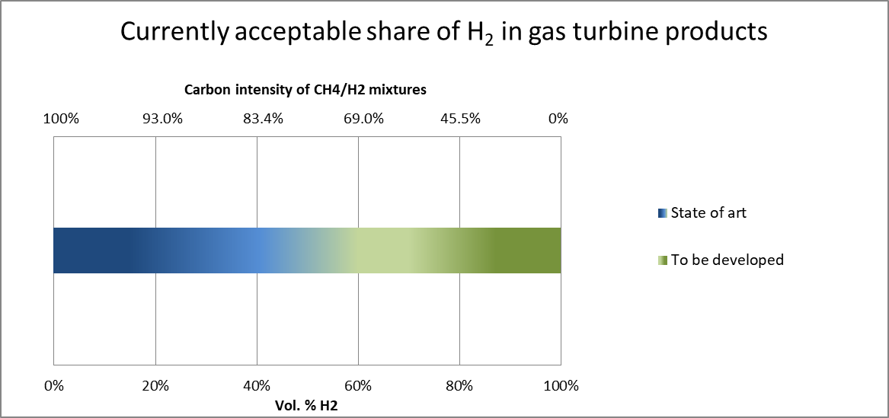

Figure 11 - Currently acceptable share of H2 in gas turbine products

## Ansaldo Energia

Ansaldo Energia currently offers the following hydrogen contents for its engine portfolio:

* 0-50% vol. H2 in natural gas for the GT36 H-class engine
* 0-30 or 0-45% vol. H2 in natural gas depending on the respective GT26 F-class engine rating
* up to 25% vol. H2 in natural gas for the AE94.3A F-class engine
* up to 35% vol. H2 in natural gas for GE 6B/7E/9E machines fitted with lean premixed combustors
* 0-40% vol. H2 for engine retrofits with FlameSheet combustor (available for existing GE, Siemens and MHI, E and F-class machines)

The advantage of the Ansaldo GT26 with reheat technology is an additional degree of freedom balancing the power of the two combustion chambers. A variation of flame temperature of the first burner is an effective parameter to maintain low NOx emissions as well as offsetting the impact of fuel reactivity on the auto-ignition delay time of the downstream reheat burner[28], [29]. Extensive single burner high pressure tests at full scale were performed for existing Ansaldo GT26 standard premix and reheat burners with 15 to 60% vol. H2 in natural gas. This confirmed that the latest rating (2011) can cope with contents of up to 30% vol. H2 with no changes in hardware and without performance penalty. With further validation and minimal de-rating, this limit can be extended to 45% vol. H2.

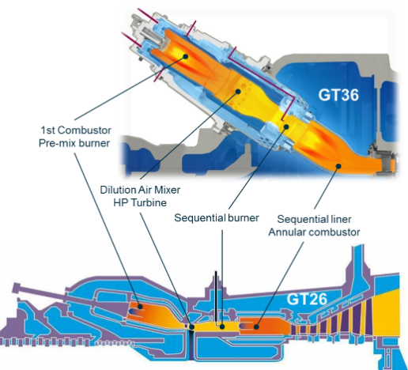

Figure 12 GT26 / GT36 layout.

This additional degree of freedom is exploited to and even larger extent in the Ansaldo Energia GT36. Since this can-annular engine does not have a high-pressure turbine separating the two combustors the system is referred to as Constant Pressure Sequential Combustion (CPSC). Due to this, no efficiency or power penalty is induced when lowering the temperature between the two combustion stages. The GT36 is today offered for commercial operation with hydrogen contents of up to 50% vol. Further validation is ongoing, including full scale, high pressure tests[30]. With the hardware as is, operation with up to 70% vol. was demonstrated feasible with minimal or no de-rating, without dilution or Selective Catalytic Reduction (SCR) needs. With further optimisation this level is expected to be further extended. Since the CPSC system is a can-combustor, retrofits to other can engines are in principle possible. Recently, Ansaldo Energia and Equinor announced a collaboration regarding a 100% H2 gas turbine combustor[31].

The AE94.3A acquired broad experience on H2 operation in a commercial power plant, operating with hydrogen in natural gas with concentrations up to 25% vol., cumulating several hundred thousands of Equivalent Operating Hours on two units at various hydrogen / natural gas blends.

A retrofit of 3x 9E gas turbines demonstrated the capability to consume H2 to 25% vol., with 35% vol. successfully tested with sub 9ppm NOx emissions. The combustor upgrade combined with automated tuning (AutoTune system) has demonstrated robust operation with varying natural gas / H2 mixtures over the past 2 years of commercial operations. The flexible operation with H2 waste gas from an adjacent chemical facility provides the additional benefit of reduced fuel costs and a reduced carbon footprint.

The “FlameSheet Combustor”[32], specifically developed and proven as a commercial solution for being retrofitted with low emissions and high fuel flexibility is available for commercial implementation in E & F-class GTs with H2capability of up to 40% vol.. Blending of H2 up to 80% vol. has been demonstrated on combustion rig tests. A Dutch government subsidised programme with several industry/academic partners is in progress to demonstrate 0-100% hydrogen capability with sub 9ppm NOx emissions in 2019/2020 in a combustion rig. The FlameSheet is already in commercial operation on seven F-class GE machines and is a simple retrofit for existing GE, Siemens and MHI, E and F-class machines.

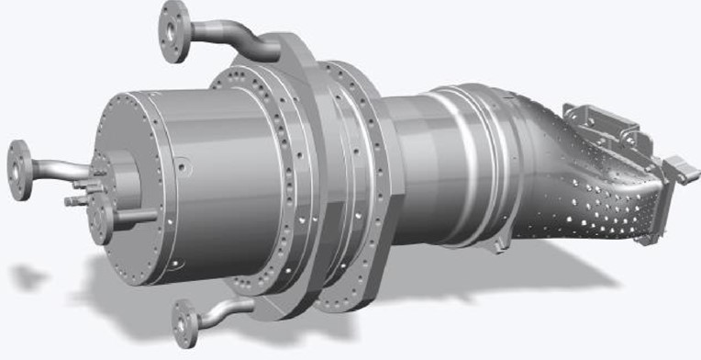

Figure 13 FlameSheet for E/F class GE, Siemens and MHI machines

## Baker Hughes

Baker Hughes reinforced its presence in the gas turbine market as an independent OEM in October 2019, after separation from General Electric as it reduced its ownership stake in BHGE below 50%. BHGE (formed in 2017 joining GE Oil & Gas and former Baker Hughes company), now renamed Baker Hughes, retains a wide and deep expertise in the field of gas turbines, leveraging decades of knowledge sharing and cooperation with other GE businesses, and inherited the ownership of GE heavy duty gas turbine portfolio in the power range below 40 MW. Collaboration with GE is granted by a joint venture to manage the aeroderivative fleet (approximate power range from 25 to 100 MW), while the recently introduced light industrial GT family (NovaLT) was designed and is currently developed by Baker Hughes to target the power range up to 20 MW with high efficiency, availability, flexibility and low cost of ownership.

The maximum allowable H2 concentration in lean premixed combustors varies significantly across the Baker Hughes gas turbine fleet, as different combustion technologies are employed. Fuels with significant hydrogen content are carefully evaluated, and the feasibility is assessed case by case considering the peculiarities of each specific project.

Standard and Lean Head End combustors (for heavy duty gas turbines) or Single Annular Combustors (SAC, for aeroderivative gas turbines) have been tested and employed in the past to burn very large hydrogen concentrations, with diluent injection for NOx emission abatement. 100% H2 capability was demonstrated on GE10-1 with steam injection at Enel combined cycle power plant in Fusina, Italy[33],[34].

As far as the application of lean premixed combustors is concerned, capabilities are consistent with limits specified for DLE and DLN1/DLN2 combustors as reported in the section devoted to General Electric.

Regarding the NovaLT family (see NovaLT-16 in Figure 1), the engines are equipped with piloted premixed burners arranged in annular combustors, capable to modulate the fuel split between pilot and premix lines along the operating range and based on fuel composition. This flexibility allows the engines to burn up to 100% H2, with variable fuel gas mixtures, with and without diluent injection, and with consequently variable NOx emission levels (demonstrated on Full Annular Rig; industrialisation ongoing for NovaLT-16).

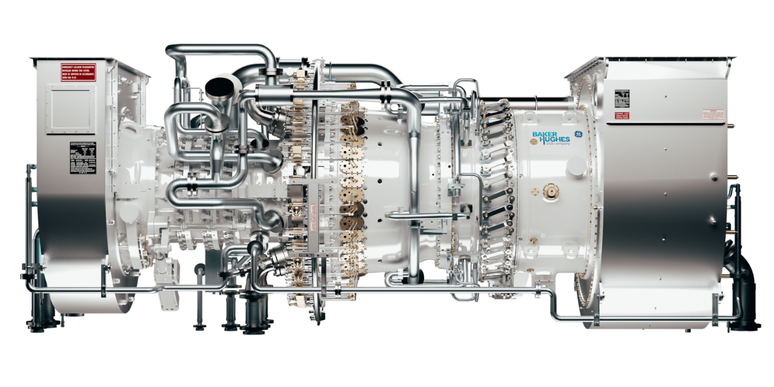

Figure 14 - Baker Hughes NovaLT-16 gas turbine

Baker Hughes has been working for several years on the development of novel burner technologies to allow the reliable application of lean premixed systems with hydrogen-rich fuels. An atmospheric rig test was performed in the past years at Enel laboratories (see Fig. 2) to identify the most promising technology for hydrogen lean premixed combustion.

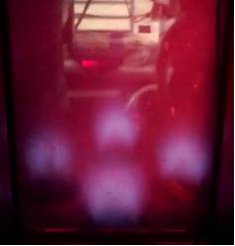

Figure 15 - 100% hydrogen combustion test of Baker Hughes experimental burner at Enel laboratories

Results[35] clearly indicate that the most mature solution consists of a cluster of partially premixed burners. This concept exhibited emissions consistent with the natural gas Best Available Techniques (BAT) and revealed to be strongly resistant to flashback, well above the nominal operating conditions, thus appearing promising for full scale arrangement design and experimental characterisation. A dedicated flame holding survey was also carried out to focus onto flame anchoring mechanisms more in details and delimit the intervention scope, providing weak points to be addressed to increase the flashback margin of the proposed solution.

## General Electric

In General Electric’s (GE) literature (see GEA33861[36] for a brief summary), particularly high values in terms of hydrogen concentration can be found in aeroderivative gas turbines, configured with single annular combustor (SAC) and also in single nozzle and multi-nozzle combustors applied to GE’s heavy-duty gas turbines in B, E and F class. Values up to 90-100% vol. are presented for diffusion combustion, hence needing significant amounts of dilution (steam or nitrogen) and NOx control with for example SCR.

GE’s DLE and DLN combustion systems are capable of operation with limited amounts of hydrogen in the fuel. The DLE combustor, which is found on GE’s aeroderivative gas turbines, is limited to 5% vol. hydrogen. The DLN1 combustion system, which is available on GE’s 6B, 7E, and 9E gas turbines, can operate with up to 33%vol. hydrogen when blended with natural gas.

GE’s DLN 2.6+ combustors go up to ~15% vol.. The associated fuel systems for these combustors are typically only configured for a maximum of 5% vol. hydrogen and would require upgrading to safely operate at higher hydrogen concentrations.

As part of the US Department of Energy’s Advanced IGCC/Hydrogen Gas Turbine programme, GE developed a low-NOx hydrogen combustion system based on small-scale jets in crossflow for rapid mixing of fuel with air streams (Multi-tube -mixer)[37].

Preliminary tests suggest up to 50%vol. H2 levels could potentially be reached.

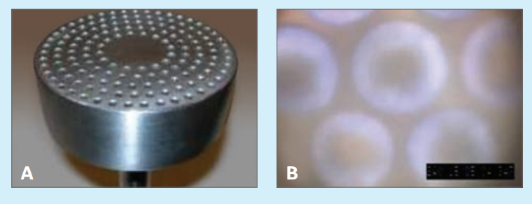

Figure 16 Multi-tube mixer (left panel) and its operation with a blend of H2 and N2 (right panel)

## MAN Energy Solutions

MAN Energy Solutions' current gas turbine portfolio covers the 6 and 12MW power range with two gas turbine families: the THM (9-12MW) and the MGT (6-9MW). MAN’s gas turbines include single-shaft and two-shaft machines, for power generation and mechanical drive applications.

The primary fuel for all gas turbines is natural gas, while liquid fuel and dual fuel capability is offered as an option. Fuel flexibility has been a design requirement from the beginning.

The THM gas turbines are available with a standard diffusion combustion system. This system allows up to 60% vol. H2 content in a mixture with natural gas, but requires exhaust gas treatment when low NOx emissions are a requirement.

Some THM models are also offered with a dry low emission combustion system designated Advanced Can Combustion (ACC). These systems achieve very low emissions without water injection or exhaust treatment, and can also handle up to 20% vol. hydrogen.

The MGT range of gas turbines is also equipped with the dry low emission combustion system ACC, which also allows up to 20% vol. hydrogen in a mixture with natural gas.

ACC systems for both THM and MGT gas turbines have been thoroughly tested in high pressure test facilities at DLR, Cologne. The full range of flows, pressures and temperatures has been covered without compromise. During those tests, fuel composition was varied as well, and proved that 20% vol. hydrogen was handled without any problems when minor modifications were applied to the system.

With some additional modifications, stable and low emission combustion was achieved even up to 50% vol. hydrogen.

Both the THM and the MGT range of gas turbines feature externally mounted can combustion systems. The THM has two combustors, while the MGT has six in a circumferential arrangement.

This arrangement has a number of benefits. Advanced, modified designs having greater fuel flexibility can easily be retrofitted to existing machines without disassembly of the core engine. In addition, extensive testing at a high pressure test facility is more easily carried out on a single can.

Theoretical and experimental studies have been carried out since 2010 in cooperation with DLR Stuttgart, in line with the target to reach 100% vol. hydrogen capability with low NOx emissions. These results contribute to ongoing H2 combustion developments.

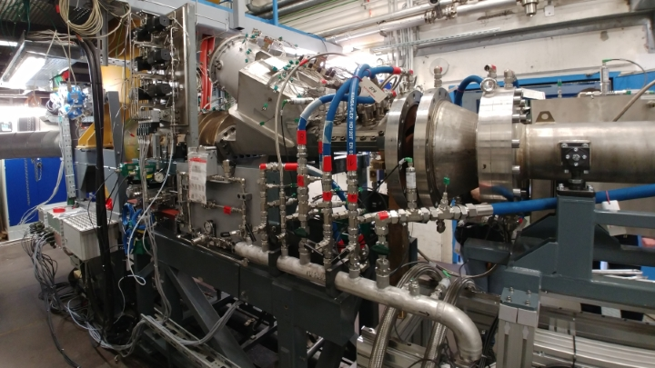

Figure 17 - MGT MAN Energy Solution High pressure test rig at DLR Cologne

## Mitsubishi Hitachi Power Systems

Mitsubishi Hitachi Power Systems (MHPS) has developed 3 types of combustors for hydrogen-fired gas turbines that can be used for the co-firing and firing of hydrogen.[38] Figure 18 provides an overview of these technologies.[39]

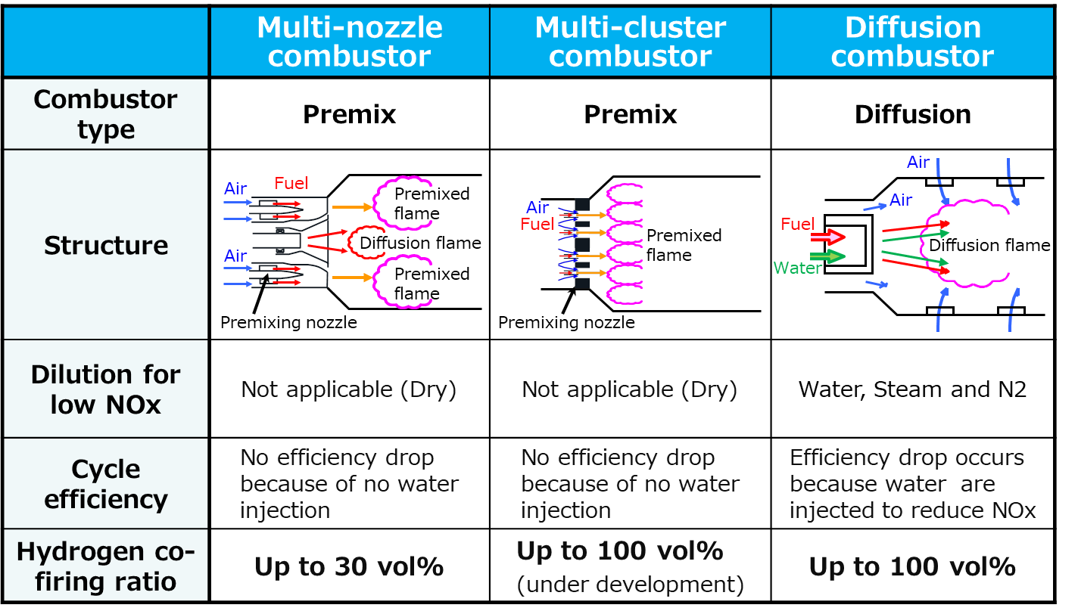

Figure 18 - Combustor types overview

**Multi-nozzle combustor**

The Dry Low NOx (DLN) multi-nozzle combustor is a newly developed combustor for hydrogen co-firing. It is based on conventional DLN combustor technology, with the aim of preventing flashback. The air supplied from the compressor to the inside of the combustor passes through a swirler and forms a swirling flow. Fuel is supplied from a small hole on the swirler’s wing surface and is mixed rapidly with the surrounding air thanks to the swirling flow effect. Combustion tests were performed successfully with a 30% vol. hydrogen mix in natural gas([40]) and achieved a 10% reduction in carbon dioxide emissions compared to a natural-gas-fired power plant. The tests were performed at firing conditions of J-Series gas turbines.

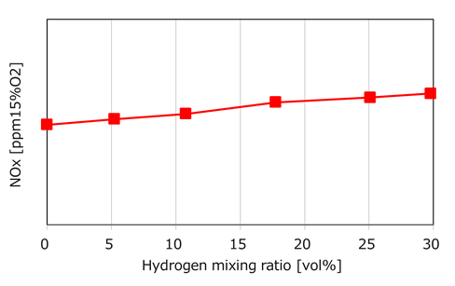

Figure 19 - NOx with respect to hydrogen mixing ratio

Having tested the 30%vol. hydrogen/natural gas mixture, the next stage is to reach up to 100% hydrogen, which will probably involve more development of the cluster combustor.

**Multi-cluster combustor**

The swirling flow used by hydrogen co-firing DLN combustor to mix fuel and air requires a relatively large space and increases the risk of flashback. Consequently, the mixing must be performed in a short time and in a narrow space.

The multi-cluster combustor is a promising alternative which uses a greater number of nozzles than the eight fuel supply nozzles of a DLN combustor. The mixing system devised by MHPS disperses the flame and blows out the fuel in smaller quantity and more finely. MHPS has adopted a system where the nozzle hole was made smaller, air is fed in, and hydrogen is blown in for mixing. With such solution, it is possible to mix air and hydrogen at a smaller scale without using swirling flow, which may allow compatibility to both high flashback resistance and low NOx combustion. Combustion characteristics with 80%vol. hydrogen co-firing have been confirmed at rig test.

**Diffusion combustor**

As energy companies turn to hydrogen, MHPS has extensive hydrogen firing experience that dates back nearly 50 years and includes refineries, syngas and COG locations. Our network of 31 power plants uses fuel with up to 90%vol. hydrogen content and has been in operation for more than 3 million hours with diffusion combustors.

A diffusion combustor injects fuel to air into the combustor. Compared with a premixed combustion method, a region with a high flame temperature is likely to be formed, increasing the amount of NOx generated and therefore requiring steam or water injection as a measure for reducing NOx emissions. On the other hand, the stable combustion range is relatively wide, and the allowable fluctuation range of fuel property is also large.

## Siemens

New Siemens gas turbines are available with different levels of hydrogen admixing capability, depending on the type:

* Aero-engines up to 100% vol. H2 in diffusion combustion mode with NOx abatement using water. With DLE technology, up to 15% vol. H2 are possible for the A65 and A35.
* Utility gas turbines with up to 30% vol. hydrogen admixtures in DLE
* Medium-size industrial gas turbines (SGT-600 to SGT-800) with admixtures of up to 60% vol. H2
* Small industrial turbines SGT-100 and SGT-300 with up to 30% vol. and SGT-400 with up to 10% vol.. Choosing diffusion technology with unabated NOx will increase the admixture capability up to 65% vol. H2.

The specific capability of admixing hydrogen in an existing gas turbine always needs to be checked for each site individually, as the specific installed hardware and plant setup might differ based on age and local conditions. To reach the same abovementioned values as for new apparatus, upgrades to the control system and the hardware might be needed and are available for many GT types.

For example, for Siemens Gas Turbines 2000E and 4000F the standard Upgrade package “H2DeCarb” for higher H2 contents is available. The 2000E upgraded with the “H2DeCarb” package machines can operate with up to 30% vol. H2 admixture. For the 4000F an upgrade up to 15% vol. H2 admixture is possible.

The standard capability for industrial gas turbines reaches up to 10% vol. H2 in existing packages, depending on the actual package generation design, and up to 15% vol. H2 standard for new units. On existing sites, an analysis needs to be conducted to assess the need for components exchange to allow higher share of hydrogen in the fuel. Today’s Industrial Gas Turbines with 3rd generation DLE system (standard for all delivered SGT-700 and SGT-800 and option for SGT-600) have a high capabilities to burn hydrogen, with levels up to 50-70% vol. H2.

Aeroderivatives gas turbines, equipped with Wet Low Emissions (WLE) system usually reach high hydrogen share capabilities. However, similar per-site assessment by Siemens should always be conducted, to clarify if service overhaul times would be affected by higher concentrations than already guaranteed.

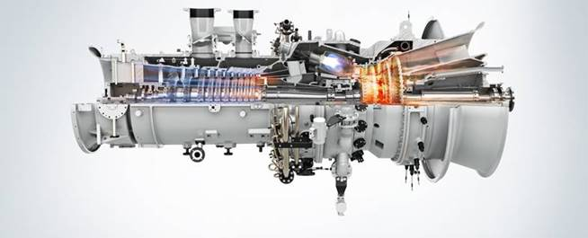

Figure 20 - Siemens SGT-600

## Solar Turbines

Solar Turbines has gathered experience with many applications operating with significant concentrations of hydrogen. In the past decade many of these have been using Coke Oven Gas (COG) on TitanTM 130 and TaurusTM 60 generator sets. COG is a typically waste gas generated in the process of creating coke for steel production. The typical gas turbine fuel created with COG has 55 to 60% vol. hydrogen, 25 to 30% vol. methane, 5 to 10% vol. CO, and 5 to 10% vol. diluents (N2+CO2).

Most of the applications have been in China where over 40 gas turbine packages have been installed. A Titan 130 installation is included in Figure 12. These units have operated with few problems and cumulatively have operated for more than 1.4 million operating hours. Many of these units have gone through multiple overhaul cycles. Where issues have occurred, the root cause was determined to be fuel and air contaminants unique to these applications. Once the appropriate filtration was installed, these units have operated without incident.

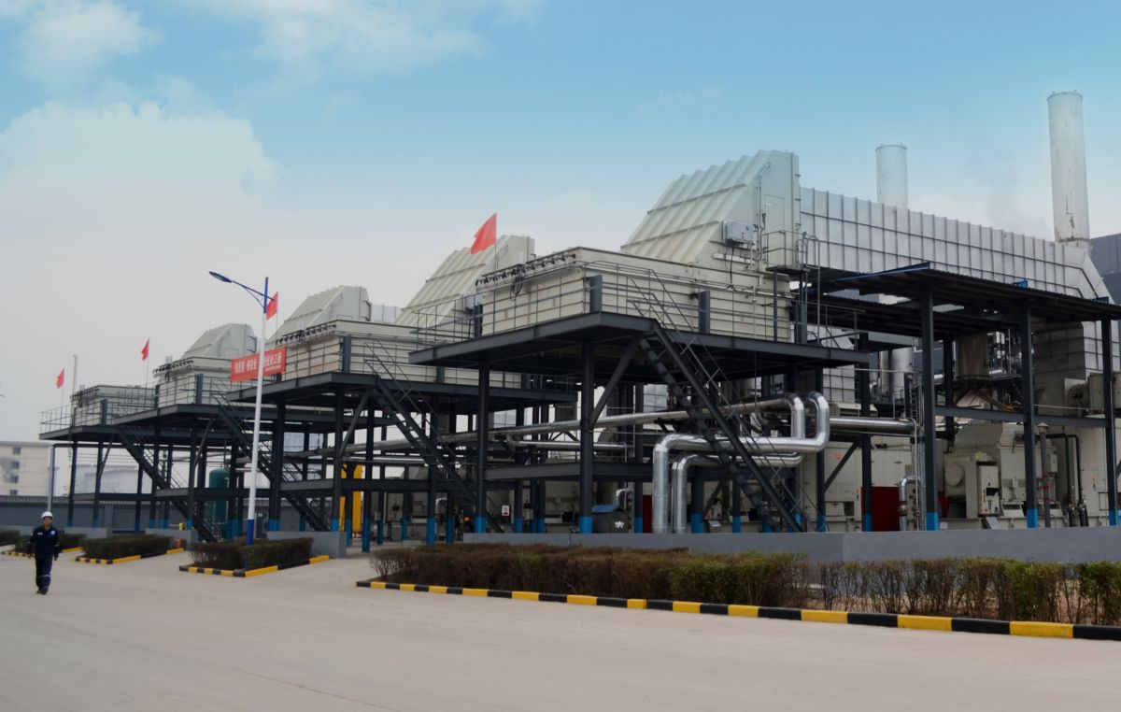

Figure 21 - Titan 130 conventional combustion gas turbine packages operating with COG

The initial assessment at Solar Turbines is that using existing SoLoNOx gas turbines with the latest combustion system technology with pipeline gas mixed with 5 to 20% vol. hydrogen will not require significant modification. The ability of earlier generations of SoLoNOx combustion systems to use these levels of hydrogen is under investigation. The impacts on the combustion system and the gas turbine package are of primary consideration.

In contrast to the diffusion flames combustion packages, SoLoNOx gas turbine packages operating on hydrogen have only recently started to expand. It is worth noting that SoLoNOx experience with associated and raw natural gases has become very extensive. These gases are quite comparable, in the range of flame speed and flame temperature, which result from hydrogen mixed with natural gas in the range of 5 to 20% vol..

Direct experience on the SoLoNOx platform is currently limited to a refinery generator set application where a Titan 130S has operated with natural gas mixed with up to 9% vol. hydrogen. Qualification and combustor performance mapping were completed and the unit demonstrated 15 ppm and no operational issues. The unit was started on 100% natural gas and the package was updated to be compliant with the requirements for applications greater than 4% vol. H2. However, due to customer requirements, the operating time accumulated with the 9% vol. hydrogen fuel mix has been brief.

Package shipments to customers with high and medium Wobbe Index associated and raw natural gases are much more extensive. These units have few modifications from the standard configurations supporting operation on pipeline gas. The earliest shipments have been in operation for multiple years with many of these packages reaching the standard overhaul operating hour interval. Typically, these SoLoNOx engines run on associated gases in much the same way as they operate on pipeline natural gas. As indicated earlier on the applications with fuels with higher adiabatic flame temperatures the NOx emissions are slightly higher. As with all DLE gas turbines, fuel quality with adequate fuel treatment is a pre-requisite for trouble free operation.

**Conclusions**

Hydrogen as a future energy vector will redefine the role of gas turbines in a carbon neutral energy scenario. Being a highly efficient, well-established and versatile technology, gas turbine systems can facilitate the smooth transition towards a decarbonised future by limiting the high capital costs associated with a strongly electrified future energy system. In the short term already existing assets and infrastructure can be used with adapted gas turbine technology to drastically reduce the carbon footprint of power generation as well as of the oil & gas industry.

To fully unlock the potential of zero-emission hydrogen gas turbine technology in a future energy landscape, cooperation between manufacturers, end-users and academia will be essential in order to raise the Technology Readiness Level (TRL) up to demonstration level. Research and development activities are specifically needed to overcome combustion instabilities and to further develop (premixed) combustion technologies maintaining low NOx emission for up to 100% H2. Changes in the hot gas properties for hydrogen combustion also require development of new materials and cooling technologies for hot gas path components.

The deployment of new technology in a real world environment will be another challenge to be overcome in the demonstration phase. Future gas turbines will have to deal with a wide range of variable hydrogen/natural gas mixtures while being operationally flexible in order to stabilise the grid frequency fluctuations. Appropriate demonstration projects are required throughout Europe in order to verify the feasibility of new system solutions faced with different local/regional boundary conditions. The retrofit of existing gas turbines needs to be evaluated on a case to case basis for given hydrogen levels in the public pipeline network, considering modifications in the fuel skid, and in the controls and combustion system.

Capital expenditures associated with retrofit solutions for gas turbines power plants have to be met by market conditions favourable for the wide-spread introduction of the technology. Regulatory measures should ensure a level playing field for all technology providers.

1. IEA, „Energy Technoloy Perspectives 2017“, 2017.
2. Sandbag and Agora Energiewende, [<https://sandbag.org.uk/wp-content/uploads/2019/01/The-European-Power-Sector-in-2018-1.pdf>], Accessed November 4, 2019.
3. Durzaam Ameland, [<http://www.duurzaamameland.nl/projecten/#waterstof>]. Accessed November 4, 2019.
4. IEA, „The Future of Hydrogen – Seizing today’s opportuniteis“, June 2019.
5. U.S. Department of Energy, [<https://www.energy.gov/eere/fuelcells/hydrogen-production-natural-gas-reforming>], Accessed November 4, 2019
6. Danish Energy Agency, Energinet (2018), Technology Data for Renewable Fuels – February 2019 update.
7. A. Buttler, H. Spliethoff, 2018, Current status of water electrolysis for energy storage, grid balancing and sector coupling via power-to-gas and power-to-liquids: A review”, Renewable and Sustainable Energy Reviews Vol. 82, pp. 2440-2454
8. M.E. Demir, I. Dincer, 2018, Cost assessment and evaluation of various hydrogen delivery scenarios,International Journal of Hydrogen Energy Vol. 43, pp. 10420 – 10430.
9. A. T. Wijayanata et. al., 2019, Liquid hydrogen, methylcyclohexane and ammonia as potential storage: Comparison review,International Journal of Hydrogen Energy Vol. 44, pp. 15026 – 15044.
10. Aakko-Saksa et. al., 2018, Liquid organic hydrogen carriers for transportation and storing of renewable energy. Journal of Power Sources Vol. 396, pp. 803 – 823.
11. Niermann et. al., 2019, Liquid Organic hydrogen Carrier (LOHC) – Assessment based on chemical and economic properties, International Journal of Hydrogen Energy Vol. 44, pp. 6631-6654.
12. Kraftwerk Forschunghttps, [kraftwerkforschung.info/en/hydrogen-gas-turbines/], Accessed November 4, 2019.
13. Morris, S., 2013, Cardiff University Progress Report July 2013, FP7 H2-IGCC Project.
14. Jansohn, P, Lin, YC., 2013, Results of turbulent flame speed for H2-rich and syngas fuel mixtures measured, FP7 H2-IGCC Project.
15. Runyon, J, Marsh, R, Pugh, D, Bowen, P, Giles, A, Morris, S, and Valera-Medina, A., 2017, Experimental Analysis of Confinement and Swirl Effects on Premixed CH4-H2 Flame Behavior in a Pressurized Generic Swirl Burner. Proceedings of the ASME Turbo Expo 2017: Turbomachinery Technical Conference and Exposition, GT2017-64794.
16. Karlis, E, Liu, Y, Hardalupas, Y, Taylor, A., 2019, H2 enrichment of CH4 blends in lean premixed gas turbine combustion: An experimental study on effects on flame shape and thermoacoustic oscillation dynamics, Fuel, 254: 11524.
17. Runyon, J, Pugh, D, Bowen, P, Marsh, R, Giles, A, Morris, S., 2018, Experimental and Numerical Evaluation of Pressurized, Lean Hydrogen-Air Flame Stability with Carbon Dioxide Diluent, 37th International Combustion Symposium.
18. NS Energy, [www.nsenergybusiness.com/projects/nuon-magnum-power-plant/], Accessed November 4, 2019
19. Ross, K., 2019, Verbund in landmark project to run gas plant on hydrogen, Power Engineering International
20. ENABLing cryogEnic Hydrogen based CO2 free air transport (ENABLEH2), [cordis.europa.eu/project/rcn/216008/factsheet/en], Accessed November 4 2019.
21. Dennis, R., 2016, University Turbine Systems Research Project Review Meeting, [www.netl.doe.gov/sites/default/files/event-proceedings/2016/utsr/Tuesday/Rich-Dennis-Overview.pdf], Accessed November 4 2019.
22. Ohira, E., 2019, Japan Policy and Activity on Hydrogen Energy, [www.nedo.go.jp/content/100890039.pdf], Accessed November 4 2019
23. Griebel, P., 2016, Hydrogen Science and Engineering – Material, Processes, Systems and Technology, Detlef Stolten, Bernd Emonts, Vol. 2, p. 1011-1032, Wiley.
24. Goy, C.J., James, S.R., Rea, S., 2005, Monitoring combustion instabilities: E.ON UK’s experience, Lieuwen 2005: pp. 163-175.
25. Griebel, P., 2018, Hydrogen in Gas Turbine Combustion Systems: Challenges and Opportunities, TOTeM 45 „Gas Turbines for Future Energy Systems”.
26. A. Keçebaş, M. Kayfeci (2019), "Hydrogen properties", in *Solar Hydrogen Production*.
27. <https://hynet.co.uk/>
28. Wind, T., Güthe, F., Syed, K., 2014, Co-Firing of Hydrogen and Natural Gases in Lean Premixed Conventional and Reheat Burners (Alstom GT26), Proceedings of ASME Turbo Expo 2014, GT2014-25813
29. Bothien, M. R., Ciani, A., Wood, J. P., Fruechtel, G., 2019, Sequential combustion in gas turbines – the key technology for burning high hydrogen contents with low emissions, ASME Turbo Expo 2019, GT2019-90798.
30. Ciani, A., Bothien, M. R., Bunkute, B., Wood, J. P., and Früchtel, G., 2019, Superior fuel and operational flexibility of sequential combustion in Ansaldo Energia gas turbines, Proceedings of Global Power and Propulsion Society - Technical Conference 2019, GPPS-TC-2019-0032.
31. Ansaldo Energia: https://www.ansaldoenergia.com/Pages/Ansaldo-Energia-and-Equinor-collaborate-on-validation-of-100-hydrogen-gas-turbine-combustor.aspx.
32. Stuttaford P.J., Rizkalla, H., Chen Y., Copely B., Faucett T., 2010, Extended Turndown, Fuel Flexible Gas Turbine Combustion System, Proceedings of ASME Turbo Expo, GT2010-22585
33. S. Cocchi, M. Provenzale, V. Cinti, L. Carrai, S. Sigali and D. Cappetti, 2008, Experimental Characterization of a Hydrogen Fueled Combustor With Reduced NOx Emissions for a 10 MW Class Gas Turbine, Proceedings of ASME Turbo Expo, GT2008-51271
34. S. Cocchi and S. Sigali, 2010, Development of a Low NOx Hydrogen Fuelled Combustor for 10 MW Class Gas Turbines, Proceedings of ASME Turbo Expo, GT2010-23348
35. M. Cerutti, S. Cocchi, R. Modi, S. Sigali and G. Bruti, 2014, Hydrogen Fueled Dry Low NOx Gas Turbine Combustor Conceptual Design, Proceedings of ASME Turbo Expo, GT2014-26136
36. Goldmeer, J., 2018, Power to gas: hydrogen for power generation, Electrify Europe, GEA33861
37. York, W., Ziminsky, W., and Yilmaz, E., 2013, Development and Testing of a Low NOx Hydrogen Combustion System for Heavy-Duty Gas Turbines, Journal of Engineering for Gas Turbines and Power, ASME, vol. 135.
38. MHPS, [https://www.mhps.com/catalogue/pdf/mhps_hydrogen_en.pdf], Accessed November 4 2019
39. Inoue, K., Miyamoto, K., Domen, S., Tamura, I., Kawakami, T., Tanimura, S., 2018, Development of hydrogen and natural gas co-firing gas turbine, Mitsubishi Heavy Industries Technical Review Vol. 55 No. 2
40. Mitsubishi Hitachi Power Systems, 2018, news “MHPS Successfully Tests Large-scale High-efficiency Gas Turbine Fueled by 30% Hydrogen Mix”