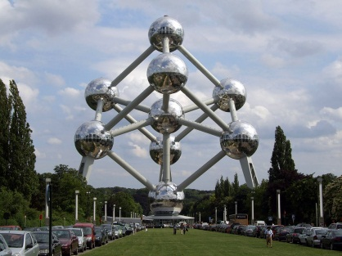Air Filtration Meeting

Agenda

25-26 September 2018,

ETN office, Chaussée de Charleroi 146, 1060, Brussels

|  |  |
| --- | --- |
| **25 September 2018, ETN office, Chaussée de Charleroi 146, 1060, Brussels** | |
| **8:45 – 9:00** | **Welcome coffee** |
| 9:00 - 10:45 | 1. Welcome and Introduction 2. Presentation of the ETN Water/Salt test procedure related to the ISO 29461 – Part 5   (O. Brekke)   1. Test activities at W.L. Gore’s lab (M. Endrulat) 2. Test activities at Camfil’s lab (R. Ringström) 3. Outcomes of the ISO/TC 142 Meeting in Beijng (S. Taylor) |
| **10:45 – 11:00** | **Coffee Break** |
| 11:00 – 12:45 | 1. Review of the comments on the ETN Water/Salt test procedure |
| **12:45 – 13:45** | **Lunch** |
| 13:45 – 15:30 | 1. Review of the comments on the ETN Water/Salt test procedure |
| **15:30 – 15:45** | **Coffee Break** |
| 15:45 – 17:30 | 1. Review of the comments on the ETN Water/Salt test procedure |
| **17:30** | **End of the meeting** |

|  |  |
| --- | --- |
| **26 September 2018, ETN office, Chaussée de Charleroi 146, 1060, Brussels** | |
| **8:15 – 8:30** | **Welcome coffee** |
| 8:30 - 10:15 | 1. Review of the comments on the ETN Water/Salt test procedure |
| **10:15 – 10:30** | **Coffee Break** |
| 10:30 – 12:00 | 1. Review of the comments on the ETN Water/Salt test procedure |
| **12:00 – 13:00** | **Lunch** |
| 13:00 – 14:30 | 1. Review of the comments on the ETN Water/Salt test procedure 2. Conclusions and next steps |
| **14:30** | **End of the meeting** |

|  |  |  |
| --- | --- | --- |
| **Name** | **Organisation** | **Title** |
| Paul Jackson | AAF |  |
| Marco Tappani | Ansaldo Energia | R&D Secondary Air System Team Leader |
| Giorgio Marchetti | BHGE - Baker Hughes, a GE company | Engineering Manager |
| Daniel Iggander | Camfil | Project Technician |
| Richard Ringstrom | Camfil | Product Manager |
| Wim Van Gelder | Donaldson | Principal Engineer |
| Andrew Thomson | EMW Filtertechnik GmbH | Key Account Manager |
| Achim Breidenbach | EMW Filtertechnik GmbH | Filtration Specialist R & D |
| Arnaud Lambert | ENGIE | GT expert |
| Valentin Moens | European Turbine Network | Technical Project Officer |
| Ugo SImeoni | European Turbine Network | Research & Innovation Manager |
| Gianluca de Arcangelis | Faist Anlagenbau | Air Filtration Authority |
| Matthias Eber | Fiatec Filter & Aerosol Technologie | Managing Director |
| Mike Garnett | Freudenberg Filtration Technologies | Market Manager |
| Scott Taylor | ISO TC 142 |  |
| Carlo Coltri | Mann+Hummel | Marketing Manager |
| Martin Östemar | Siemens | Advisory key expert, Gas Turbine packaging and auxiliaries |
| Olaf Brekke | Statoil | Leading Advisor Upstream Rotating Equipment |
| Dominique Orhon | Total | Turbomachinery Specialist |
| Mark Endrulat | W.L. Gore & Associates | Product Manager |
|  |  |  |
|  |  |  |