**Introduction of water/salt test procedure for ETN Air filtration Working Group**

**Gas Turbine / Compressor Air Inlet Filter Systems**

**Definition: Most air filters are affected by salt / water spray are located on Offshore platforms, FPSO or coastal sites (defined <10km) from the Sea.**

**3rd draft for comment.**

**Date: 6th July 2018**

**To be added:**

**See review note for draft 1-8**

Contents

Foreword 4

Introduction 5

Terms and definitions 6

1. Scope 6

2. Description of test method 6

3. Test apparatus 7

3.1. General 7

3.2. Test duct 7

3.2.1. Test rig layout 7

3.2.2. Test air conditioning 7

3.2.3. Adjustment of the volume flow rate 8

3.2.4. Measurement of the volume flow rate 8

3.2.5. Measuring points for pressure drop 8

3.2.6. Aerosol mixing section 8

3.2.7. Test filter mounting assembly 9

3.3. Measurement equipment 9

3.4. Aerosol generation 10

3.4.1. Salt concentration 10

3.5. Water injection system 10

3.6. Equipment used during trials 10

3.7. Water collection 10

4. Test method for single filter or multi-stage system 10

4.1. Test rig and equipment 10

4.1.1. Test conditions 10

4.1.2. Test rig 11

4.2. Test method 12

4.2.1. Idea 12

4.2.2. Preparatory checks 12

4.2.3. Starting up the aerosol generator 13

4.2.4. Installation of the test filter 13

4.2.5. Flushing the test filter 13

4.2.6. Measurements to be made 13

4.3. Test cycle 14

5. Report 15

APPENDIX A – Mk. II Prototype salt generator 15

APPENDIX B - Equipment used during trials 15

APPENDIX C – Test duct configure for testing of single filter element. 16

APPENDIX D - Test duct configuration for testing of complete system 17

# Foreword

The ventilation and combustion air system usually consists of a filter house structure, silencers, fans, and associated ductwork. The filter house is comprised of weather hoods, droplet vanes or similar, air filter elements, optional chiller or anti-icing coils, and plenum chamber assembly. Air from the plenum assembly is ducted to the turbine engine intake for combustion and sometimes to the turbine and generator compartments for cooling and ventilation.

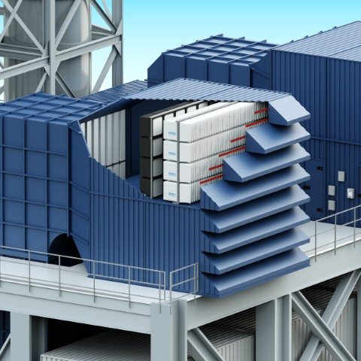 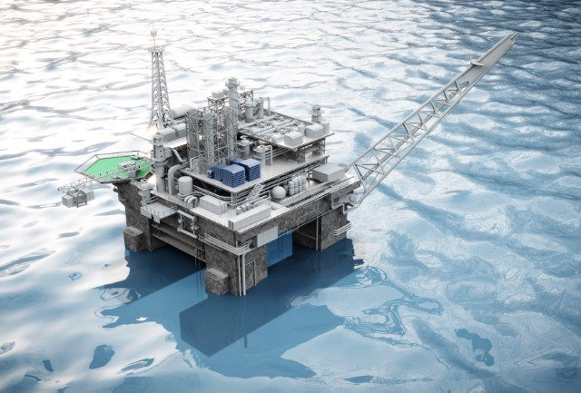

High Efficiency Particulate Air filters ((H)EPA) filters static filters can be fitted behind pulse filters to optimize the air cleanliness for the compressor (or act as a secondary barrier filter especially in areas of high hydrocarbons particles).

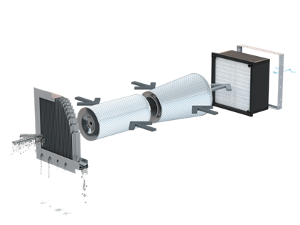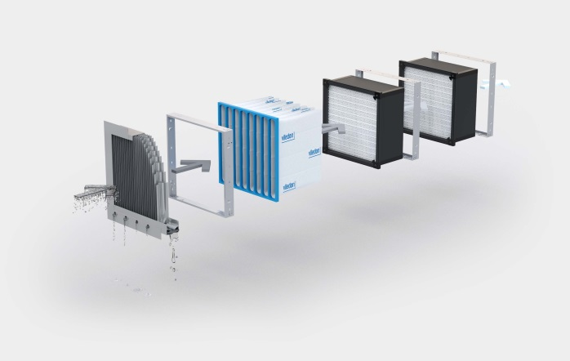

# Introduction

The use of gas turbines in the oil & gas industry represents one of the most challenging applications for this engine technology. The major constraint of the oil & gas business is to run 24/7 at full load with minimum downtime. In oil & gas activity, it is of prime importance to run the installation as close as possible to 100% of the time with the highest level of efficiency (current production compared to nominal production).

An additional challenge for oil & gas applications lies in the absence of a back-up on site especially for mechanical-drive gas turbine configurations.

To complete the picture, the coastal and offshore environment probably represents the harshest conditions for gas turbines. Humidity, rainfall and wind dust are the most obvious visible conditions that operators face on site. Hidden in the combustion air, alkali such as potassium, sodium or magnesium, as well as sulfur, soot, volatile hydrocarbons, oily vapors, and particles all generate gas turbine issues including compressor fouling, air-cooling passage fouling, vane and blade erosion, and compressor corrosion. Combined with sulfur in fuels, these alkali in combustion air create hot corrosion. Finally, heavy rainfall may induce filter washings that release filtered particles into the compressor. All these phenomena impact the gas turbine availability on site. An operating company aiming for excellence has to strive to minimize lack of availability and performance deterioration in order to make the asset more energy efficient and profitable.

The role of a highly efficient air filtration system is to maintain the engine cleanliness by preventing the introduction of contaminants into the gas turbine air intake. Achieving a high level of engine cleanliness helps maintain engine integrity and efficiency and reduces the need for water washes which generate avoidable downtime. Consequently, this reduces OPEX by minimizing the requirement for onsite maintenance and overhaul.

Currently, high efficiency filter elements are characterized by a limited number of parameters, namely filter efficiency and MPPS (Most Penetrating Particle Size, ISO 1822). These parameters, related to a single filter element, are measured in laboratory conditions close to favorable inland conditions with synthetic dust. Consequently, these conditions are far from the reality observed on site, offshore or near coast, where filter elements are usually part of a system. The test results do not therefore provide a basis for predicting either operational filter performance or service life.

The objective of ISO 29461 - Part 5 is to close the gap between the current filter element characterization conditions and the site environment. As a first criterion, the standard considers the effect of humidity and alkali such as salt changing its structure with humidity. The tested air flow passing through the filter element is close to the air flow operated on site for the three different concepts: low, medium or high velocity filter elements.

Soot, volatile hydrocarbons, oily vapors and particles also have impact on filter characterization. Particles are covered in separate parts of ISO 29461, while soot, volatile hydrocarbons and oily vapors will have to be addressed in future revisions of ISO 29461 – Part 5. The work on the current revision has revealed that current test methods are not mature enough for inclusion of soot, volatile hydrocarbons and oily vapors.

The ageing of a filter element installed offshore and near coast is addressed to allow the prediction of operational filter performance and its associated service life. It is of paramount importance to understand how filter elements perform during different cycles representing typical site conditions such as heavy rainfall, low and high humidity, filter element unloaded and loaded. In addition, these test outcomes allow a true comparison of the three different concepts and the different brands.

Depending on the gas turbine applications, the service life of the filter element is also a criterion to take into consideration. A minimum service life of 3 years is required, especially for LNG applications. In this case the robustness, loading capacity and pressure drop characteristics of the filter elements become key parameters for design and testing.

Finally, how to test and measure the performance of a complete intake air filter system (series of different filter elements, vane separators, etc.) against the offshore and coastal harsh conditions is addressed through ISO 29461 - Part 5.

# Terms and definitions

*Review note for draft 1: To be added*

# Scope

The scope of this procedure includes methods for performance testing of individual filter elements (M5-EPA) and of the complete filtration system. This procedure is intended for filter elements and filter systems which operating at flow rated up to 8000 m3/h.

# Description of test method

Air intake filters in marine and offshore installations are almost constantly exposed to high humidity, wet foggy conditions and sea water spray containing mainly NaCl salt.

Salt ingestion into the gas turbine can cause either or a combination of erosion, fouling and corrosion depending on amounts. Hot corrosion may also occur.

Within the GT industry differential pressure (dP) is the most common way to indicate end of life of air filter elements. Often salt breach and salt related damages can be experienced even without the air intake differential pressure showing any significantly high or increasing dP values. This depends both on system design and air filter selection.

When testing in lab conditions, most conditions i.e. salt and dust load must be accelerated to be practical. The acceleration compared to real life must be done without creating a new failure mechanism.

The following test method is designed to challenge the air intake test object (the test object could be a complete system, a single filter or a multi-stage filter system) with sub-micron salt to ensure that the fiber structure is challenged deep within the filter and not only on the surface. This allows simulation of salt loading, and the cycling of relative humidity allows simulation of aging because the salt particulates will transform from dry to liquid phase. In real life the filters are exposed to both sub-micron and larger salt particles and water droplets.

**Main “failure” modes – weaknesses to detect using this test procedure/method:**

1. **Bypass of salt and water through not properly sealed construction.**

*Example: To little glue between frame parts causing leakage.*

1. **Bypass of salt and water through the filter media.**

*Example: Construction is sealed good, but the filter media has poor water repellency causing leaks through media.*

1. **Bypass of dry salt through filter.**

*Example: Low particle filtration efficiency, not suitable as final filter.*

1. **High dP spikes** (i.e. passing 600 Pa or similar pre-set value) during in more than 3 subsequent cycles or whenever passing 1000 Pa.

**Observations to be made during test**

1. Media bulging
2. Filter breaking
3. Pleat deformations
4. Water penetration

**Challenges**

Small leakages are hard to detect by instrumentation. Regardless of the slope on the test duct floor, it takes a certain volume to flow to a low collection point. Can be solved by collecting the water using a sponge of known weight and weighing the sponge again after collecting the water in it.

# Test apparatus

## General

At this point in the draft we are not able to describe everything to the point were its possible to just order and build a test rig according to what is described in this document. The goal as time progresses is of course to do further testing and add levels of detail until that is the case. For now we have chosen to simple list the equipment that we’ve used so far in our trials.

## Test duct

### Test rig layout

The test rig (see Figure 3) consists of several duct sections (may be rectangular or square) with a typical 650mm x 650mm (25.6” x 25.6”) nominal inner dimensions. If different, cross section dimensions to be stated in the report. The section where the test filter is installed is to be representative of the cross-sectional area and geometry for a single filter within the proposed offshore inlet system.

In case of circular cartridges, the test setup (mounting of the filters in the test duct) shall be as close to the real application as possible. This must however be analysed specifically for each construction, taking into consideration possible jetting effect that can affect the velocity and aerosol concentration in the test duct cross section.

The test rig is operated in a negative pressure airflow arrangement, which represents the typical air flow condition for a gas turbine. A positive pressure arrangement is not typically encountered in gas turbine air inlet systems.

### Test air conditioning

A higher efficiency HEPA class filter (than the tested filter element) shall be placed in the loop to ensure

high quality air is entering in the measurement area.

Depending on numerus external factors such as the ambient relative humidity of the test lab etc. additional equipment might need to installed in the test rig in order to adjust the conditions of the test air to within specification (see section 4.1.1)

### Adjustment of the volume flow rate

Filters shall always be tested at by one of the three default airflows or by customer specific airflow. It shall be possible to adjust the volume flow rate by means of a suitable provision (e.g. by changing the speed of the fan, or with dampers) to a value ± 5 % of the nominal flow rate which shall then remain constant within ± 5 % throughout each test.

**Default airflows:**

Depending on the intended use of the filter, choose a corresponding airflow for the test to be run at. Airflows as follows:

1. **Nominal airflow**

4250 m3/h

1. **Increased airflow**

6000 m3/h

1. **High Velocity**

8000 m3/h

*Review note for draft 2: Current testing has been done at 4250m3/h, it is unknown what effects there would be when using higher than nominal airflow. To be tested.*

### Measurement of the volume flow rate

The volume flow rate shall be measured using a standardized or calibrated method (e.g. measurement of the differential pressure using standardized equipment such as orifice plates, venturi tubes etc.)

### Measuring points for pressure drop

The measuring points for pressure drop shall be so arranged that the mean value of the static pressure in

the flow upstream and downstream of the filter can be measured. The planes of the pressure

measurements upstream and downstream shall be positioned in regions of an even flow with a uniform

flow profile.

In rectangular or square test ducts, smooth holes with a diameter of 1 mm to 2 mm for the pressure

measurements shall be bored in the middle three of the channel walls, the hole in the floor should be left out as there is a high risk of that hole clogging with water and/or salt. The holes should be bored normal to the direction of flow. The three holes shall be interconnected with a circular pipe/tube.

### **Aerosol mixing section**

The aerosol input and the mixing section shall be so constructed that the aerosol concentration measured at individual points of the duct cross section, directly in front of the test filter, shall not deviate by more than 15 % from the mean value of at least 9 measuring points, over the channel cross section.

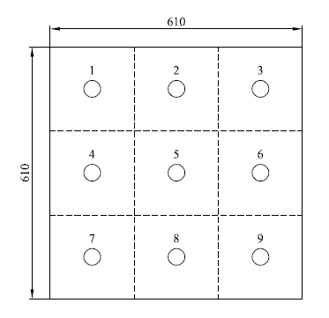

**Figure 1. Test points for aerosol uniformity testing.**

### **Test filter mounting assembly**

*Review note for draft 3: Too be included in final version.*

## Measurement equipment

**Rig test typical instrumentation:**

* Pressure transducers for measuring atm. pressure as well as pressure drop over filters, droplet separators etc. Also using an orifice for flow measurement.
* Humidity sensors.
* Thermocouple

**Flame Photometer:**

When a solution of metallic salt is sprayed as fine droplets into a flame. Due to the heat of the flame, the droplets dry leaving a fine residue of salt. This fine residue converts into neutral atoms.

Due to the thermal energy of the flame, the atoms get excited and after that return to ground state. In this process of return to ground state, excited atoms emit radiation of specific wavelength. This wavelength of radiation emitted is specific for every element.

This specificity of the wavelength of light emitted makes it a qualitative aspect. While the intensity of radiation depends on the concentration of element. This makes it a quantitative aspect.

Elements of Group IA and Group IIA (like Li, Na, K & Ca, Mg) are only analyzed.

The radiation emitted in the process is of a specific wavelength. Like for Sodium (Na) 589nm radiation, Potassium 767nm range radiation.

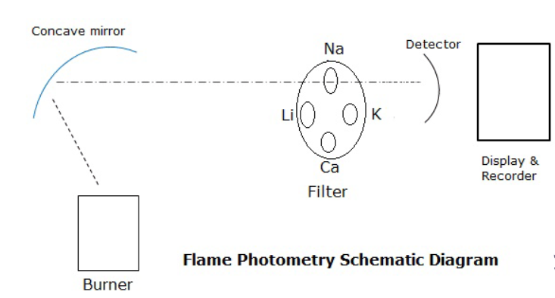

**Figure 2. Flame Photometry Schematic Diagram**

**SMPS & CPC:**

Please refer to EN1822-2:2011.

## Aerosol generation

*Review note for draft 4: Salt generator – see APPENDIX A “Mk. II Prototype salt generator”*

### Salt concentration

*Review note for draft 5: To be defined*

## Water injection system

*Review note for draft 6: Too be specified in more detail at a later stage. For now please refer to section 3.6 to see what equipment we used (Camfil and Gore).*

## Equipment used during trials

*Review note for draft 7: See APPENDIX B “Equipment used during trials”*

## Water collection

The collection basins connected to the drains shall be built and configured in such a way that they can be closed off from the rig and removed while keeping the rig free from leaks (i.e by using ball valves). They should also have ventilation that is connected back to the test rig to ensure free flow of water into the basins.

# Test method for single filter or multi-stage system

## Test rig and equipment

### Test conditions

Room air or outdoor air may be used as the test air source. The air temperature shall be in the range of 10 °C to 45 °C. The exhaust flow may be discharged outdoors, indoors or re-circulated.

### Test rig

The test rig can be configured in multiple different ways depending on if the object being tested is a single filter element or a multi-stage solution (see Figure 3&4). Larger images can be found in APPENDIX C and D.

In case of circular cartridges, the test setup (mounting of the filters in the test duct) shall be as close to the real application as possible. This must however be analyzed specifically for each construction, taking into consideration possible jetting effect that can affect the velocity and aerosol concentration in the test duct cross section.

**Figure 3. Test duct configure for testing of single filter element.**



**Figure 4. Example of test duct configuration for testing of complete system**

**Instrumentation:**

Upstream:

* Sub-micron salt injection using salt generator (described in section 3.4)
* Water spray nozzles (described in section 3.5)
* dP sensing port (according to section 3.2.5)
* Low point drainage point with collecting basin
* Sodium flame photometer

Downstream:

* dP sensing port (according to section 3.2.5)
* temp and r.H. sensor.
* Low point drainage point with collecting basin.

## Test method

### Idea

The size and weight of salt particles changes drastically during periods of high and low relative humidity. It is therefore important to transfer this into the lab test by cycling the RH from low to high while introducing the salt particles from the salt generator, the accelerated cycling will cause accelerated aging. The tested filter will be challenged by salt in all phases as it transforms with relative humidity levels. A fine water spray is used to determine the water repellency of the filter and visually allows detection of any leakages. The process is repeated until water bypasses the filter media or pressure drop reaches a certain limit.

### Preparatory checks

After switching on the test apparatus the following parameters shall be checked:

1. **Operational readiness of the measuring instruments:**

Before each measurement the sodium flame photometer need to be turned on and warmed-up as specified by the instrument maker.

1. **Zero count rate of the particle counter and/or sodium flame photometer:**

The measurement of the zero count rate shall be carried out using flushing air which is free of particles.

1. **Absolute pressure, temperature and relative humidity of the test air:**

These parameters shall be checked to ensure that they comply with the specifications described in section 4.1.1.

### **Starting up the aerosol** generator

Before turning on the heater, start by checking the level in the tank containing the saline solution to see that it is at the appropriate level as specified in APPENDIX A.

Have the salt generator been unused for one week or more, remove the water container and rinse it completely in order to remove any salt build-up that may have occurred due to evaporation of the saline solution. Make sure that the holes in the laskin nozzles are not clogged.

After adjusting the operating parameters of the dry salt generator and observing an appropriate warming-up period, the salt concentration shall be checked to ensure that it complies with the requirements specified in section 3.4.1. The salt concentration shall be determined as close to the filter mounting assembly as possible i.e. by sampling through the upstream sampling probe.

### **Installation of the test filter**

The test filter shall be handled in such a way as to ensure that it is not damaged.

The test filter shall be installed in the mounting assembly with regard to air flow direction and gasketing side as it is foreseen for use.

The interface between the filter element and the duct shall use the filter's production gasket and compressed to the filter manufactures recommended setting. The gasket shall not be sealed by any other means (i.e. tape).

### Flushing the test filter

In order to reduce the self-emission of particles by the test filter and to equalize the temperatures of the test filter and the test air, the test filter shall be flushed with test air for 10 minutes at the nominal volume flow rate.

### Measurements to be made

1. **Measuring the pressure drop**

The pressure drop across the test filter shall be measured in the unloaded state using the pure test air. The nominal volume flow rate shall be set up, as specified in section 3.2.3. The measurements shall be made when a stable operating state has been reached.

1. **Measure the dry salt removal efficiency**

Using the sodium flame photometer a number of efficiency reading needs to be taken during the test. Using the upstream and downstream sampling probes.

1. **Measure the water removal efficiency**

Measure the water removal efficiency by collecting the water at each of the drains and note how much water each drain has collected in relation to the water injected into the test rig. In the event that the volume of the water found downstream of the filter is low enough that it will not run towards the drain, weigh a piece of paper or similar before and after drying out the duct with said paper.

## Test cycle

* 1. With no filter element installed in the rig, run the rig up to 100% airflow and switch the salt generator on. Using the different parameters on the salt generator, adjust so that the outlet salt concentration is within the tolerances specified in section 3.4.1. This empty tunnel/upstream test is performed in order to avoid having to adjust the parameters while the filter is in the test rig.
  2. Once the salt concentration is determined to be within the specified range turn of the salt generator and leave the airflow at 100% for approx. 5 minutes or until the background salt concentration is not detectable using the SFP.
  3. Zero the SFP, once finished reduce the airflow to 0%.
  4. Clean out the test rig from any salt and/or dirt to ensure that the following test results are not contaminated from existing contaminants.
  5. Weight filter element in a dry state (<40%RH). Fit the filter element to be tested into the rig and tighten the filter in place to prevent bypass of water downstream other than through the filter element and filter gasket itself.
  6. Close the test rig access door and run the airflow up to 100%. Once the pressure drop has stabilized, note the pressure drop and add to report as ‘Initial pressure drop’.
  7. Turn on the salt generator and perform a salt removal efficiency test using the sodium flame photometer (consider performing efficiency test using DEHS-oil according to EN1822).
  8. Turn on the water injection system (described in section 3.5) and adjust the water flow rate to a LWC of 1.732g/m3. Run for three (3) hours with the water injection system on. Check closely for any leaks that might occur and note if they are leaks in the construction (I.e. lack of glue) or through bypass in the filter media itself.
  9. Switch of the water injections system upon completion of the three (3) hours and quantify the collected water at each basin while noting how much water was collected at each location.
  10. Dry the filter by reducing the humidity. Once the relative humidity reaches <40%, start a drying period of one (1) hour where the relative humidity is not allowed to go over 40%.
  11. Upon completion of Step 7, start a cycle of high relative humidity by increasing the relative humidity to >95%. Run for two (2) hours.
  12. Dry the filter by reducing the humidity. Once the relative humidity reaches <40%, start a drying period of one (1) hour where the relative humidity is not allowed to go over 40%.
  13. Repeat step 8-12 until water can be found downstream of the filter. Note how many cycles (8-12 is one (1) cycle) the filter could withstand before leaking.
  14. Upon completion of step 13. Dry the filter by reducing the humidity. Once the relative humidity reaches <40%, start a drying period of one (1) hour where the relative humidity is not allowed to go over 40%.
  15. Weigh the filter element and note the final weight of the filter. Calculate the difference in weight compared to the initial weight and add to report as “Weight change”.

# Report

*Review note for draft 8: To be added at a late stage.*

# APPENDIX A – Mk. II Prototype salt generator

See separate document.

# APPENDIX B - Equipment used during trials

See separate document.

# APPENDIX C – Test duct configure for testing of single filter element.



# APPENDIX D - Test duct configuration for testing of complete system

