**Introduction of water/salt test procedure for ETN Air filtration Working Group**

**Gas Turbine / Compressor Air Inlet Filter Systems**

**Definition: Most air filters are affected by salt / water spray are located on Offshore platforms, FPSO or coastal sites (defined <10km) from the Sea.**

**1st draft for comment.**

**Date: 1st December 2015**

# General requirements

The ventilation and combustion air system usually consists of a filter house structure, silencers, fans, and associated ductwork. The filter house is comprised of weather hoods, droplet vanes or similar, air filter elements, optional chiller or anti-icing coils, and plenum chamber assembly. Air from the plenum assembly is ducted to the turbine engine intake for combustion and sometimes to the turbine and generator compartments for cooling and ventilation.

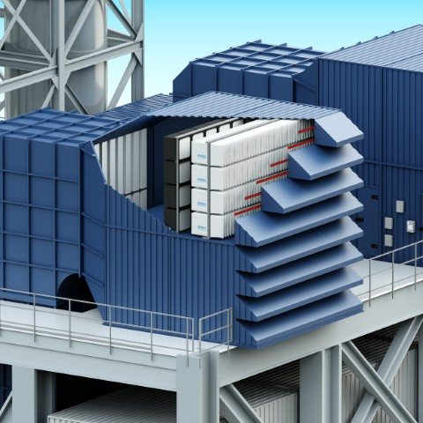 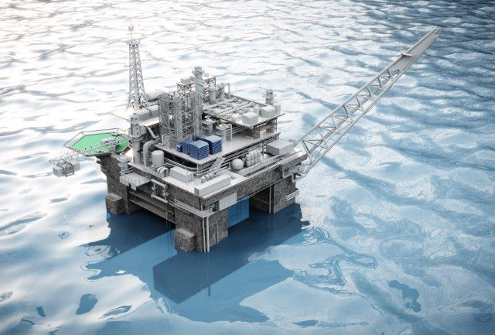

High Efficiency Particulate Air filters ((H)EPA) filters static filters can be fitted behind pulse filters to optimize the air cleanliness for the compressor (or act as a secondary barrier filter especially in areas of high hydrocarbons particles).

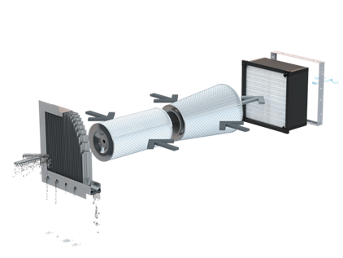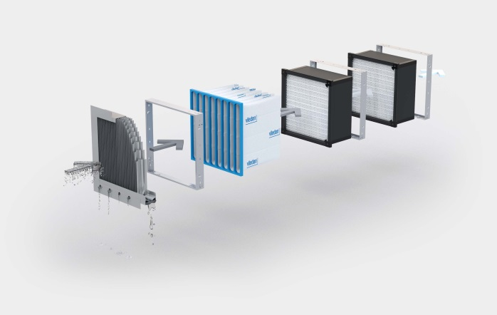

The scope of this procedure includes methods for performance testing of individual filter elements and of the complete filtration system. This procedure are intended for filter elements and filter systems which operating at flow rated within the range 0,25 m3/s (900 m3/h) up to the 8000 m3/h.

# Test method for single filter element

## Test rig and equipment

### Test conditions

Room air or outdoor air may be used as the test air source. Relative humidity shall be no less than 90% in the test duct in the incoming air upstream spray nozzles, in order to prevent saline solution aerosol droplet evaporation. The air temperature shall be in the range of 10 °C to 38 °C. The exhaust flow may be discharged outdoors, indoors or re-circulated.

### Test rig

The test rig (see Figure 1) consists of several duct sections (may be rectangular or square) with a typical 610mm x 610mm (24” x 24”) nominal inner dimensions. If different, cross section dimensions to be stated in the report. The section where the test filter is installed is to be representative of the cross-sectional area and geometry for a single filter within the proposed offshore inlet system.

In case of circular cartridges, the test setup (mounting of the filters in the test duct) shall be as close to the real application as possible. This must however be analysed specifically for each construction, taking into consideration possible jetting effect that can affect the velocity and aerosol concentration in the test duct cross section.

The test rig is operated in a negative pressure airflow arrangement, which represents the typical air flow condition for a gas turbine. A positive pressure arrangement is not typically encountered in gas turbine air inlet systems.

### Measurement systems

Salt mass concentration readings are required to be made using a flame photometer AND / OR Millipore membrane or expressed a salt ppmw content (or *other methods to be suggested ?*).

Sensors should be located fore and aft of the test filter, and should allow for readings across the full system to be taken also.

### Saline solution aerosol generation

The saline solution aerosol shall be generated using a rotary atomiser or water spray nozzle system (*advise on other systems* *and decide* ?) The rotary atomiser or spray nozzles deliver the required distribution of saline solution aerosol droplet sizes.

The volumetric flow of the saline solution is varied according to the test airflow rate.

The volumetric flow of the mist shall correspond to range 0.1 – 0.5 litre/min OR 2- 5ml/m³ airflow (*members to advise on volume and units)*. For example, at an airflow of 3400m³/h, the volume of saline solution aerosol produced will be 13.4 litres per. hour (l/h). Higher volumes can be considered but flooding of the filter has to be considered.

### Saline solution aerosol droplet size distribution

NGTE 30 knot

OR a more limited smaller range (0.2 – 5um?)

Solution should 3.6PPM NaCL content.

### Saline solution

Where possible, seawater shall be used for the saline solution in the test procedure. Where sufficient quantities of sea water are unavailable, the saline solution can be artificially manufactured. The artificial sea water should be made using potable water, and have a salinity of 3.5%W.T concentration. When using artificial seawater to provide the saline solution aerosol challenge to the test filter, the chemical composition of the artificial seawater should be:

|  |  |
| --- | --- |
| Particle size [mm] | Inlet con. [ppm] |
| < 2 | 0,0038 |
| 2 – 4 | 0,0212 |
| 4 – 6 | 0,1404 |
| 6 – 8 | 0,3060 |
| 8 – 10 | 0,4320 |
| 10 – 13 | 0,6480 |
| > 13 | 2,0486 |
| Total | 3,6 30knot |

*Particle distribution / size % content of the saline solution which should be used?*

*Always repeatability / laboratory / replication of real atmospheric conditions?*

## Saline solution aerosol removal efficiency test for filter element

The below is a summary of the test procedure steps for testing the saline solution aerosol removal efficiency of the test filter

1. Measurements to be taken for initial test filter pressure drop as well as test duct temperature and %RH. Pressure drop, temperature and %RH are to be logged throughout the test procedure.
2. Allow the pressure drop across the test filter to stabilize at rated airflow[1], and record.
3. Inject the nominal liquid water content relative to air volume flow over a period of 60 minutes (±10%).

Turn on the saline solution aerosol generation system. The concentration of the aerosol is to be set as per specified. Constantly record the pressure drop across the test filter.

1. After the saline solution aerosol generation system has been running for 10 minutes, take readings of the salt mass concentration upstream and downstream of the test filter with the relevant measurement systems (e.g. Sodium flame photometer). Readings should be taken at an interval of 10 minute. The average upstream and downstream saline concentration can now be calculated.
2. Turn off the saline solution generation system and fan so there is no airflow over the test filter/system. Allow any water contained within the test filter to drain freely due to the effects of gravity.
3. Dry out the test filter. This can be done by running the fan at a reduced setting so that a low volumetric airflow (around 1000m³/h for static) passes over the test filter.
4. Increase the volumetric airflow to the rated airflow of the test filter, and allow the pressure drop across the test filter to stabilize as per step 2.
5. Repeat Steps 3-9 three times (*comments?*)
6. The test filter is loaded with ISO fine test dust, until the recommended final pressure drop across the test filter/system is reached. The mass of ISO fine dust fed into the test filter is recorded (Most fine filters for TM tested to 625Pa).
7. Repeat Steps 3-9.
8. Dry out the test filter as per Step 8, with the exception that the test filter returns to the recommended final pressure drop of the test filter, not the pressure drop of the test filter at a volumetric flow of 1000m³/h.
9. Repeat Steps 5-8, with the exception that the saline solution aerosol generation system is allowed to run for a period of three (3) hours. Upstream and downstream sampling is to be performed, as per Step 4, in the final hour of this part of the test. (comments how many times?)
10. End of test procedure.

### Saline solution aerosol sampling system

1. A sodium flame photometer shall be used to determine the saline solution aerosol removal efficiency of the test filter measuring the upstream salt mass concentration in either parts per million (ppm) or as a percentage of the sample of air taken.
2. Optical particle counter (White light) measure particle droplet size.
3. Particle counter measurement
4. Membrane system (downstream)
5. Calculation method (by ppmw)

**The key questions and comments required**

1. which spray solution?
2. generated how?
3. particle size distribution?
4. Flowrates for saline solution ?
5. Measurement systems?
6. Test repeat how many times?
7. This test is aimed at single filter elements?
   1. Pre-filters
   2. Fine filters
   3. EPA filters
8. If a combined air filtration system was tested this way then you could run this test for days before a downstream reading is recorded ?

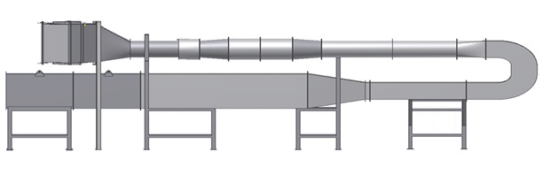

**Airflow**

**1**

**2**

**2**

**3**

**4**

**5**

**6**

**7**

**8**

**9**

Test filter/system

END

**Key**

1. Dust, saline solution aerosol and mineral oil aerosol (as per. Annex A) injection points
2. Pressure ring
3. Manometer
4. Upstream sampling point
5. Downstream sampling point
6. Fan
7. Flow Control
8. Flow meter
9. Exhaust filter

# Test Method for complete filtration system

## Test rig and equipment

### Test conditions

Room air or outdoor air may be used as the test air source. Relative humidity shall be no less than -90% in the test duct, in order to prevent saline solution aerosol droplet evaporation. The air temperature shall be in the range of 10 °C to 38 °C. The exhaust flow may be discharged outdoors, indoors or re-circulated. Requirements of certain measuring equipment may impose limits on the temperature of the test air.

### Test rig

The test rig (see Figure xxx ) consists of several duct sections (may be rectangular or square) with a typical 610mm x 610mm (24” x 24”) nominal inner dimensions. If different, cross section dimensions to be stated in the report. The section where the test system is installed is to be representative of the cross-sectional area and geometry for all the stages of the filtration system within the proposed offshore inlet system.

When performing a full system test, the plenum for the final filter element must be positioned in such a way that all proposed pre-filtration component(s) (e.g. coalesce / prefilter pads, moisture removal vanes etc.) are installed the correct distance upstream from the final filter, so as to best replicate the movement of air within the proposed offshore inlet system(s). In addition, any downstream vanes are to be located at the correct distance from the final filter, to best replicate the movement of air on the downstream side.

In case of circular cartridges, the test setup (mounting of the filters in the test duct) shall be as close to the real application as possible. This must however be analysed specifically for each construction, taking into consideration possible jetting effect that can affect the velocity and aerosol concentration in the test duct cross section.

The test rig is operated in a negative pressure airflow arrangement, which represents the typical air flow condition for a gas turbine. A positive pressure arrangement is not typically encountered in gas turbine air inlet systems.

### Measurement systems

Salt mass concentration readings are required to be made using a flame photometer AND / OR Millipore membrane or expressed a salt ppmw content (or *other methods to be suggested ?*).

Sensors should be located fore and aft of the test system, and should allow for readings across each filter element of the full system to be taken also.

## Saline solution aerosol generation

The saline solution aerosol shall be generated using a rotary atomiser or water spray nozzle system (*advise on other systems* *and decide* ?) The rotary atomiser or spray nozzles deliver the required distribution of saline solution aerosol droplet sizes.

The volumetric flow of the saline solution is varied according to the test airflow rate.

The volumetric flow of the mist shall correspond to range 0.1 – 0.5 litre/min OR 2- 5ml/m³ airflow (*members to advise on volume and units)*. For example, at an airflow of 3400m³/h, the volume of saline solution aerosol produced will be 13.4 litres per. hour (l/h). Higher volumes can be considered but flooding of the filter has to be considered.

### Saline solution aerosol droplet size distribution.

NGTE 30 knot

OR a more limited smaller range (0.2 – 5um?)

Solution should 3.6PPM NaCL content.

### Saline solution

Where possible, seawater shall be used for the saline solution in the test procedure. Where sufficient quantities of sea water are unavailable, the saline solution can be artificially manufactured. The artificial sea water should be made using potable water, and have a salinity of 3.5%W.T concentration. When using artificial seawater to provide the saline solution aerosol challenge to the test system, the chemical composition of the artificial seawater should be:

|  |  |
| --- | --- |
| Particle size [mm] | Inlet con. [ppm] |
| < 2 | 0,0038 |
| 2 – 4 | 0,0212 |
| 4 – 6 | 0,1404 |
| 6 – 8 | 0,3060 |
| 8 – 10 | 0,4320 |
| 10 – 13 | 0,6480 |
| > 13 | 2,0486 |
| Total | 3,6 30knot |

*Particle distribution / size % content of the saline solution which should be used?*

*Always repeatability / laboratory / replication of real atmospheric conditions?*

## Saline solution aerosol removal efficiency test for filtration system

The below is a summary of the test procedure steps for testing the saline solution aerosol removal efficiency of the test system (the outline below will need to reflect this time period accordingly once filter test clarified.)

Please note:

1. System test will require longer time periods to reflect any downstream measurement (days or weeks).
2. The system is designed to protect the unit for periods of months,
3. Test costs substantially higher accordingly.
4. Measurements to be taken for initial test filter pressure drop as well as test duct temperature and %RH. Pressure drop, temperature and %RH are to be logged throughout the test procedure.
5. Allow the pressure drop across the test system to stabilize at 1,000m3/hr and record. Increase the flow rate as specified for test.
6. Turn on the saline solution aerosol generation system. The concentration of the aerosol is to be set as per specified. Monitor the rise in pressure drop across the test filter.
7. After the saline solution aerosol generation system has been running for 10 minutes, take readings of the salt mass concentration upstream and downstream of the test filter with the relevant measurement systems (Sodium flame photometer). Readings should be taken at an intervals of 10 minute. The average upstream and downstream saline concentration can now be calculated.
8. When each reading is taken, visual checks should also be conducted and logged to check for water bypass through the test system. Visual checks should be made, at an interval of 5 minutes.
9. Allow the saline solution aerosol generation system to operate for a total of one (1) hour.
10. Turn off the saline solution generation system and fan so there is no airflow over the test system. Allow any water contained within the test filter/system to drain freely due to the effects of gravity.
11. Dry out the test system. This can be done by running the fan at a reduced setting so that a low volumetric airflow (around 1000m³/h for static) passes over the test filter.
12. Increase the volumetric airflow to the rated airflow of the test system, and allow the pressure drop across the test system to stabilize as per step 2.
13. Repeat Steps 3-9 three times (*comments?*)
14. The test system is loaded with ISO fine test dust, until the recommended final pressure drop across the test filter/system is reached. The mass of ISO fine dust fed into the test system is recorded (Most fine filters for TM tested to 625Pa).
15. Repeat Steps 3-9.
16. Dry out the test system as per Step 8, with the exception that the test system returns to the recommended final pressure drop of the test system, not the pressure drop of the test system at a volumetric flow of 1000m³/h.
17. Repeat Steps 5-8, with the exception that the saline solution aerosol generation system is allowed to run for a period of three (3) hours. Upstream and downstream sampling is to be performed, as per Step 4, in the final hour of this part of the test. (comments how many times?)
18. End of test procedure.

### Saline solution aerosol sampling system

1. A sodium flame photometer shall be used to determine the saline solution aerosol removal efficiency of the test system measuring the upstream salt mass concentration in either parts per million (ppm) or as a percentage of the sample of air taken.
2. Optical particle counter (White light) measure particle droplet size.
3. Particle counter measurement
4. Membrane system (downstream)
5. Calculation method (by ppmw)

1.