**Micro Gas Turbine**

**Technology**

Research and

Development

for European

Collaboration

**Combustion**



# Acknowledgments

This document was produced by the European Turbine Network (ETN) in order to identify a number of key areas that require substantial R&D efforts for micro turbines from the European community to become competitive in the energy sector worldwide.

The manuscript was produced by Andreas Huber from Deutsches Zentrum für Luft- und Raumfahrt (DLR) and co-authored by Hamidreza Darabkhani from Cranfield University.

The European industry involved or interested in the development of micro turbine technology has identified a number of key areas that require substantial R&D efforts for micro turbines to become competitive in the energy industry. These include recuperator technology, turbomachinery, system integration, multi-fuel combustion technology and material technology. These areas correspond to the working groups defined in the minutes of the ETN meeting on MGT technology held in Brussels 8 October 2015. This document presents potential work areas and proposed project outlines for European collaboration to improve MGT technology, based on the input of the member of the MGT Combustion working group.

Contributions to this document were provided by the organisations listed below:

|  |  |
| --- | --- |
| Deutsches Zentrum für Luft- und Raumfahrt | logo |
| Cranfield University | https://upload.wikimedia.org/wikipedia/en/7/7b/Cranfield_logo_2007.jpg |
|  |  |
|  |  |
|  |  |
|  |  |
|  |  |
|  |  |

Contents

Acknowledgments 1

1 Introduction 3

2 State of the Art 4

3 Necessary Technology Developments 5

4 Working group member contributions 12

5 References 12

# Introduction

Microturbines are small gas turbines used for small-scale power generation at one point in a distributed network or at a remote location. These power sources typically have rated power outputs between 25 kW and 500 kW. Relative to other technologies for small-scale power generation, microturbines offer a number of advantages, including: a small number of moving parts, compact size, light weight, low emissions, low electricity costs, potential for low cost mass production, and opportunities to utilize waste fuels. They have been commonly used in many engineering fields.

The current challenging performance targets for microturbines include fuel-to-electricity efficiencies of 40% or higher, capital costs less than $500/kW, NOx emissions reduced to single parts per million, several years of operation between overhauls, lives of 40,000 hours and fuel flexibility [1-2].

A schematic diagram of the TURBEC T100 Micro turbine is shown in following figure 1 [3], where the different components are:

1. Electric Generator
2. Air inlet
3. Combustion chamber
4. Recuperator air by-pass
5. Compressor
6. Turbine
7. Regenerator
8. Heat exchanger



Figure 1 – Schematic draw of the TURBEC T100 Micro turbine system [3]

Typical operating conditions are:

* Combustion chamber pressure = 4.5 bar
* Turbine Inlet Temperature = 950°C
* Turbine exit gas temperature = 620-650°C
* Exhaust gases temperature = 80°C
* Rotation speed = 70000 rpm

# State of the Art

## Fuel Flexibility

Micro gas turbines are generally able to operate on a variety of different gaseous and liquid fuels, including natural gas, biogas, syngas, gasoline, kerosene, and diesel fuel/distillate heating oil.

Compared to piston engines micro gas turbines can be operated with fuels with low heating value without engine derating. The combustion systems of micro gas turbines can also designed in a way, that fuels with lower Methane Number (increased autoignition / detonation tendency) as gases with heavier hydrocarbon components (C2+ like Propane, Ethan, Butane, etc.) can be easily burned. The same is true for fuels containing hydrogen (> 5% volume percent). Also the minimum required level of CH4 content in the fuel can be lower when micro gas turbines are used.

Beside the large fuel flexibility of micro gas turbines the NOx, CO, UHC emissions are much lower than these of piston engines. Piston engines require post-combustion emissions control using catalytic exhaust gas treatment (DOC, SCR, etc.). Especially in case of syngas containing CO the CO emissions of piston engines increase drastically due to the fuel slip.

Whatever fuel is used combustion systems have to ensure a stable and efficient combustion with lowest emissions and low pressure loss at all relevant operating conditions. Especially the part load capability in terms of exhaust gas emissions (especially CO) is becoming very important in the future. In addition serial production costs of the combustor should be low while maintaining a lifetime of about 30000 h. When different fuels are used in a micro gas turbine the combustion systems should keep the same dimensions even for fuels with a very low LHV, thus ensuring an easy exchange of combustors.

Most micro gas turbines are currently operated with natural gas (NG) and biogas. Usually a different design of the combustor system or an adaption of the basic design is used for different fuels. An overview of the fuels used by the different MGT manufacturer is shown below:

Capstone:

|  |  |  |
| --- | --- | --- |
| **Fuel** | **LHV [MJ/m3]** | **Fuel requirements** |
| Natural Gas | 32,5 – 50,2 |  |
| LPG (Propane) |  |  |
| Biogas | > 13,8 | CH4 > 24 Vol.% |
| Diesel / Kerosene |  |  |

FlexEnergy:

|  |  |  |
| --- | --- | --- |
| **Fuel** | **LHV [MJ/m3]** |  |
| Low caloric value gas | 12,1 – 22,3 WI | Model SW |
| Low caloric value gas | 18,6 – 36,1 WI | Model ST |
| Medium / high caloric value gas | 29,8 – 70,7 WI | Model SM |
| Biogas / sour gas |  | CH4 > 30%  H2S < 6500 ppmv |

Ansaldo:

|  |  |  |
| --- | --- | --- |
| **Fuel** | **LHV [MJ/m3]** |  |
| Natural Gas | 38 – 50 |  |
| Biogas | > 16 | CH4 > 40 Vol.%  H2S < 1500 ppm |

MTT:

|  |  |  |
| --- | --- | --- |
| **Fuel** | **LHV [MJ/m3]** |  |
| Natural Gas | 32 – 45 |  |

## Emissions

### Noise

### Gaseous

# Necessary Technology Developments

The potential fuels for gas turbines range from conventional gaseous or liquid fuels like natural gas, heating oil or diesel to renewable fuels from biomass and waste fuels.

## Gaseous fuels

**Natural gas (also sour gas)**

Natural gas is a mixture of lightweight alkanes. The chemical composition depends on the place of discovery. Main composite is methane CH4 with 70-99 Vol. %. Further components are ethane, propane, butanes and pentanes (C2+ 0-20 Vol. %).

Sour gas is unprocessed natural gas from the gas well or any other gas containing significant amounts of hydrogen sulfide (H2S). Natural gas is usually considered sour if there are more than 5.7 milligrams of H2S per cubic meter of natural gas, which is equivalent to approximately 4 ppm by volume under standard temperature and pressure .

**Biogas (digester gas)**

Biogas is produced by anaerobic digestion of biomass/ biogenic material. Anaerobic digestion is a collection of processes by which microorganisms break down biodegradable material in the absence of oxygen. It consists of CH4 and CO2 with a CH4 content of about 40 - 75 Vol.-%. Raw materials are residual material or waste products (sewage sludge, biowaste, food waste), fertilizer (slurry, dung) and energy crops or plant remains.

**Landfill gas**

Landfill gas is a complex mix of different gases created by the action of microorganisms within a landfill. Landfill gas is produced by evaporation of volatile organic compounds and by chemical reaction or microbial actions. The biochemical degradation can be divided in aerobic and anaerobic processes. The landfill gas contains CH4 and CO2 with a CH4 content of about 25 – 60 Vol.-% .

**Manufactured gases**

Manufactured gases is typically a syngas with a low heating value produced as products of gasification (e.g. of wood (wood gas), coal (coal gas / city gas)) or pyrolysis processes. The gas contains H2, CO, CH4, CO2 and N2.

Gaseous fuels obtained by gasification of biomass include a set of substances such as tar, which is an obstacle to the use of gaseous fuels in internal combustion engines due to its high corrosive power of components and reduced engine efficiency.

**Hydrogen**

Currently the dominant technology for the production of hydrogen is steam reforming from hydrocarbons. In the future the production using electrolysis and excess electricity produced by renewable energies is becoming more and more important (‚power to gas‘).

**Industrial waste gas**

Industrial waste gases that are common used as fuels include refinery gases and process off-gases. Refinery gases typically contain components such as H2, CO, light hydrocarbons, H2S, and ammonia, as well as CO2 and N2. Process off-gases include a wide variety of compositions. Generally, waste gases are gases with medium to low heating values. Depending on their origin and contaminants, industrial gases sometimes require pretreatment comparable to that applied to raw landfill gas / biogas. Particulates (e.g. catalyst dust), oils, condensable gases, water, C4+ hydrocarbons and acid gases may all need to be removed.

**Blast-furnace gas**

Blast furnace gas is a by-product of blast furnaces that is generated when the iron ore is reduced with coke to metallic iron. It has a very low heating value consisting of about 60% N2 and 18-20 % of CO2. The remaining components are CO and some H2. The LHV is typically in the range of 3,3 - 4 MJ/m3.

## Liquid fuels

**Heating oil**

Heating oil, or oil heat, is a low viscosity, liquid petroleum product used as a fuel for furnaces or boilers in buildings. Heating oil consists of a mixture of petroleum-derived hydrocarbons in the 14- to 20-carbon atom range that condenses between 250 and 350 °C during oil refining

**Diesel / Kerosene**

The most common type of diesel fuel is petrodiesel, which is produced from the fractional distillation of crude oil between 200 °C (392 °F) and 350 °C (662 °F) at atmospheric pressure, resulting in a mixture of carbon chains that typically contain between 8 and 21 carbon atoms per molecule . Kerosene is a thin, clear liquid formed from hydrocarbons obtained from the fractional distillation of petroleum between 150 °C and 275 °C, resulting in a mixture with a density of 0.78–0.81 g/cm3 composed of carbon chains that typically contain between 6 and 16 carbon atoms per molecule .

**LPG / NGL / LNG**

Liquefied petroleum gas (LPG) or NGL (Natural Gas Liquids) is composed primarily of propane and/or butane. Liquefied Natural Gas (LNG) is a product of natural gas which consists primarily of methane. Its properties are those of liquid methane, slightly modified by minor constituents.

**Liquid hydrocarbons**

Liquid hydrocarbons can be produced by excess renewable electricity, electrolysis, gasification and Fischer-Tropsch synthesis (‚power to liquid‘). Examples are iso-alkanes or n-alkanes (e.g. Nonan C9)

**Liquid biofuels**

Pure vegetable oil, Biodiesel, Bioethanol, Biomethanol, glycerine or pyrolysis oil are promising liquid biofuels for power generation applications.

Liquid biofuels are produced from biomass through conversion processes e.g. biochemical or thermochemical conversion. In a biochemical conversion process such as alcohol fermentation, fuel is obtained by means of chemical reactions caused by the presence of enzymes and microorganisms.

Biodiesel is developed by transesterification from vegetable oil (rape, soy or palm oil) or animal fats/oils with added alcohol (usually methanol) and glycerine removed. It is functionally identical to petroleum diesel. Biodiesel is most commonly sold in blends with normal diesel e.g. B5 which is 5 percent biodiesel and 95-percent petroleum diesel. Biodiesel is known to reduce the health and environmental risks associated with petroleum diesel (Clean Air Act; 1990).

Pure vegetable oil has been shown to cause major increases in unburned hydrocarbons, CO, and particulate matter emissions. Greatest potential for use in gas turbines are biodiesel and ethanol, due to factors such as availability and physical-chemical characteristics similar to fossil fuels. Also, butanol and pentanal would be feasible fuels as they have a larger energy density.

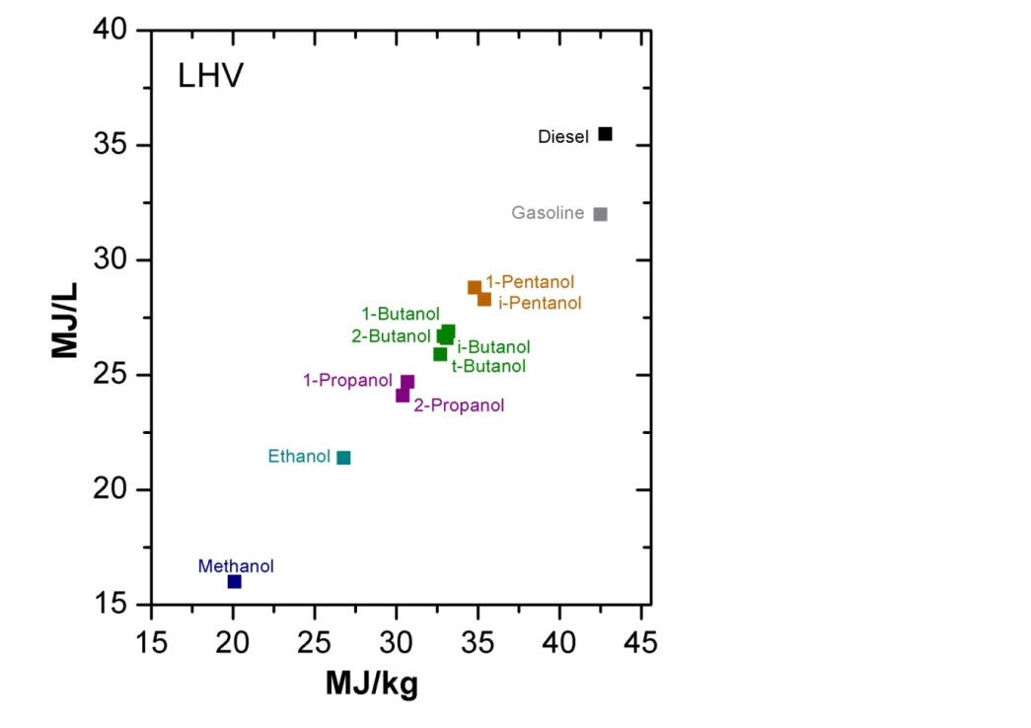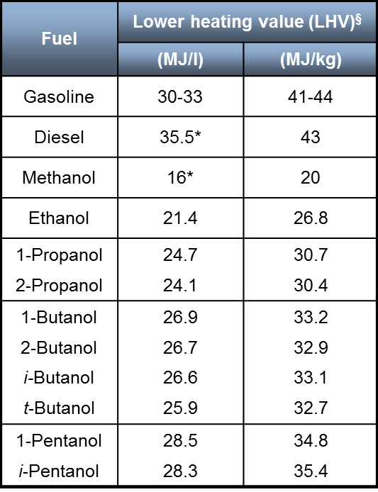

Figure 1: Energy density and lower heating value of alcohols, gasoline and diesel

In Thermochemical processes such as pyrolysis technology gaseous or liquid biofuels are obtained by the action of heating and of a catalyst.

Biodiesel has similar properties to diesel. It can be used directly in a gas turbine. Lower Heating Value (LHV) of liquid bio-fuels such as biodiesels is between 37,500 and 44,500 kJ/kg, which is close to regular diesel. The viscosities of ethanol, biodiesel and its blends with diesel are lower than the residual oil from the kitchen making it easier to spray. Vegetable oils and oils derived from pyrolysis have a very high viscosity and should be heated before being injected into the combustor.

A main by-product obtained during the production of biodiesel is glycerine. Glycerol is a simple polyol (sugar alcohol) compound and can also be used as a fuel for piston engines and gas turbines.

The fast pyrolysis process converts biomass with low energy content and high ash level, high moisture and inhomogeneity mainly into a liquid ash-free product with low Sulphur and relatively high energy content. The solid product of the process can be mixed with the liquid product to form a slurry containing almost all of the bioenergy, whereas the gaseous product can be used to cover the heat and power demand of the process. The liquid product or the slurry is pumpable and allows, in contrast to the feedstock with low energy density, a transport to various places and therefore to use it in multiple applications. Pyrolysis liquids, compared to light fuel oil or kerosene, are highly viscous, acidic and unstable liquids with significantly lower heating value containing a large amount of chemically dissolved water and solids. The proposed ranges of the pyrolysis liquids to be addressed are basic pyrolysis liquids up to pyrolysis liquid emulsions. Basic pyrolysis liquids include generally homogenous single-phase liquids with water content of maximum of 28% weight and a solid content below 0.5% weight. The quality of the liquids can be improved by the removal of solid particles using e.g. on-line hot water filtration or centrifugation. A further improvement can be achieved in adding alcohols, thus improving the homogeneity and the storage stability, at the same time reducing viscosity. To upgrade pyrolysis liquids and facilitate the use in existing technologies for heat and power production emulsions are commonly used. Emulsions can be generated by homogenization of immiscible liquids and by using additives lowering the surface energy of the interface of the produced droplets. The yield and thermo-fluid-dynamic properties of the pyrolysis liquids are significantly affected by the process and type of biomass used as feedstock. A fast pyrolysis process using a catalytically active material for example can reduce the oxygen content, which reduces the acidity and increases storability and energy content. The yield of the organic liquids using wood depends e.g. on the volatile matter and the ash content of the feedstock.

## Solid fuels (biomass and waste)

Biomass is a collective term for all plant and animal material. Different forms of biomass can be burned or digested to produce energy. Examples of biomass include wood, straw, poultry litter and purpose-grown energy crops such as willow and poplar. Biomass fuels can be considered renewable as long as they come from sustainable sources such as forest residues, tree surgery wastes, energy crops, agricultural waste and other wood residues such as sawdust. Theoretically, it is possible to burn any type of biomass but, in practice, combustion is feasible only for biomass with moisture content lower than around 50% .

**Wood**

In the form of logs, woodchip and wood pellets in stoves or boilers for space and water heating.

- Logs and pellets are generally suitable for use on a domestic scale. Woodchips are generally only used in larger boilers (schools, etc.)

- On a larger scale, wood can also be used for the production of electricity (Combustion plant, burned to produce steam).

- Two other possibilities: Gasification (an oxidation process whereby biomass is broken down into CO, H2, CO2, and possibly hydrocarbon molecules such as CH4), and Pyrolysis (where the wood is heated in the absence of oxygen to produce a bio-oil liquid with some charcoal and gas).

**Agricultural waste**

**B**y-products of conventional agricultural activity:

• 'Dry' agricultural wastes such as straw that can be burned to produce energy.

• 'Wet' wastes such as green matter or slurry can be digested to produce methane in a process known as anaerobic digestion. This can then be used to fuel a gas engine to produce electricity and heat.

**Municipal and industrial waste**

- Waste food and waste wood (from the construction industry).

- Waste food can be recycled and used to produce compost - or used for the production of electricity in an anaerobic digestion plant. Waste vegetable oil can be used in the production of bio-diesel.

- Care has to be taken with emissions and residues as they can cause environmental problems.

- The calorific value of biofuel is lower than that of fossil fuel; the volume required for a given heat output is greater. Hence economic transportation of biomass over long distances, storage and drying should be assessed in any evaluation. Calorific values of biofuels are compared with other fuels as below :

|  |  |
| --- | --- |
| **Fuel** | **GCV (MJ/kg)** |
| **Biodiesel(from oilseed rape or recycled vegetable oil)** | 37.27 |
| **Veg. oil** | 39 |
| **Processed biogas** | 22 |
| **Agricultural waste (straw)** | 15.8 |
| **Animal waste** | 18 |
| **Waste food/fruits** | 15 |
| **Wood pellet/chips** | 17.6 |
| **Gas/diesel oil** | 48 |
| **Landfill gas** | 22/m3 |
| **Natural gas** | 39/m3 |

Table 1: Calorific values of various fuels

**VOCs (Volatile Organic Compounds)**

Volatile organic compounds (VOCs) are organic / carbonic substances that have a high vapour pressure due to the low boiling point at ordinary room temperature. Today’s main source in Germany is usage of chemical solvents and cleaning agents in industrial processes. In technical processes like painting streets, VOCs are present as a waste product in the exhaust air. Typical components are methanol, ethyl acetate, acetone and toluene.

## Fuel pretreatment

Using waste fuel or biofuels a fuel pretreatment is required to reduce the level of contaminants (H2S, halogen acids, HCN; ammonia; salts and metal-containing compounds; organic halogen-, sulfur-, nitrogen-, and silicon-containing compounds such as siloxanes). In combustion, halogen and sulfur compounds form halogen acids, SO2, some SO3 and possibly H2SO4 emissions. The acids can corrode downstream equipment. When siloxanes are exposed to high temperatures inside the combustion and exhaust sections of the turbine, they form hard silicon dioxide deposits that can eventually lead to turbine failure .

## Future research activities for fuel flexibility

In general all mentioned fuels can be used by a micro gas turbine to produce electric and thermal power. Type and composition of the fuel has a direct influence on efficiency and exhaust gas emission. The LHV of the fuel is important because it defines the mass flow of fuel and consequently its specific consumption. Currently for each type of fuel design optimisation is required with reference to a low value of the LHV of fuel. To compensate for the lower value of LHV for the fuel gases, the fuel injection system must provide a fuel rate much higher than when the combustor operates on fuel with higher calorific value. Due to the high rate of mass flow of gas with low LHV, the passage of fuel has a much larger cross section than that corresponding to natural gas.

Due to the high effort in designing new combustion systems, the design of multi-fuel combustors or combustors capable to operate with fuels over a broad range of LHV would be essential. Especially a design for a specific “niche” fuel is usually not developed due to economic reasons. But these “niche” fuels like fuels with a very low heating value containing CO could be very successful applied in micro gas turbines as piston engines can hardly operate with these fuels with acceptable exhaust gas emissions.

Fuel flexibility of a fixed combustor design is also favourable for micro gas turbines connected to a biogas micro grid. The role of micro grids with so-called satellite CHP systems for local utilisation of biogas has gained significance in the last years with the support of public funding. However, the use of micro biogas grids requires CHP systems that can withstand varying fuel qualities, peak demands or feeding-in natural gas to the local biogas grid to compensate for the downtime at the fermentation plants.

In general the coupling of a micro gas turbine system with “fuel producing units” (hybrid systems) requires a fuel flexible system. An example is the hybrid power plant, a combination of a solid oxide fuel cell and a micro gas turbine. The system requires a combustion system able to oxidize the main fuel (natural gas, biogas) and the SOFC off-gas, a syngas with a very low heating value of about 2 MJ/kg. Another example would be the coupling of a micro gas turbine and an electrolysis plant. Here, hydrogen produced by excessive renewable electricity is used in times of no or low electricity produced by renewable energies. To compensate peak demands the micro gas turbine could also be operated with natural gas or mixtures of natural gas and hydrogen.

The duel fuel capability of a micro gas turbine using the same combustor design for natural gas and heating oil for example would reduce the development effort of separate designs and would increase the application range of the micro gas turbine in the CHP sector.

An interesting evolution of natural gas microturbines consists on the external combustion microturbines (Externally Fired Micro Gas Turbine),that, although still being in the development phase, could ensure the typical advantages of the gas turbines technology, together with the exploitation of a "carbon neutral" fuel. An EFMGT can fulfil a regenerative Joule cycle, in which an exchanger is introduced instead of a combustor with the purpose of heating the air coming from the compressor before it expands in the turbine. However, even if this kind of configuration has been studied and developed for a long time, the temperature limits imposed by the materials used for heat exchangers construction and oxidation phenomena they are subjected to, are still extremely limiting factors in terms of performance and reliability. For a better understanding of these issues, RSE signed a cooperation agreement for monitoring the mini combined consisting of two external combustion microturbines fuelled by wood chips and a Rankine organic fluid cycle. The activity has provided a complete energetic characterization of this plant and has highlighted its current operational limits. Characterization has shown that increasing air temperature will promote the oxidation phenomenon affecting heat exchangers tubes, causing higher quantity of solid particles to reach the microturbines promoting solid particle erosion of stationary and rotating parts. Samples of solid particulate taken from the filter located upstream of a turbine have been analysed, confirming that the gaseous flow carries substantially only iron oxide particles, whose origin can therefore be related to high working temperature of the exchangers and not to any specific chemical agent. For a better understanding of the origins of the observed oxidation phenomenon and its effects, as well as for finding a possible solution to the problem, a wide-ranging investigation has been made.

Efforts are now oriented to optimize heat exchanges and to identify specifically recommended materials for applications where high temperature resistances, oxidation and thermal cycling are required.

Further tests will be performed to evaluate the capability of the turbine material to withstand erosion due to impact of oxide particulate on its nozzles and blades.

## Future research activities for emission reduction

# Working group member contributions

|  |  |  |  |  |  |  |  |  |
| --- | --- | --- | --- | --- | --- | --- | --- | --- |
| Task | DLR | Cranfield | KIT | UNIGE (TPG) |  |  |  |  |
| Literature Review |  |  |  | X |  |  |  |  |
| Fuel injector design |  |  |  |  |  |  |  |  |
| Multi-fuel combustor for broad LHV range |  |  |  |  |  |  |  |  |
| Fuel flexibility of a fixed combustor |  |  |  | X |  |  |  |  |
| Dual Fuel Capabilities |  |  |  |  |  |  |  |  |
| LES of combustor |  |  | x |  |  |  |  |  |
| Thermodynamic aspects (e.g. cycle modifications) related to fuel change |  |  |  | X |  |  |  |  |
|  |  |  |  |  |  |  |  |  |
|  |  |  |  |  |  |  |  |  |
|  |  |  |  |  |  |  |  |  |
|  |  |  |  |  |  |  |  |  |

## Karlsruhe Institute of Technology (KIT)

The calculation of combustors is notoriously difficult because of the strong interaction of the combustion process with the turbulent flow. It is well known that RANS or URANS method does not do a satisfactory job so that the combustion community is using Large Eddy Simulation since many years. In this field, the Karlsruhe Institute of Technology KIT at the Institute of Fluid Mechanics has a long lasting experience in the modelling and application of Large Eddy Simulation and related aspects for combustion calculation. The advantage of LES is that a large fraction of the turbulent effects as wells as the combustion time scales are resolved instead of modelled as in the classical RANS approach. The advantage of a very accurate prediction is especially useful in predicting combustion instabilities at lean premixed conditions. This improved predictive capability on the other hand goes along with a much higher computational time. In order to keep the wall clock times for the calculations small a parallelization of the LES codes is mandatory. For that the KIT, Institute of Fluid Mechanics has developed an efficient parallel solver. KIT proposes to calculate and analyse the different fuels mentioned above.

References

1. E.Lara-Curzio R.Trejo, K.L.More, P.A.Maziasz and B.A.Pint, *Screening and evaluation of materials for Microturbine recuperator*. Proceeding of ASME Turbo Expo 2004 – GT 2004-54254.
2. D.J. Zhang, M. Zeng, J.W. Wang, Q.W. Wang, *Creep analisys of cross wavy primary surface recuperator for microturbine system*. Proceeding of ASME Turbo Expo 2008 – GT 2008-51505
3. E. Bianchi, *Microturbina TURBEC*.
4. F. Magagnato, B. Pritz and M. Gabi: A Novel Approach to Predict the Stability Limit of Combustion Chambers with LES. International Symposium on Experimental and Computational Aerothermodynamics of Internal Flows. 9th ISAIF, Gyeongju,South Korea, 2009